**MINISTRY OF EDUCATION AND TRAINING**

**FPT UNIVERSITY**

Capstone Project Document

**E-Printer Services**

|  |  |
| --- | --- |
| **Group 03** | |
| **Group members** | Dương Lê Đình Khang – Team Leader – SE61059  Nguyễn Trần Minh Hoà – Team Member – 60297 (Dropped out)  Nguyễn Trần Hoàng Quý – Team Member – 60356 (Dropped out)  Châu Chiêu Nguyên – Team Member – SE60911 |
| **Supervisor** | Mr. Kiều Trọng Khánh |
| **Ext. Supervisor** | N/A |
| **Capstone Project code** | EPS |

-Ho Chi Minh City, 06/01/2015-

*This page is intentionally left blank*

# Table of Contents

[Table of Contents 3](#_Toc417274982)

[List of Tables 5](#_Toc417274983)

[List of Figures 5](#_Toc417274984)

[Definitions, Acronyms, and Abbreviations 8](#_Toc417274985)

[A. Report No. 1 Introduction 9](#_Toc417274986)

[1. Project Information 9](#_Toc417274987)

[2. Introduction 9](#_Toc417274988)

[3. Current Situation 9](#_Toc417274989)

[4. Problem Definition 9](#_Toc417274990)

[5. Proposed Solution 9](#_Toc417274991)

[5.1 Feature functions 10](#_Toc417274992)

[5.2 Advantages and disadvantages 10](#_Toc417274993)

[6. Functional Requirements 10](#_Toc417274994)

[6.1 Make the report 10](#_Toc417274995)

[6.2 Manage the items with attribute 10](#_Toc417274996)

[6.3 Manage the printer communicating with mobile device 11](#_Toc417274997)

[6.4 Manage user 11](#_Toc417274998)

[7. Role and Responsibility 11](#_Toc417274999)

[B. Report No.2 Software Project Management Plan 12](#_Toc417275000)

[1. Problem Definition 12](#_Toc417275001)

[1.1 Name of this Capstone Project 12](#_Toc417275003)

[1.2 Problem Abstract 12](#_Toc417275004)

[1.3 Project Overview 12](#_Toc417275005)

[2. Project organization 14](#_Toc417275006)

[2.1 Software Process Model 14](#_Toc417275007)

[2.2 Roles and responsibilities 15](#_Toc417275008)

[2.3 Tools and Techniques 15](#_Toc417275009)

[3. Project Management Plan 17](#_Toc417275010)

[3.1 Product Backlog 17](#_Toc417275011)

[3.2 Sprint Backlog 18](#_Toc417275012)

[3.3 All Meeting Minutes 18](#_Toc417275013)

[4. Coding Convention 18](#_Toc417275014)

[C. Report No. 3 Software Requirement Specification 19](#_Toc417275015)

[1. User Requirement Specification 19](#_Toc417275016)

[1.1 Guest Requirement 19](#_Toc417275017)

[1.2 Admin Requirement 19](#_Toc417275018)

[1.3 StoreOwner Requirement 19](#_Toc417275019)

[1.4 Employee Requirement 19](#_Toc417275020)

[2. System Requirement Specification 19](#_Toc417275021)

[2.1 External Interface Requirement 19](#_Toc417275022)

[2.2 System Overview Use Case 20](#_Toc417275023)

[2.3 List of Use Case 21](#_Toc417275028)

[3. Software System Attribute 69](#_Toc417275030)

[3.1 Usability 69](#_Toc417275031)

[3.2 Reliability 69](#_Toc417275032)

[3.3 Availability 69](#_Toc417275033)

[3.4 Security 69](#_Toc417275034)

[3.5 Maintainability 70](#_Toc417275035)

[3.6 Portability 70](#_Toc417275036)

[3.7 Performance 70](#_Toc417275037)

[4. Conceptual Diagram 70](#_Toc417275038)

[D. Report No. 4 Software Design Description 71](#_Toc417275039)

[1. Design Overview 71](#_Toc417275040)

[2. System Architectural Design 71](#_Toc417275041)

[3. Component Diagram 73](#_Toc417275042)

[4. Detailed Description 74](#_Toc417275043)

[4.1 Class Diagram 74](#_Toc417275044)

[4.2 Class Diagram Explanation 74](#_Toc417275045)

[4.3 Sequence Diagram 78](#_Toc417275046)

[4.4 Activity Diagram 91](#_Toc417275047)

[5. User Interface Design 93](#_Toc417275048)

[5.1 Admin Interface Design 93](#_Toc417275049)

[5.2 Storeowner Interface Design (Website) 97](#_Toc417275050)

[4.1 Employee Interface Design 117](#_Toc417275051)

[6. Database Design 126](#_Toc417275052)

[6.1 Logical Diagram 126](#_Toc417275053)

[6.2 Data Dictionary 127](#_Toc417275054)

[7. Algorithms 129](#_Toc417275055)

[7.1 K-Medoids Algorithm 129](#_Toc417275056)

[7.2 Create a printable order 132](#_Toc417275057)

[E. Report No. 5 System Implementation & Test 134](#_Toc417275058)

[1. Introduction 134](#_Toc417275059)

[1.1 Overview 134](#_Toc417275060)

[1.2 Test Approach 134](#_Toc417275061)

[2. Database Relationship Diagram 134](#_Toc417275062)

[2.1 Physical Diagram 134](#_Toc417275063)

[2.2 Data Dictionary 134](#_Toc417275064)

[F. Report No. 6 Software User’s Manual 156](#_Toc417275065)

[1. Installation Guide 156](#_Toc417275066)

[1.1 Setting up environment at server side 156](#_Toc417275067)

[1.2 Deployment at server side 156](#_Toc417275068)

[1.3 Setting up the environment at client side 160](#_Toc417275069)

[2. User Guide 160](#_Toc417275070)

[2.1 Computer Guide 160](#_Toc417275071)

[2.2 Mobile Guide 168](#_Toc417275072)

# List of Tables

[Table 1: Definitions 6](#_Toc417272979)

[Table 2: Roles and Responsibilities 9](#_Toc417272980)

[Table 3: Hardware Requirement for Server 12](#_Toc417272981)

[Table 4: Hardware Requirement for Mobile 12](#_Toc417272982)

[Table 5: Roles and Responsibilities Details 13](#_Toc417272983)

[Table 6: Product Backlog Detail 16](#_Toc417272984)

[Table 7: Entity Data Dictionary 125](#_Toc417272985)

[Table 8: Detail Data Dictionary 127](#_Toc417272986)

# List of Figures

[Figure 1: Scrum Development Model 14](#_Toc417275073)

[Figure 2: System Overview Use Case 19](#_Toc417275074)

[Figure 3: <Guest> Overview Use Case 20](#_Toc417275075)

[Figure 4: <Guest> Login usecase diagram 20](#_Toc417275076)

[Figure 5: <Guest> Register usecase diagram 22](#_Toc417275077)

[Figure 6: <StoreOwner> Overview Use Case 24](#_Toc417275078)

[Figure 7: <StoreOwner> Insert Item Use Case Diagram 24](#_Toc417275079)

[Figure 8: <StoreOwner> Update Item Use Case Diagram 27](#_Toc417275080)

[Figure 9: <StoreOwner> Change Item Status Use Case Diagram 29](#_Toc417275081)

[Figure 10: <StoreOwner> Import Item Use Case Diagram 30](#_Toc417275082)

[Figure 11: <StoreOwner> Insert Employee Use Case Diagram 33](#_Toc417275083)

[Figure 12: <StoreOwner> Update Employee Use Case Diagram 34](#_Toc417275084)

[Figure 13: <StoreOwner> Change Employee Status Use Case Diagram 36](#_Toc417275085)

[Figure 14: <StoreOwner> Select Template Use Case Diagram 39](#_Toc417275086)

[Figure 15: <StoreOwner> Set Default Use Case Diagram 41](#_Toc417275087)

[Figure 16: <StoreOwner> Customize Template Use Case Diagram 43](#_Toc417275088)

[Figure 17: <StoreOwner> Create Order Use Case Diagram 46](#_Toc417275089)

[Figure 18: <StoreOwner> Print Order Use Case Diagram 49](#_Toc417275090)

[Figure 19: <StoreOwner> Assign Order Use Case Diagram 51](#_Toc417275091)

[Figure 20: <StoreOwner> Assign Order Use Case Diagram 53](#_Toc417275092)

[Figure 21: <Employee> Overview Use Case Diagram 55](#_Toc417275093)

[Figure 22: <Employee> Create Order Use Case Diagram 55](#_Toc417275094)

[Figure 23: <Employee> Print Order Use Case Diagram 58](#_Toc417275095)

[Figure 24: <Employee> Get Assigned Order Use Case Diagram 60](#_Toc417275096)

[Figure 25: <Admin> Overview Use Case Diagram 62](#_Toc417275097)

[Figure 26: <Admin> Upload Template Use Case Diagram 62](#_Toc417275098)

[Figure 27: <Admin> Delete Template Use Case Diagram 65](#_Toc417275099)

[Figure 28: <Admin> Change StoreOwner Status Use Case Diagram 67](#_Toc417275100)

[Figure 29: <Guest> Register 77](#_Toc417275101)

[Figure 30: <Guest> Login 77](#_Toc417275102)

[Figure 31: <StoreOwner> Insert Item 78](#_Toc417275103)

[Figure 32: <StoreOwner> Update Item 78](#_Toc417275104)

[Figure 33: <StoreOwner> Change Item Status 79](#_Toc417275105)

[Figure 34: <StoreOwner> Import Item 80](#_Toc417275106)

[Figure 35: <StoreOwner> Insert Employee 80](#_Toc417275107)

[Figure 36: <StoreOwner> Update Employee 81](#_Toc417275108)

[Figure 37: <StoreOwner> Change Employee Status 82](#_Toc417275109)

[Figure 38: <StoreOwner> Import Employee 83](#_Toc417275110)

[Figure 39: <StoreOwner> Select Template 83](#_Toc417275111)

[Figure 40: <StoreOwner> Set Template Default 84](#_Toc417275112)

[Figure 41: <StoreOwner> Custom Template 85](#_Toc417275113)

[Figure 42: <StoreOwner> Print Order 86](#_Toc417275114)

[Figure 43: <StoreOwner> Assign Order 87](#_Toc417275115)

[Figure 44: <StoreOwner> Suggest Assign Order 88](#_Toc417275116)

[Figure 45: <Admin> Upload Template 88](#_Toc417275117)

[Figure 46: <Admin> Delete Template 89](#_Toc417275118)

[Figure 47: <Admin> Change StoreOwner Status 90](#_Toc417275119)

[Figure 48: <Employee> Get Assigned Order 91](#_Toc417275120)

[Figure 49: <Employee> Create Order 91](#_Toc417275121)

[Figure 50: <Employee> Print Order 92](#_Toc417275122)

[Figure 51: Logical Diagram 126](#_Toc417275123)

[Figure 52: Physical Database Diagram 133](#_Toc417275124)

[Figure 56: Enviroment variable 156](#_Toc417275125)

[Figure 57: Server location 157](#_Toc417275126)

[Figure 58: Database server login 158](#_Toc417275127)

[Figure 59: Database script 158](#_Toc417275128)

[Figure 60: Connection String 159](#_Toc417275129)

[Figure 61: Register screen 160](#_Toc417275130)

[Figure 62: Select Template screen 160](#_Toc417275131)

[Figure 63: Manage Template screen 161](#_Toc417275132)

[Figure 64: Manage Item 161](#_Toc417275133)

[Figure 65: Import item 162](#_Toc417275134)

[Figure 66: Manage employee 162](#_Toc417275135)

[Figure 67: Import employee 163](#_Toc417275136)

[Figure 68: Manage Order 163](#_Toc417275137)

[Figure 69: Import order 164](#_Toc417275138)

[Figure 70: Assign order 164](#_Toc417275139)

[Figure 71: Manage StoreOwner 165](#_Toc417275140)

[Figure 72: Upload Template 166](#_Toc417275141)

[Figure 73: Delete Template 166](#_Toc417275142)

[Figure 74: Login 167](#_Toc417275143)

[Figure 75: Menu Screen 168](#_Toc417275144)

[Figure 76: Create Order Screen 168](#_Toc417275145)

# Definitions, Acronyms, and Abbreviations

|  |  |
| --- | --- |
| **Name** | **Definition** |
| EPS | E-Printer Services |
| App | Application |
| OS | Operating System |
| Playstore | A Market where you can install an app for Android device. |

Table 1: Definitions

# Report No. 1 Introduction

## Project Information

* Project name: **E-Printer Services**
* Project Code: **EPS**
* Product Type: **Website & Android Application**
* Start Date: **Jan 6th, 2015**
* End Date: **April 20­th,2015**

## Introduction

Beside cloud computing and big data, mobility is a new trend that is dominating the information technology industry right now and will continue in the future. There are huge potential to improve the quality of your life, your work if you can apply and maximize the advantages of mobility.

In this project, we will use the Bluetooth feature of smart phone devices which using Android OS to connect to a mini printer and help you print out reports, invoices and even if contracts for your business anywhere, anytime. By printing this way, you can save a lot of time than the traditional way like handwriting or come back to company to print an invoice and take it to the customer.All you need to print is a printer and an Android phone which installed our app,you can do that everywhere not only in your office. Moreover, imagine how easy it is when you are travelling far away from home but one customer wants to make a contract with you right now.

## Current Situation

When you sale a product, you should have an invoice.To have an invoice,there are some way like handwritten or return to the store to print then bring it to customer. In the market already have some printing app,it’s just an app written by mini printer’s producer provide to their customer,or app from third party such as [PrinterShare™ Mobile Print](https://play.google.com/store/apps/details?id=com.dynamixsoftware.printershare&hl=en) to perform the printing action with simple document,image easily.

## Problem Definition

Below are the disadvantages of current situation:

- Handwritten: Seller has an invoice roll to write the bill. One for customer, one for seller used for analysis, statistics at the end of day.With handwritten, they are difficult to preserve, easy to lose or damaged… However, they have strengths is the instantaneous and rapid.

- Return to the store to print: Time consuming for customer and seller but easy to manage and archive/store.

## Proposed Solution

Based on the difficulty of creating an invoice today, we offer a solution to meet the needs of users based on Bluetooth technology.

Our system includes a web app and an android app helps users to print invoices with customizable template from any printer that supports Bluetooth connection.

In more detail, our system has the following functions:

### **Feature functions**

* Web application:
* Staff can upload a new template to the system.
* Staff can manage StoreOwner’s status.
* StoreOwner can manage their item.
* StoreOwner can manage their employee.
* StoreOwner can select template from system, set template default and customize it.
* StoreOwner can create order then combine it with a template to make a report.
* StoreOwer can assign order to employee for printing purpose.
* Mobile application:
* Employee can receive order from StoreOwner.
* Employee can select template which suitable with them, then use their Android phone and connect to a printer that supports Bluetooth connection to print order.
* Employee can also create an order on mobile.

### Advantages and disadvantages

The advantages and disadvantages of the proposed solution:

* Advantages:
  + This system is easy for user to use, reduce error in handwriting and increase flexibility.
  + It is easier to store, they do not have to keep many papers.
  + Speed up the process of printing a report.
  + Users can customize their own report’s template.
  + System has high mobility.
* Disadvantages:
  + Users must have an Android smartphone to use the mobile app, they also need a bluetooth-supported printer.
  + Internet connection is required.

## Functional Requirements

Function requirements of the system are listed as below:

### Make the report

* Define report based on template and attributes of item.

### Manage the items with attribute

* Manage items: insert, update, lock /unlock item.
* Combine item’s attribute to custom the template for pirnt order.

### Manage the printer communicating with mobile device

* Support prints with mobility mini printer that using bluetooth.

### Manage user

* Manage accounts: create, update, active, de-active user.

## Role and Responsibility

|  |  |  |  |  |
| --- | --- | --- | --- | --- |
| No | Full Name | Role | Position | Contact |
| 1 | Kiều Trọng Khánh | Scrum Master/Product Owner | Instructor | [khanhkt@fpt.edu.vn](mailto:Khanhkt@fpt.edu.vn) |
| 2 | Dương Lê Đình Khang | Developer | Leader | [khangdldse61059@fpt.edu.vn](mailto:khangdldse61059@fpt.edu.vn) |
| 3 | Châu Chiêu Nguyên | Developer | Member | [nguyenccse60911@fpt.edu.vn](mailto:NguyenCCSE60911@fpt.edu.vn) |

Table 2: Roles and Responsibilities

# Report No.2 Software Project Management Plan

## Problem Definition



### Name of this Capstone Project

* E-Printer Services (EPS)

### Problem Abstract

Nowaday,The way people print something such as report,invoice not really effective when almost printers using in business right now are fixed type and it's only suitable for ,it's mean you can't print any document when stay outside of the office or store. The final solution for this situation is handwriting, but this way will involve human mistake. If you can do that in a smarter way, you will save a lot of time, effort and increase productivity of your business many times.

To solve those problems already mentioned above, we need to improve the mobility of the printing process by using a mini printer and a mobile app that can connect with it through Bluetooth connection to perform printing process without installing any driver.

### Project Overview

#### Current Situation and Disadvantages

Below are some current behaviors of user:

* Handwriting:
  + User uses an invoice book to write-on.
  + User keeps one copy of an invoice and gives another one for their customer.
  + When user wants to make a statistic of sale, they will need to do that by themselves.
* Return store to print invoice:
  + User makes a sale and return store to print an invoice.
  + User must come back to customer and gives them an invoice.
  + When user wants to make a statistic of sale, they can do it easily on computer.
* Use mini printer+app of producer or third party:
  + Before perform printing process user must download mobile app which compatible with their printer from website of producer or play store.
  + User can print an invoice easily anywhere.

Below are the disadvantages of current situation:

* The process of handwriting can involve some human mistakes.
* Invoice makes by handwriting hard to store, manage and may be it will crumpled, loss.
* It really time consuming for both user and their customer when they return to print an invoice.
* Finding app which compatible with mini printer may cause some annoys for the user you not familiar with a smartphone.
* You will get low or almost zero support when using their app.

Our project is also taking into consideration about:

- Technology Feasibility:

- Bluetooth applied in Android implementation.

- Bluetooth printer’s specification.

- Bluetooth printer applied.

- Bluetooth printer Compare with Other Printer.

#### The Proposed System

Taking advantages of wireless technology and Android smartphone, we propose a system to solve those problems. This system includes a web application and an Android application in order to help users print invoice in a very smart way.

##### Web Site

* Admins can manage the status of StoreOwner.
* Admins can upload a new template to the system or delete an existed template.
* StoreOwner can customize template.
* StoreOwner can create a new order and print it or assign to an employee.
* Guest can register for new accounts.

##### Mobile Application

* The mobile application is for users to print order.
* StoreOwner or Employee can download templates from website.
* StoreOwner or Employee create an order.
* Employee can get assigned order from their StoreOwner.
* Users can connect to a printer by Bluetooth to print order.

#### Boundaries of the System

* Everybody with an Android smartphone, which enable and a mini printer what have both connections, can use the system.
* The language of the system is Vietnamese.
* The complete product includes:

+ The website is for admins and StoreOwner.

+ The mobile application is for StoreOwner and their employee.

+ All the process document involved.

#### Development Environment

##### Hardware requirements

**For server**

|  |  |  |
| --- | --- | --- |
| Windows | Minimum Requirements | Recommended |
| Internet Connection | Wi-Fi Connection 2Mb | Wi-Fi Connection 12MB |
| Operating System | Windows Server 2008 Enterprise | Windows Server 2012 Enterprise |
| Computer Processor | Intel Xeon M3 2.53GHz | Intel Xeon M5 3.0GHz |
| Computer Memory | 1 GB | 2GB |

Table 3: Hardware Requirement for Server

**For Mobile**

|  |  |  |
| --- | --- | --- |
| Mobile | Minimum Requirements | Recommended |
| Internet Connection | Wi-Fi Connection 2MB | Wi-Fi Connection 12MB |
| Operating System | Android 4.4.2 | Android 5.0 |
| Hardware | Bluetooth supported | Bluetooth supported |
| Memory | 1 GB | 2 GB |

Table 4: Hardware Requirement for Mobile

##### Software requirements

* Window Server 2008 Enterprise: operating system and platform for deploy.
* SQL Server 2008 Enterprise R2: used to create and manage the database for system.

- Eclipse Luna 4.4: used to implement website, web service and

Mobiles app.

* Google Code & TortoiseSVN: used for source control.
* StarUML: used to create models and diagrams.
* Skype: used for communication and meeting.

##### Hardware requirements

Mini Bluetooth printer (for printing purpose):

* Manufacturer: TAWA (Taiwan Technology).
* Model Number: PRP 085 - BT.
* Paper roll: 58mm.
* Communication method: Bluetooth.

## Project organization

### Software Process Model

Project is developed under scrum model. We choose this model because the unpredictable properties of the project, when the requirement changes day by day and technology need to be research to adapt the scope of the project.

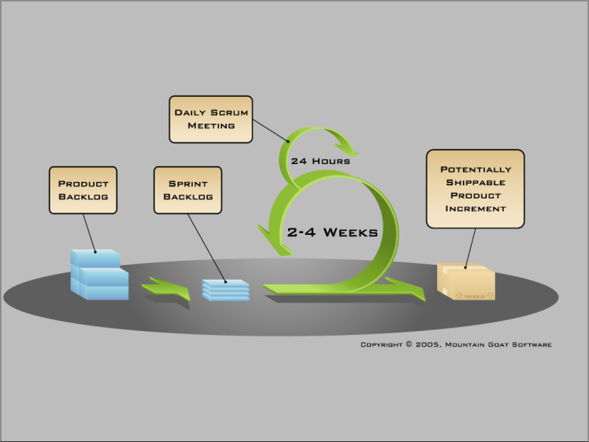

Figure 1: Scrum Development Model

For more information: <http://www.mountaingoatsoftware.com/agile/scrum>

### Roles and responsibilities

|  |  |  |  |
| --- | --- | --- | --- |
| **No** | **Full name** | **Role in Group** | **Responsibilities** |
| **1** | Kiều Trọng Khánh | Scrum Master/Product Owner | * Specify user requirement * Control the development process * Give out technique and business analysis support |
| **2** | Dương Lê Đình Khang | Team Leader, BA, DEV, Tester | * Managing process * Designing database * Clarifying requirements * Prepare documents * GUI Design * Create test plan * Coding * Testing |
| **3** | Châu Chiêu Nguyên | Team Member, BA, DEV, Tester | * Designing database * Clarifying requirements * Prepare documents * GUI Design * Create test plan * Coding * Testing |

Table 5: Roles and Responsibilities Details

### Tools and Techniques

- Front-end technologies: HTML5, CSS3, JavaScript, jQuery, AJAX.

- Back-end technologies:

+ Website: Java EE

+ Web service: Java + Jersey

+Third-party libraries: Apache POI, Java Excel API, Parse.com API, Html2Image library, XSSF Helper.

- Mobile: Android KitKat 4.4.2 – Java 7

- Web Server: Installed Tomcat 7.0.34.

- Database Management System: MSSQL Server 2008 R2 Enterprise.

## Project Management Plan

### Product Backlog

|  |  |  |  |
| --- | --- | --- | --- |
| Project: E-Printer Services | | | |
|
| ID | User Story | State | Priority |
| 1 | As an unauthorized User, I want to create a new account as StoreOwner role. | Approved | 1 |
| 2 | As an unauthorized User, I want to Login as StoreOwner role. | Approved | 2 |
| 3 | As an unauthorized User, I want to Login as Staff role. | Approved | 2 |
| 4 | As a StoreOwner, I want to Logout. | Approved | 11 |
| 5 | As a Staff, I want to Logout. | Approved | 11 |
| 6 | As a Staff, I want to upload template to system. | Approved | 3 |
| 7 | As a Staff, I want to lock a StoreOwner. | Approved | 12 |
| 8 | As a StoreOwner, I want to favorite template from list of template from Website. | Approved | 4 |
| 9 | As a StoreOwner, I want to set a template as default. | Approved | 13 |
| 10 | As a StoreOwner I want to customize template | Approved | 4 |
| 11 | As a StoreOwner, I want to view list of item. | Approved | 5 |
| 12 | As a StoreOwner, I want to add new item. | Approved | 5 |
| 13 | As a StoreOwner, I want to update an existed item. | Approved | 14 |
| 14 | As a StoreOwner, I want to lock an item. | Approved | 15 |
| 15 | As a StoreOwner, I want to import a list of item. | Approved | 4 |
| 16 | As a StoreOwner, I want to view list of employee. | Approved | 5 |
| 17 | As a StoreOwner, I want to add new employee. | Approved | 16 |
| 18 | As a StoreOwner, I want to update an existed employee. | Approved | 4 |
| 19 | As a StoreOwner, I want to lock an employee. | Approved | 17 |
| 20 | As a StoreOwner, I want to import a list of employee. | Approved | 18 |
| 21 | As a StoreOwner, I want to view list of order. | Approved | 5 |
| 22 | As a StoreOwner, I want to create an order. | Approved | 6 |
| 23 | As a StoreOwner, I want to import a list of order. | Approved | 4 |
| 24 | As a StoreOwner, I want to l to print out the order. | Approved | 7 |
| 25 | As a StoreOwner I want to get notification when employee decline or accept job | Approved | 6 |
| 26 | As a StoreOwner I want to clustering order list by distance | Approved | 19 |
| 27 | As a StoreOwner, I want to assign order for the employee. | Approved | 6 |
| 28 | As a Employee I want to receive notification when my StoreOwner assign job for me. | Approved | 6 |
| 29 | As an Employee, I want to select template for order before printing. | Approved | 8 |
| 30 | As an Employee, I want to print an order. | Approved | 9 |
| 31 | As an Employee, I want to create an order. | Approved | 10 |

Table 6: Product Backlog Detail

### Sprint Backlog

Place at Sprint Backlog folder in SVN.

### All Meeting Minutes

Place at Meeting Minute folder in SVN.

## Coding Convention

Use Java coding convention to develop website, web service and mobile app.

Summary:

* Naming Convention.
  + Use camel case for both variable and function name.
  + Use Pascal case for class name.
* Indentation.
  + Avoid lines longer than 80 characters, since they are not handled well by many terminals and tools.
* Declaration.
  + One declaration per line is recommended since it encourages commenting.
  + In absolutely no case should variables and functions be declared on the same line.
  + Do not put different types on the same line.
* Code Examples

Follow “Code Conventions for the Java TM Programming Language, by Sun Microsystems, rev April 20, 1999”.

<http://www.oracle.com/technetwork/java/codeconventions-150003.pdf>

# Report No. 3 Software Requirement Specification

## User Requirement Specification

### Guest Requirement

Guest is a person who does not have access to the system. The function guest can use:

* Login.
* Register.

### Admin Requirement

Admin is the person who manages the system. Admin is super user who cans you following function:

* Lock/Unlock StoreOwner.
* Upload Template.
* Delete Template.

### StoreOwner Requirement

StoreOwner is the person who uses our service to create order and print it. StoreOwner account will be created when Guest register as StoreOwner. StoreOwner can use these functions:

* Manage their item.
* Select Template.
* Set Template default.
* Customize Template.
* Create order.
* Print order.
* Manage Employee.
* Suggest Assign Order.
* Assign order to Employee.

### Employee Requirement

Employee is the person who works for StoreOwner. Employee can use the following functions:

* Create order
* Get Assigned order.
* Print order.

## System Requirement Specification

### External Interface Requirement

#### User Interface

* General requirement for graphics user interface is the GUI should be simple, clear, intuitive, and reminiscent.
* The interface design is an iterate process includes design, sketching, prototyping, user assessment.
* Some design principles will be taken into consideration:
  + UI for business web applications - Janko Jovanovic [Ref: <http://www.smashingmagazine.com/2010/02/25/designing-user-interfaces-for-business-web-applications/>]
  + Ten principles of effective web design – Vitaly Friedman [Ref: <http://www.smashingmagazine.com/2008/01/31/10-principles-of-effective-web-design/>]
  + Principles of mobile interface design – Jonathan Stark [Ref: <http://www.oreilly.com/pub/e/2144>]

#### Hardware Interface

* N/A

#### Software Interface

* Run with FireFox (version 37.0.1), Chrome (version 42.0.2311.90 m) browser and must support Javascript and HTML5.

#### Communication Protocol

* Using HTTP/HTTPS protocol
* Using Bluetooth protocol

### System Overview Use Case

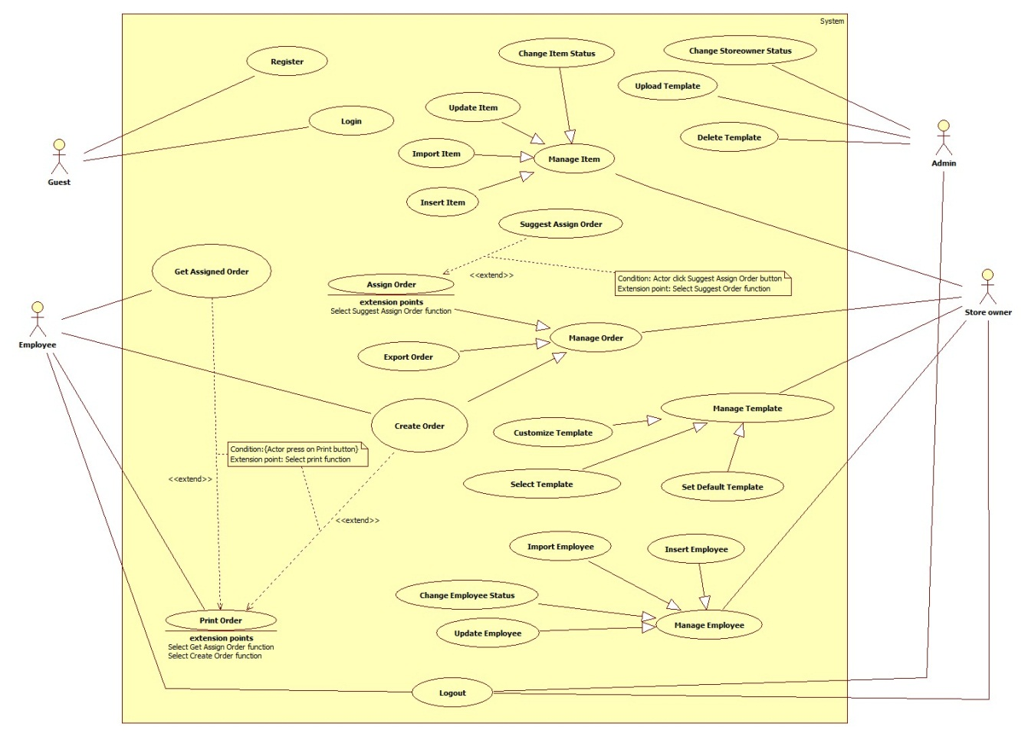

Figure 2: System Overview Use Case



### List of Use Case

#### <Guest> Overview Use Case

**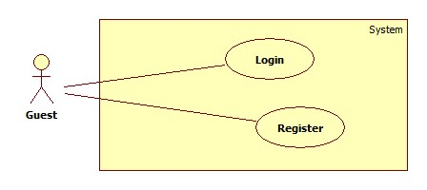**

**Figure 3: <Guest> Overview Use Case**



##### <Guest> Login Use Case Diagram

**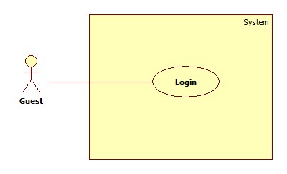**

**Figure 4: <Guest> Login use case diagram**

**Use Case Specification**

|  |  |  |  |
| --- | --- | --- | --- |
| **USE CASE -1 SPECIFICATION** | | | |
| **Use-case No.** | EPS001 | **Use-case Version** | 2.0 |
| **Use-case Name** | Login | | |
| **Author** | Chau Chieu Nguyen | | |
| **Date** | 22/01/15 | **Priority** | High |
| **Actor:**  Guest  **Summary:**  This use case allows guest to login to the system.  **Goal:**  Allow guest login to the system.  **Triggers**   * Guest press login button on Login screen.   **Preconditions:**   * N/A   **Post Conditions:**   * **On Success**: Guest logged in to the system. * **On Failure**: Show error message.   **Main Success Scenario:**   |  |  |  | | --- | --- | --- | | Step | Actor Action | System Response | | 1 |  | System will display Login screen:  - “Tài khoản”: textbox, min length 4, max length 50.  - “Mật khẩu”: textbox, min length: 6, max length 50.  -“Đăng nhập”: button.  - “Quên mật khẩu”: Link  [Alternative 1] | | 2 | Guest input username and password |  | | 3 | Press “Đăng nhập” button | System will navigate to Home screen.  [Exceptions 2, 3, 4, 5, 6] |   **Alternative Scenario:**   * -N/A   **Exceptions:**   |  |  |  | | --- | --- | --- | | No | Actor Action | System Response | | 1 | Guest press “Quên mật khẩu” link | System will navigate to Forgot Password screen on web application. | | 2 | Guest lefts “Tài khoản” or “Mật khẩu” textboxes blank. | Show message: “Tên tài khoản hoặc mật khẩu không được để trống”. | | 3 | Guest login to the web application with employee account. | Show message:”Bạn không được phép đăng nhập vào trang web này”. | | 4 | Guest login with wrong username or password. | Show message:”Tên tài khoản hoặc mật khẩu không đúng”. | | 5 | Guest login with non-existed account. | Show message:” Tên tài khoản không hợp lệ”. | | 6 | Guest login fail 5 times | Show message:”Bạn đã bị khóa 15 phút vì đăng nhập sai quá nhiều lần”. |   **Relationships:**   * N/A   **Business Rules:**   * Guest have to login with Admin account or Store Owner account to access the web application. * On mobile application, user name and password will be saved to login without Internet connection next times. * If user changes their password, they still can use the mobile application until they logout. * If guest login fail for 5 times, login function will be disable for 15 minutes. | | | |

##### <Guest> Register Use Case Diagram

**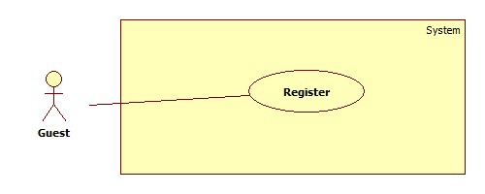**

**Figure 5: <Guest> Register use case diagram**

|  |  |  |  |
| --- | --- | --- | --- |
| **USE CASE -2 SPECIFICATION** | | | |
| **Use-case No.** | EPS002 | **Use-case Version** | 2.0 |
| **Use-case Name** | Register | | |
| **Author** | Duong Le Dinh Khang | | |
| **Date** | 13/04/15 | **Priority** | High |
| **Actor:**  Guest  **Summary:**  This use case allows guest register info system as StoreOwner account.  **Goal:**  Allow guest register to the system.  **Triggers**   * Guest press Register button on Register screen.   **Preconditions:**   * N/A   **Post Conditions:**   * **On Success**: New StoreOwner account will be created. * **On Failure**: Show error message.   **Main Success Scenario:**   |  |  |  | | --- | --- | --- | | Step | Actor Action | System Response | | 1 |  | System will display Register screen:  - “Tài khoản”: textbox, min length 4, max length 50.  -“Địa chỉ Email”: textbox, regurlar expression: “^[a-zA-Z0-9\_.+-]+@[a-zA-Z0-9-]+\.[a-zA-Z0-9-.]+$".  - “Mật khẩu”: textbox, min length: 6, max length: 50, required.  -“Nhập lại mật khẩu”: textbox, min length: 6, max length: 50, required.  -“Tên”: textbox, min length: 5, max length: 100.  -“Số điện thoại”: textbox, min length: 9, max length: 11.  -“Website của bạn”: textbox, min length: 5, max length: 50.  -“Tên cửa hàng”: textbox, min length: 6, max length: 50.  -“Địa chỉ nhà”:  -“Đăng Ký”: button. | | 2 | Guest input personal information into textbox. |  | | 3 | Press “Đăng Ký” button | System will navigate to Register Success screen.  [Exceptions 1, 2, 3]  [Alternative 1] |   **Alternative Scenario:**   |  |  |  | | --- | --- | --- | | No | Actor Action | System Response | | 1 | Guest navigates to another page. | Close “Đăng ký” page and navigate to new page. |   **Exceptions:**   |  |  |  | | --- | --- | --- | | No | Actor Action | System Response | | 1 | Guest not fills all the required texbox. | Show message: “Vui lòng nhập thông tin vào những ô bắt buộc”. | | 2 | “Mật khẩu” and “Nhập lại mật khẩu” not matched. | Show message: “Mật khẩu nhập lại không khớp”. | | 3 | Guest register with a username already existed in system. | Show message:”Tên tài khoản không khả dụng”. |   **Relationships:**   * N/A   **Business Rules:**   * All fill with required attribute must be filled. * “Mật khẩu” and “Nhập lại mật khẩu” must be same. * Exception must not violate. | | | |

#### <StoreOwner> Overview Use Case

**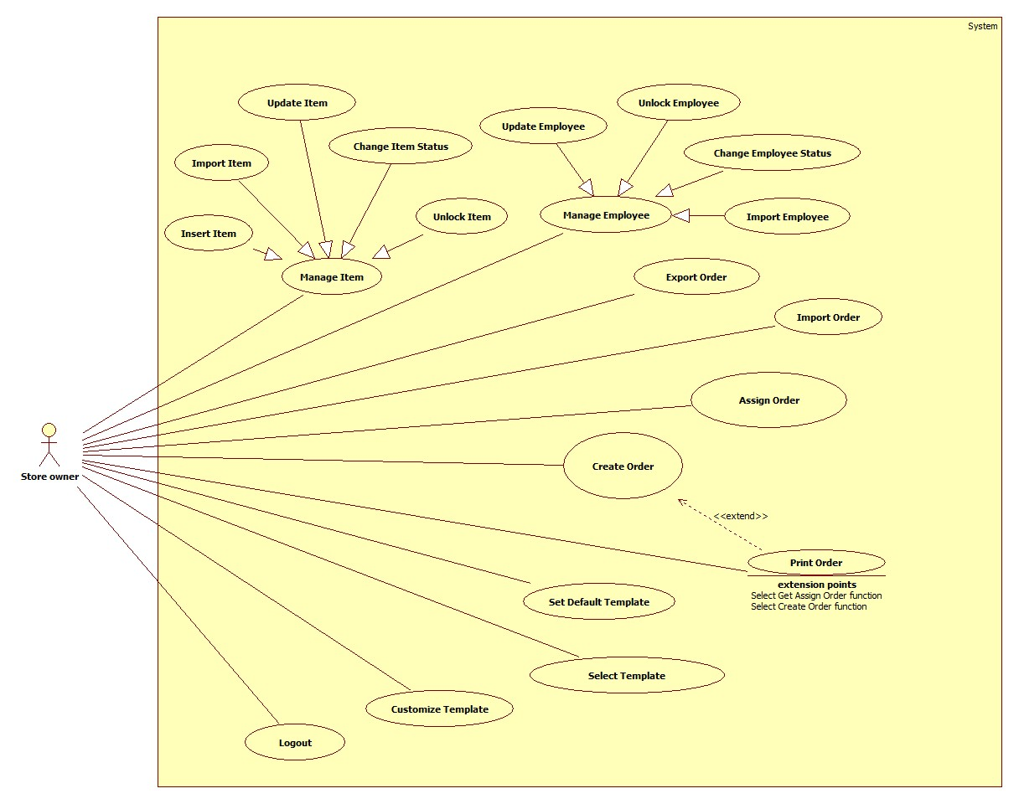**

**Figure 6: <StoreOwner> Overview Use Case**

##### <StoreOwner> Insert Item Use Case Diagram

**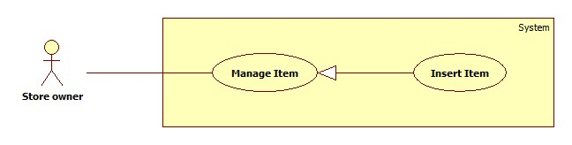**

**Figure 7: <StoreOwner> Insert Item Use Case Diagram**

**Use Case Specification**

|  |  |  |  |
| --- | --- | --- | --- |
| **USE CASE-3 SPECIFICATION** | | | |
| **Use-case No.** | EPS003 | **Use-case Version** | 2.0 |
| **Use-case Name** | Insert Item | | |
| **Author** | Duong Le Dinh Khang | | |
| **Date** | 16/01/15 | **Priority** | Medium |
| **Actor:**  Store owner  **Summary:**  This use case allow StoreOwner insert their product items into our system.  **Goal:**  Add a new item.  **Triggers**   * Store’s owner chooses add item function.   **Preconditions:**   * User must login with role StoreOwner.   **Post Conditions:**   * **On Success**: A new item will be added. * **On Failure**: Show error message.   **Main Success Scenario:**   |  |  |  | | --- | --- | --- | | Step | Actor Action | System Response | | 1 | StoreOwner clicks on “Quản lý sản phẩm” navigator. | System will navigate to “Quản lý sản phẩm” page.  “Thêm sản phẩm”: button.  “Nhập danh sách sản phẩm”: button.  “Danh sách sản phẩm”: table data. List of items. | | 1 | StoreOwner clicks on “Thêm sản phẩm” button. | System will navigate to “Thêm sản phẩm” page.  -“Tên sản phẩm”: textbox, min length: 10, max length: 30, required.  -“Mô tả”: text area, min length: 20, max length: 500.  -“Loại sản phẩm”: texbox, min length: 6, max length: 50.  -“Đơn vị tính”: textbox, min length: min length 6, max length: 50.  -“Số lượng”: textbox, min length: 1, max length: 3 with range [1, 999].  -“Giá”: textbox, regular expression: “\d\* [.]?\d+”, min value: 10, max value: 100.000 with unit are 1000VNĐ, required.  -“Thêm sản phẩm”: button | | 2 | Input fields. |  | | 3 | Click on “Thêm sản phẩm” button. | Item will be added to database and show: “Bạn đã thêm sản phẩm thành công”.  [Exception 1, 2, 3, 4, 5 ,6, 7]  [Alternative 1] |   **Alternative Scenario:**   |  |  |  | | --- | --- | --- | | No | Actor Action | System Response | | 1 | StoreOwner navigates to another page. | Close “Thêm sản phẩm” page and navigate to new page. |     **Exceptions:**   |  |  |  | | --- | --- | --- | | No | Actor Action | System Response | | 1 | Length of item name is not in range. | Show error message: “Độ dài tên sản phẩm phải từ 10-30 ký tự!” | | 2 | Category is not specificed. | Show error message: “Hãy chọn thể loại!” | | 3 | Unit is not specificed. | Show error message: “Hãy chọn đơn vị!” | | 4 | Quantity is “0” | Show error message: “Số lượng của sản phẩm ít nhất là 1!” | | 5 | Price is not in range. | Show error message: “Giá sản phẩm phải từ 10.000 đồng trở lên!” | | 6 | Description is blank. | Show error message: “Mô tả không được để trống!” |   **Relationships:**  N/A  **Business Rules:**   * In main success scenario, a new item with be added to database. * StoreOwner can only use item which they added to database for generate report purpose. * Employee can use item which added by their StoreOwner. * Range of item price is from 10.000VNĐ to 100.000.000VNĐ. * StoreOwner can add two or more item with same name. * New item will be showed in “Danh sách sản phẩm” table. * Exception must not violate. | | | |

##### <Store owner> Update Item Use Case Diagram

**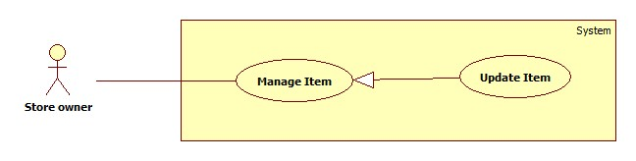**

**Figure 8: <StoreOwner> Update Item Use Case Diagram**

**Use Case Specification**

|  |  |  |  |
| --- | --- | --- | --- |
| **USE CASE-4 SPECIFICATION** | | | |
| **Use-case No.** | EPS004 | **Use-case Version** | 2.0 |
| **Use-case Name** | Update Item | | |
| **Author** | Duong Le Dinh Khang | | |
| **Date** | 16/01/15 | **Priority** | Medium |
| **Actor:**  Store owner  **Summary:**  This use case allow StoreOwner update their product items into our system.  **Goal:**  Update an item.  **Triggers**   * StoreOwner chooses update item function.   **Preconditions:**   * User must login with role StoreOwner.   **Post Conditions:**   * **On Success**: Item will be updated with new information. * **On Failure**: No item will be edited. Show error message.   **Main Success Scenario:**   |  |  |  | | --- | --- | --- | | Step | Actor Action | System Response | | 1 | Choose “Quản lý sản phẩm” in navigator. | System will navigate to “Quản lý sản phẩm” page.  “Thêm sản phẩm”: button.  “Nhập danh sách sản phẩm”: button.  “Danh sách sản phẩm”: table data. List of items. | | 2 | Click on “Cập nhật” button on which item you want to edit. | Navigate to “Cập nhật sản phẩm” page  -“Tên sản phẩm”: textbox, min length: 10, max length: 30, not editable.  -“Mô tả”: text area, min length: 20, max length: 500.  -“Loại sản phẩm”: texbox, min length: 6, max length: 50.  -“Đơn vị tính”: textbox, min length: min length 6, max length: 50.  -“Số lượng”: textbox, min length: 1, max length: 3 with range [1, 999].  -“Giá”: textbox, regular expression: “\d\* [.]?\d+”, min value: 10, max value: 100.000 with unit are 1000VNĐ, required.  -Hoàn tất:button | | 3 | Input field. |  | | 4 | Click on “Hoàn tất” button. | Item will be edited from database and a message will be showed: “Bạn đã sửa sản phẩm thành công”.  [Exception 1, 2, 3] |   **Alternative Scenario:**  N/A  **Exceptions:**   |  |  |  | | --- | --- | --- | | No | Actor Action | System Response | | 1 | Quantity is “0” | Show error message: “Số lượng của sản phẩm ít nhất là 1!” | | 2 | Price is not in range. | Show error message: “Giá sản phẩm phải từ 10.000 VNĐ đến 100.000.000 VNĐ!” | | 3 | Description is blank. | Show error message: “Mô tả không được để trống!” |   **Relationships:**  N/A  **Business Rules:**   * StoreOwner cannot edit name of item. * Item edited will be synchronized with mobile app when it connect to the internet. * Item can only edit by StoreOwner who created it. * Range of item price is from 10.000VNĐ to 100.000.000VNĐ. * Updated Item will be showed new info in “Danh sách sản phẩm” table. * Exception must not violate. | | | |

##### <Store owner> Change Item Status Use Case Diagram

**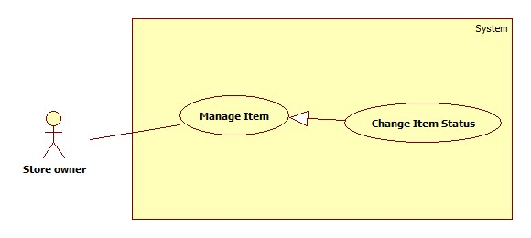**

**Figure 9: <StoreOwner> Change Item Status Use Case Diagram**

**Use Case Specification**

|  |  |  |  |
| --- | --- | --- | --- |
| **USE CASE-5 SPECIFICATION** | | | |
| **Use-case No.** | EPS005 | **Use-case Version** | 2.0 |
| **Use-case Name** | Change Item Status | | |
| **Author** | Duong Le Dinh Khang | | |
| **Date** | 16/01/15 | **Priority** | Medium |
| **Actor:**  StoreOwner  **Summary:**  Make item you want to lock not available for future use and unlock to continue use it.  **Goal:**  Change the item status.  **Triggers**   * StoreOwner chooses lock item or unlock item function.   **Preconditions:**   * User must login with role StoreOwner.   **Post Conditions:**   * **On Success**: Item’s status changed to locked. * **On Failure**: No item will be lock. Show error message.   **Main Success Scenario:**   |  |  |  | | --- | --- | --- | | Step | Actor Action | System Response | | 1 | Choose “Quản lý sản phẩm” in navigation bar | Show “Quản lý sản phẩm” page with table of list items.  “Thêm sản phẩm”: button.  “Nhập danh sách sản phẩm”: button.  “Danh sách sản phẩm”: table data. List of items. | | 2 | Click on “Khoá” button on which item you want to lock. | Show message: “Khoá sản phẩm thành công”.  [Alternative 1] |   **Alternative Scenario:**   |  |  |  | | --- | --- | --- | | No | Actor Action | System Response | | 1 | Click on “Mở khoá” button on which item you want to unlock. | Show message: “Mở khoá thành công”. |   **Exceptions:**   * N/A   **Relationships:**   * N/A   **Business Rules:**   * If item’s status is lock, this use case will show “Mở khoá” button. * If item’s status is available, this use case will show “khoá” button. * Locked item cannot be use to create order in future. * Available item can be use to create order. | | | |

##### <StoreOwner> Import Item Use Case Diagram

**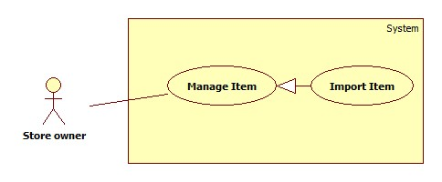**

**Figure 10: <StoreOwner> Import Item Use Case Diagram**

**Use Case Specification**

|  |  |  |  |
| --- | --- | --- | --- |
| **USE CASE-6 SPECIFICATION** | | | |
| **Use-case No.** | EPS006 | **Use-case Version** | 2.0 |
| **Use-case Name** | Import Item | | |
| **Author** | Duong Le Dinh Khang | | |
| **Date** | 14/04/15 | **Priority** | Medium |
| **Actor:**  StoreOwner  **Summary:**  StoreOwner can add multiple item at a time by import a list of item in excel file into system.  **Goal:**  Add multiple item.  **Triggers**   * StoreOwner chooses import item function.   **Preconditions:**   * User must login with role StoreOwner. * StoreOwner must have a list of item in excel file with valid format.   **Post Conditions:**   * **On Success**: Item in excel will be added into system. * **On Failure**: No item will be added. Show error message.   **Main Success Scenario:**   |  |  |  | | --- | --- | --- | | Step | Actor Action | System Response | | 1 | Choose “Quản lý sản phẩm” in navigation bar | Show “Quản lý sản phẩm” page with table of list items.  “Thêm sản phẩm”: button.  “Nhập danh sách sản phẩm”: button.  “Danh sách sản phẩm”: table data. List of items. | | 2 | StoreOwner clicks on “Nhập danh sách sản phẩm”. | Navigate to “Nhập danh sach sản phẩm” page.  -“Tải mẫu file xls”: hyperlink.  -“Browse”: button.  -“Nhập”: button. | | 3 | StoreOwner clicks on “Tải mẫu file xls” hyperlink. | System will response a excel template file to import item data. | | 4 | StoreOwner fill out item information into excel file. |  | | 5 | StoreOwner clicks on “Browse” | System will display an open file dialog for user to choose file.  -“Open”: button.  -“Cancel”: button  [Alternative 1] | | 6 | StoreOwner navigate to the excel file and click “Open”. | Name of excel will be showed right after  “Browse” button. | | 7 | StoreOwner clicks on “Nhập” button. | List of items will be import to system.  [Alternative 2]  [Exceptions 1,2] |   **Alternative Scenario:**   |  |  |  | | --- | --- | --- | | No | Actor Action | System Response | | 1 | StoreOwner clicks on “Cancel” button. | Open file dialog will be closed. | | 2 | StoreOwner navigates to another page. | “Nhập danh sách sản phẩm” page will be close and new page will be open. |   **Exceptions:**   |  |  |  | | --- | --- | --- | | No | Actor Action | System Response | | 1 | StoreOwner not fill data into required cell in excel file. | Show message: “Vui lòng nhập đầy đủ thông tin sản phẩm”. | | 2 | StoreOwner select invalid file | Show message: “File danh sách sản phẩm của bạn không hợp lệ”. |   **Relationships:**   * N/A   **Business Rules:**   * Structure of xls file:      * File type of excel file must be “xls”. * All info of item must be filled. * When import success, item list will be added to database. * “Danh sách sản phẩm” will update new item. * Exceptions must not violate. | | | |

##### <StoreOwner> Insert Employee Use Case Diagram

****

**Figure 11: <StoreOwner> Insert Employee Use Case Diagram**

**Use Case Specification**

|  |  |  |  |
| --- | --- | --- | --- |
| **USE CASE-7 SPECIFICATION** | | | |
| **Use-case No.** | EPS007 | **Use-case Version** | 2.0 |
| **Use-case Name** | Insert Employee | | |
| **Author** | Chau Chieu Nguyen | | |
| **Date** | 15/04/15 | **Priority** | Medium |
| **Actor:**  Store owner  **Summary:**  This use case allow StoreOwner insert their employees into our system.  **Goal:**  Add a new employee.  **Triggers**   * Store’s owner chooses add employee function.   **Preconditions:**   * User must login with role StoreOwner.   **Post Conditions:**   * **On Success**: A new employee will be added. * **On Failure**: Show error message.   **Main Success Scenario:**   |  |  |  | | --- | --- | --- | | Step | Actor Action | System Response | | 1 | Store’s owner chooses add employee function. | System will navigate to “Tạo tài khoản nhân viên” page includes:  -“Tên tài khoản”: textbox, min length: 4, max length: 20, required.  - “Mật khẩu”: password, min length: 4 max length: 10, required.  - “Tên nhân viên”: textbox, min length: 4; max length: 50.  -“Thêm”: button | | 2 | Input fields. |  | | 3 | StoreOwner clicks on “Thêm” button. | Employee will be added to database and system will navigate to manage employee screen.  [Exception 1, 2] |   **Alternative Scenario:**   * N/A   **Exceptions:**   |  |  |  | | --- | --- | --- | | No | Actor Action | System Response | | 1 | “Tên tài khoản” is blank. | Show error message: “Tên tài khoản không được trống”. | | 2 | “Mật khẩu” is blank. | Show error message: “Mật khẩu không được trống”. |   **Relationships:**  N/A  **Business Rules:**   * In main success scenario, a new employee will be added to database. * New employee can login to Android app. * New employee can received order that their StoreOwner assign for them. * Exception must not violate. | | | |

##### <StoreOwner> Update Employee Use Case Diagram

****

**Figure 12: <StoreOwner> Update Employee Use Case Diagram**

**Use Case Specification**

|  |  |  |  |
| --- | --- | --- | --- |
| **USE CASE-8 SPECIFICATION** | | | |
| **Use-case No.** | EPS008 | **Use-case Version** | 2.0 |
| **Use-case Name** | Update Employee | | |
| **Author** | Chau Chieu Nguyen | | |
| **Date** | 15/04/15 | **Priority** | Medium |
| **Actor:**  StoreOwner  **Summary:**  This use case allow StoreOwner update their employees in our system.  **Goal:**  Update an existed employee.  **Triggers**   * Store’s owner chooses update employee function.   **Preconditions:**   * User must login with role StoreOwner.   **Post Conditions:**   * **On Success**: An existed employee will be updated. * **On Failure**: Show error message.   **Main Success Scenario:**   |  |  |  | | --- | --- | --- | | Step | Actor Action | System Response | | 1 | Store’s owner chooses add employee function. | System will navigate to “Cập nhật tài khoản nhân viên” page includes:  -“Tên tài khoản”: textbox, min length: 4, max length: 20, required.  - “Mật khẩu”: password, min length: 4 max length: 10, required.  - “Tên nhân viên”: textbox, min length: 4; max length: 50.  -“Cập nhật”: button | | 2 | Input fields. |  | | 3 | Click on “Cập nhật” button. | Employee will be updated to database and system will navigate to manage employee screen.  [Exception 1] |   **Alternative Scenario:**   * N/A   **Exceptions:**   |  |  |  | | --- | --- | --- | | No | Actor Action | System Response | | 1 | “Mật khẩu” is blank. | Show error message: “Mật khẩu không được trống”. |   **Relationships:**  N/A  **Business Rules:**   * Store Owner cannot edit Employee’s username. * Employee still can use Android app when their StoreOwner already changed the password. * When employee log out, they will need to login with new password. | | | |

##### <StoreOwner> Change Employee Status Use Case Diagram

**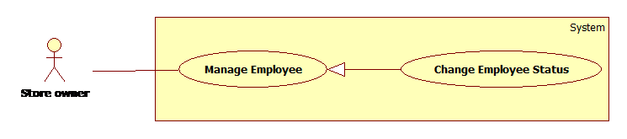**

**Figure 13: <StoreOwner> Change Employee Status Use Case Diagram**

**Use Case Specification**

|  |  |  |  |
| --- | --- | --- | --- |
| **USE CASE-9 SPECIFICATION** | | | |
| **Use-case No.** | EPS009 | **Use-case Version** | 2.0 |
| **Use-case Name** | Change Employee Status | | |
| **Author** | Chau Chieu Nguyen | | |
| **Date** | 15/04/15 | **Priority** | Medium |
| **Actor:**  Store owner  **Summary:**  This use case allow Storeowner lock or unlock their employees in our system.  **Goal:**  Lock/unlock employee.  **Triggers**   * Store’s owner chooses lock/unlock employee function.   **Preconditions:**   * User must login with role StoreOwner.   **Post Conditions:**   * **On Success**: An existed employee will be lock/unlock. * **On Failure**: Show error message.   **Main Success Scenario:**   |  |  |  | | --- | --- | --- | | Step | Actor Action | System Response | | 1 | StoreOwner chooses lock/unlock employee function in manage employee page. | System will lock/unlock employee and navigate to manage employee page. |   **Alternative Scenario:**   * N/A   **Exceptions:**   * N/A   **Relationships:**   * N/A   **Business Rules:**   * Employee has two statuses: active and deactivate. * When being locked, if employee not log out yet then they can open Android app but cannot use any function. * When being locked, if employee already logout, then they cannot login to Android app again. | | | |

##### <StoreOwner> Import Employee Use Case Diagram

**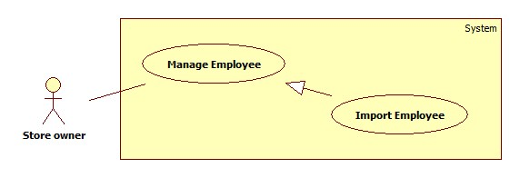**

|  |  |  |  |
| --- | --- | --- | --- |
| **USE CASE-10 SPECIFICATION** | | | |
| **Use-case No.** | EPS010 | **Use-case Version** | 2.0 |
| **Use-case Name** | Import Employee | | |
| **Author** | Chau Chieu Nguyen | | |
| **Date** | 15/04/15 | **Priority** | Medium |
| **Actor:**  StoreOwner  **Summary:**  This use case allow Storeowner import a list of employee.  **Goal:**  Insert new employees with info in excel file.  **Triggers**   * StoreOwner chooses import employee function.   **Preconditions:**   * User must login with role StoreOwner.   **Post Conditions:**   * **On Success**: StoreOwner inserts a list of employee to their store. * **On Failure**: Show error message.   **Main Success Scenario:**   |  |  |  | | --- | --- | --- | | Step | Actor Action | System Response | | 1 | StoreOwner clicks on “Quản lý nhân viên” in navigation bar. | System will navigates to “Quản lý nhân viên” page.  “Thêm nhân viên”: button.  “Nhập danh sách nhân viên”: button.  “Xuất danh sách nhân viên”: button.  “Danh sách nhân viên”: table. | | 2 | StoreOwner clicks on “Nhập danh sách nhân viên” button. | System navigates to “Nhập danh sách nhân viên” page.  “Browse”: button.  “Nhập”: button. | | 3 | StoreOwner clicks on “Browse” button. | System will display open file dialog:  “FileName”: textbox.  “Open”: button.  “Cancel”: button. | | 4 | StoreOwner selects list of Employee excel file and click “OK” button. | [Alternative 1] | | 5 | StoreOwner clicks on “Nhập” button. | System will import list of Employee then redirect StoreOwner to “Trang chủ” page.  [Exception 1] |   **Alternative Scenario:**   |  |  |  | | --- | --- | --- | | No | Actor Action | System Response | | 1 | StoreOwner clicks on “Cancel” button. | Open file dialog will close. |     **Exceptions:**   |  |  |  | | --- | --- | --- | | No | Actor Action | System Response | | 1 | StoreOwner left some column blank | Show error message “Vui lòng điền đầy đủ thông tin của nhân viên!” |   **Relationships:**   * N/A   **Business Rules:**   * Structure of excel file:      * Format of excel file is “xls” (Microsoft Office 2003). * Status of Employee when import success is “active”. * StoreOwner can assign order for theses Employee after import success. * Exception must not violate. | | | |

##### <StoreOwner> Select Template Use Case Diagram

**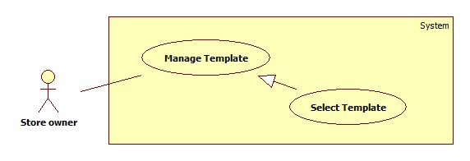**

**Figure 14: <StoreOwner> Select Template Use Case Diagram**

**Use Case Specification**

|  |  |  |  |
| --- | --- | --- | --- |
| **USE CASE-11 SPECIFICATION** | | | |
| **Use-case No.** | EPS011 | **Use-case Version** | 2.0 |
| **Use-case Name** | Select Template | | |
| **Author** | Chau Chieu Nguyen | | |
| **Date** | 06/04/15 | **Priority** | High |
| **Actor:**  Store Owner.  **Summary:**  This use case allows Store Owner to select some templates they want from the system to use.  **Goal:**  Store Owner selected a template.  **Triggers**   * Store Owner log in for the first time.   **Preconditions:**   * User must log in as Store Owner role.   **Post Conditions:**   * **On Success**: Selected templates will be available for use. * **On Failure**: Show error message.   **Main Success Scenario:**   |  |  |  | | --- | --- | --- | | Step | Actor Action | System Response | | 1 | Storeowner log in to the system for the first time. | Navigate to “Chọn Mẫu Hóa Đơn” page to choose a template.  “Danh sách mẫu hóa đơn của hệ thống”: table of system’s templates list which has 5 columns below:   * “STT”: ordinal number of a template. * “Tên mẫu hóa đơn”: Column contains name of a template. * “Hình đại diện”: Column contains a link to view image of template. * “Mẫu hóa đơn”: Column contains a link to download template. * “Loại hóa đơn”: Columns contains type of template. * A check box to select templates.   “Chọn”: button.  [Alternative 1, 2] | | 2 | StoreOwner selects templates | System display “Chọn”: button | | 3 | StoreOwner clicks “Chọn” button | Navigate to manage template page. |   **Alternative Scenario:**   |  |  |  | | --- | --- | --- | | No | Actor Action | System Response | | 1 | StoreOwner clicks on “Hình đại diện” link. | Navigate to show picture page. | | 2 | StoreOwner clicks on “Mẫu hóa đơn” link. | System will download the template to StoreOwner’s computer. |   **Exceptions:**   * N/A   **Relationships:**   * N/A   **Business Rules:**   * When Store Owner log in to the system for the first time, they will be navigate to “Chọn mẫu hóa đơn” page to choose template. * The first chosen template will be the default template. * If storeowner does not choose any template, next time when he/she login, system will navigate to choose template again. * Storeowner can only select templates for their store once. | | | |

##### <StoreOwner> Set Default Template Use Case Diagram

**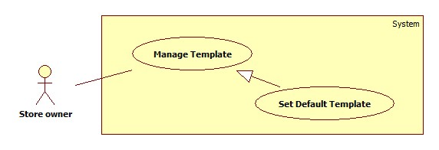**

**Figure 15: <StoreOwner> Set Default Use Case Diagram**

**Use Case Specification**

|  |  |  |  |
| --- | --- | --- | --- |
| **USE CASE-12 SPECIFICATION** | | | |
| **Use-case No.** | EPS012 | **Use-case Version** | 2.0 |
| **Use-case Name** | Set default template | | |
| **Author** | Chau Chieu Nguyen | | |
| **Date** | 06/04/15 | **Priority** | High |
| **Actor:**  StoreOwner  **Summary:**  This use case allows StoreOwner to set the default template of their store.  **Goal:**  A template will be set to default template.  **Triggers**   * StoreOwner clicks on Set default template function.   **Preconditions:**   * User must log in as StoreOwner role.   **Post Conditions:**   * **On Success**: A template is set to default * **On Failure**: Show error message.   **Main Success Scenario:**   |  |  |  | | --- | --- | --- | | Step | Actor Action | System Response | | 1 | Click on “Quản Lý Mẫu Hóa Đơn” button. | Navigate to “Chọn Mẫu Hóa Đơn” page to choose a template.  “Danh sách mẫu hóa đơn đã chọn”: table of template that store owner has chosen list which has 5 columns below:   * “STT”: Column contains ordinal number of a template. * “Chọn”: Column contains combobox to select template. * “Tên mẫu hóa đơn”: Column contains name of a template. * “Hình đại diện”: Column contains a link to view image of template. * “Mẫu hóa đơn”: Column contains a link to download template. * “Loại hóa đơn”: Column contains type of template. * “Tùy chỉnh”: link to navigate to customize page.   “Đặt làm mặc định”: button.  [Alternative 1, 2] | | 2 | Store Owner selects a template and clicks on “Đặt làm mặc định” button | That template is set to default template of store. |   **Alternative Scenario:**   |  |  |  | | --- | --- | --- | | No | Actor Action | System Response | | 1 | Storeowner clicks on “Hình đại diện” link. | Navigate to show picture page. | | 2 | Storeowner clicks on “Mẫu hóa đơn” link. | System will download the template to storeowner’s computer. |   **Exceptions:**   * N/A   **Relationships:**   * N/A   **Business Rules:**   * Storeowner can only have one default template. * Only template Bluetooth can be set as default template. | | | |

##### <StoreOwner> Customize Template Use Case Diagram

**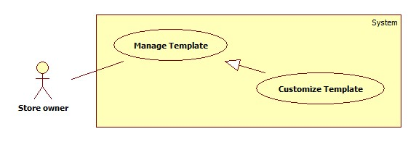**

**Figure 16: <StoreOwner> Customize Template Use Case Diagram**

**Use Case Specification**

|  |  |  |  |
| --- | --- | --- | --- |
| **USE CASE-13 SPECIFICATION** | | | |
| **Use-case No.** | EPS013 | **Use-case Version** | 2.0 |
| **Use-case Name** | Customize Template | | |
| **Author** | Chau Chieu Nguyen | | |
| **Date** | 06/04/15 | **Priority** | High |
| **Actor:**  StoreOwner  **Summary:**  This use case allows StoreOwner to customize their templates.  **Goal:**  An existed template will be redesign.  **Triggers**   * StoreOwner clicks on “Tùy chỉnh” link on manage template page.   **Preconditions:**   * User must log in as StoreOwner role.   **Post Conditions:**   * **On Success**: A template is redesign. * **On Failure**: Show error message.   **Main Success Scenario:**   |  |  |  | | --- | --- | --- | | Step | Actor Action | System Response | | 1 | Click on “Tùy chỉnh” link on manage template page. | Navigate to “Tùy chỉnh mẫu hóa đơn” page includes   * “Thông tin hóa đơn”: list of report’s information, can be draggable. * “Thuộc tính sản phẩm”: list of item’s information, can be draggable. * “Số lượng cột”: combo box, raw source is value: 2, 3, 4 for Bluetooth template and 2, 3, 4, 5, 6 for A4 template; for storeowner to select number of item’s information will be displayed. * A mock-up template for storeowner to drop information. * Image of a trash for storeowner to remove information. * “Lưu” button.   Mock-up template includes:   * Title: textbox with min length: 1 and max length: 20. * Four lines for storeowner to drop report’s information. * A table with number of columns defined by storeowner and let them drop item’s information. * “Số lượng ký tự mỗi cột”: label * “Cột 1”: textbox, max length: 2. * “Cột 2”: textbox, max length: 2. * “Cột 3”: textbox, max length: 2. * … * “Tổng tiền”: label. | | 2 | Store Owner selects the number of item’s information. | System displays item’s table with the number of column relies on storeowner’s selection. | | 3 | Store Owner input title. | System displays title in mock-up template.  [Alternative 1, 2] | | 4 | Store Owner drag information in the mock-up template. | System displays a pop-up required user to input the limit characters includes:   * “Nhập số lượng ký tự tối đa”: textbox; max length: 2. * “OK”: button. * “Hủy”: button. | | 5 | Store Owner input limit characters and clicks “OK” button |  | | 6 | Store Owner clicks on “Lưu” button | System redesigns template relies on Store Owner’s choices.  Navigate to manage template screen. |   **Alternative Scenario:**   |  |  |  | | --- | --- | --- | | No | Actor Action | System Response | | 1 | Store Owner change number of columns. | System display the mock-up template relies on Store Owner’s choice. | | 2 | Store Owner input limit characters of columns with total greater than 37 for Bluetooth template and greater than 80 for A4 template. | System display confirm message includes:   * “Số lượng ký tự bạn chọn nhiều hơn 37 (80), điều này sẽ ảnh hưởng đến định dạng của mẫu hóa đơn. Bạn có muốn tiếp tục?” * “Có”: button. * “Không”: button. |   **Exceptions:**   * **N/A**   **Relationships:**   * N/A   **Business Rules:**   * The maximum columns for template Bluetooth are four and template A4 is six. * The minimum columns of item’s information for both templates are two. * The maximum width of template Bluetooth is 37 characters and template A4 is 80 characters. * Number of columns is relying on storeowner choice in “Số lượng cột” combo box. * When storeowner wants to change item’s information, they will drag the old information to the trash and drag the new one in. | | | |

##### <StoreOwner> Create Order Use Case Diagram

**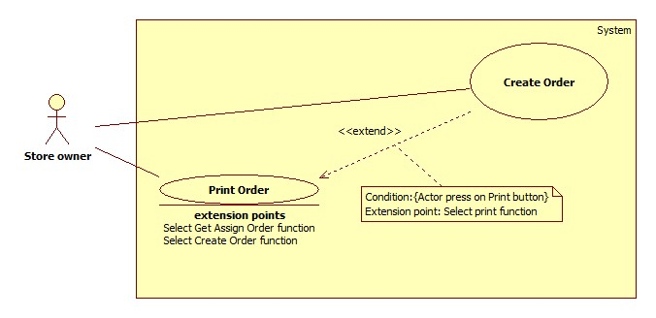**

**Figure 17: <StoreOwner> Create Order Use Case Diagram**

**Use Case Specification**

**Web**

|  |  |  |  |
| --- | --- | --- | --- |
| **USE CASE-14 SPECIFICATION** | | | |
| **Use-case No.** | EPS014 | **Use-case Version** | 2.0 |
| **Use-case Name** | Create Order. | | |
| **Author** | Duong Le Dinh Khang | | |
| **Date** | 14/04/15 | **Priority** | High |
| **Actor:**  StoreOwner.  **Summary:**  This use case allow StoreOwner or their employee make a report using a template from our system combine with their item.  **Goal:**  Create an order from template and define attribute of item.  **Triggers**   * StoreOwner click on create order function.   **Preconditions:**   * StoreOwner must have at least 1 item in system. * User must log in as StoreOwner role.   **Post Conditions:**   * **On Success**: A new order created and ready to print. * **On Failure**: Show error message.   **Main Success Scenario:**   |  |  |  | | --- | --- | --- | | Step | Actor Action | System Response | | 1 | Click on “Tạo Hoá Đơn” in navigator. | Navigate to “Tạo hoá đơn” screen to choose a template.  “Chọn mẫu hoá đơn”: combo box of template list.  “Tiếp tục”: button. | | 2 | StoreOwner selects a template and clicks on “Tiếp tục” button. | Navigate to “Thêm sản phẩm vào hoá đơn” screen.  -“Chọn sản phẩm”: combox box of item list.  -“Số lượng”: textbox, min length: 1, max length: 999.  -“Đơn giá”: textbox, not editable.  -Preview Item list: table.  -“Thêm”: button.  -“Tiếp tục”: button.  [Alternative 1] | | 3 | StoreOwner selects an item from combo box. | “Số lượng” will be set to “1” and “Đơn giá” will be filled with price of item. | | 4 | StoreOwner set the quantity of item by change “Số lượng” textbox value. |  | | 5 | StoreOwner clicks on “Thêm” button. | Preview Item List will show your item.  [Exception 1] | | 6 | StoreOwner clicks on “Tiếp tục” button. | Navigate to “Thông tin khách hàng” screen.  -“Khách hàng”: textbox.  -“Địa chỉ”: textbox.  -“Xác minh địa chỉ”: button.  -“In Hoá Đơn”: button.  -“Lưu Hoá Đơn”: button. | | 7 | StoreOwner fills out “Khách hàng” texbox with customer name, “Địa chỉ” texbox with customer address. |  | | 8 | StoreOwner clicks on “Lưu Hoá Đơn” button | Print dialog will display.  Printer: combo box.  “OK”: button.  “Cancel”: button.  [Alternative 2]  [Exception 2] |   **Alternative Scenario:**   |  |  |  | | --- | --- | --- | | No | Actor Action | System Response | | 1 | StoreOwner clicks on “Tiếp tục” button. | Default template will be applied. | | 2 | StoreOwner clicks on “In Hoá Đơn” | New order will be created, printer will print it and system navigates to “Trang chủ” page. |   **Exceptions:**   |  |  |  | | --- | --- | --- | | No | Actor Action | System Response | | 1 | Quantity is “0” | Show error message: “Số lượng của sản phẩm ít nhất là 1!” | | 2 | Click on “In Hoá đơn” before add item. | Show error message: “Bạn phải nhập ít nhất 1 sản phẩm trước khi in hoá đơn!” |   **Relationships:**   * Extend for Print Order (Select Print function).   **Business Rules:**   * Allow number of item per order is 10. * Default template will be select if StoreOwner does not choose. * Default quantity when input an item is one. * Quantity of item in database will be deduced with the number of item already add to order. * If StoreOwner already create an order and print it, they cannot assign that order for their employee to print again. * If StoreOwner only creates an order without print it, they can assign that order for their employee to print. | | | |

##### <Store owner> Print Order Use Case Diagram

****

**Figure 18: <StoreOwner> Print Order Use Case Diagram**

**Use Case Specification**

**Web**

|  |  |  |  |
| --- | --- | --- | --- |
| **USE CASE-15 SPECIFICATION** | | | |
| **Use-case No.** | EPS015 | **Use-case Version** | 2.0 |
| **Use-case Name** | Print Order | | |
| **Author** | Dương Le Dinh Khang | | |
| **Date** | 15/04/15 | **Priority** | High |
| **Actor:**  StoreOwner.  **Summary:**  This use case allow StoreOwner print an order.  **Goal:**  Print an order and have order’s paper.  **Triggers**   * StoreOwner clicks on print function.   **Preconditions:**   * Already add some item into order. * User must log in as role.   **Post Conditions:**   * **On Success**: Have an order paper. * **On Failure**: Show error message.   **Main Success Scenario:**   |  |  |  | | --- | --- | --- | | Step | Actor Action | System Response | | 1 | Press on “In Hoá Đơn” button. | Print dialog will display.  Printer: combox box (in Firefox) or list (Chrome).  “OK”: button. (In Firefox).  “Print”: button. (In Chrome).  “Cancel”: button.  [Alternative 1]  [Exception 1] | | 2 | StoreOwner selects which printer to use. |  | | 3 | StoreOwner clicks on “Ok” button (Firefox) or “Print” button (Chrome). | New order will be created, printer will print it and system navigates to “Trang chủ” page. |   **Alternative Scenario:**   |  |  |  | | --- | --- | --- | | No | Actor Action | System Response | | 1 | StoreOwner clicks on “Cancel” button | Only order will be created and no order paper will be printed. |   **Exceptions:**   |  |  |  | | --- | --- | --- | | No | Actor Action | System Response | | 1 | StoreOwner clicks on “In hoá đơn” button before add item. | Show message: “Vui lòng thêm ít nhất 1 sản phẩm vào hoá đơn”. |   **Relationships:**   * Extend by Create order (Select create order function), Get Assign Order (Select Get Assign Order function).   **Business Rules:**   * StoreOwner can print with A4 printer or mini Bluetooth printer depends on what type of template they choose for order. * When printing success, StoreOwner will get an order paper and a new order will be added to database. * In main success scenario, StoreOwner or employee will have an order paper. * In case there are no printers installed on StoreOwner computer, they can also save order to file as xps/pdf…file. * Exception must not violate. | | | |

##### <StoreOwner> Assign Order Use Case Diagram

**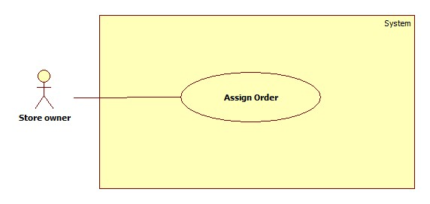**

**Figure 19: <StoreOwner> Assign Order Use Case Diagram**

**Use Case Specification**

|  |  |  |  |
| --- | --- | --- | --- |
| **USE CASE-16 SPECIFICATION** | | | |
| **Use-case No.** | EPS016 | **Use-case Version** | 2.0 |
| **Use-case Name** | Assign Order | | |
| **Author** | Dương Le Dinh Khang | | |
| **Date** | 15/04/15 | **Priority** | High |
| **Actor:**  StoreOwner.  **Summary:**  This use case allow StoreOwner assign an order for employee to print.  **Goal:**  Assign order for employee.  **Triggers**   * StoreOwner clicks on assign order function.   **Preconditions:**   * StoreOwner must have at least 1 order not printed yet. * StoreOwner must have at least 1 employee in idle time.   **Post Conditions:**   * **On Success**: Order will be assigned for employee. * **On Failure**: Show error message.   **Main Success Scenario:**   |  |  |  | | --- | --- | --- | | Step | Actor Action | System Response | | 1 | StoreOwner clicks on “Giao việc” in navigation bar. | System will navigate to “Giao việc” page.  “Danh sách hoá đơn”: table.   * “Chọn”: checkbox. * “Tên”: text. * “Địa chỉ”: text.   “Danh sách nhân viên”: combo box.  “Giao việc”: button. | | 2 | StoreOwner stick on the checkbox of order they want to assign. | [Alternative 1] | | 3 | StoreOwner selects an employee from combo box “Danh sách nhân viên”. | [Alternative 2] | | 4 | StoreOwner clicks on “Giao việc” button | System creates a notification to notify employee about orders assign for them.  [Exception 1] |   **Alternative Scenario:**   |  |  |  | | --- | --- | --- | | No | Actor Action | System Response | | 1 | StoreOwner not creates any order yet. | Show message: “Vui lòng tạo ít nhất 1 hoá đơn để có thể giao cho nhân viên!” | | 2 | StoreOwner not creates any employee yet. | Show message: “Vui lòng tạo ít nhất 1 nhân viên để có thể tiến hành giao việc!” |   **Exceptions:**   |  |  |  | | --- | --- | --- | | No | Actor Action | System Response | | 1 | StoreOwner clicks on “Giao việc” button before select order. | Show message: “Vui lòng chọn ít nhất 1 hoá đơn để giao!”. |   **Relationships:**   * N/A   **Business Rules:**   * On Success scenario, system will make a push notification to notify to employee Android smartphone about assignment. * StoreOwner will receive another notification about the assign status when their employee accept or decline the assignment using our web service. * One order can only assign for one employee, if employee decline the assign ment, orders assign for them will available for assign again. * Exception must not violate. | | | |

##### <StoreOwner> Export Order Use Case Diagram

**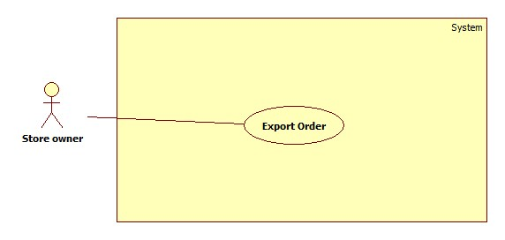**

**Figure 20: <StoreOwner> Assign Order Use Case Diagram**

**Use Case Specification**

**Web**

|  |  |  |  |
| --- | --- | --- | --- |
| **USE CASE-17 SPECIFICATION** | | | |
| **Use-case No.** | EPS017 | **Use-case Version** | 2.0 |
| **Use-case Name** | Export Order | | |
| **Author** | Dương Le Dinh Khang | | |
| **Date** | 15/04/15 | **Priority** | High |
| **Actor:**  StoreOwner.  **Summary:**  This use case allow StoreOwner export their list of order into excel file.  **Goal:**  Export list of order.  **Triggers**   * StoreOwner clicks on export order function.   **Preconditions:**   * StoreOwner must have at least 1 orders.   **Post Conditions:**   * **On Success**: StoreOwner receive an excel file contain their list of order. * **On Failure**: Show error message.   **Main Success Scenario:**   |  |  |  | | --- | --- | --- | | Step | Actor Action | System Response | | 1 | StoreOwner clicks on “Quản lý hoá đơn” in navigation bar. | System will navigate to “Quản lý hoá đơn” page.  “Danh sách hoá đơn”: table.  “Tạo hoá đơn”: button.  “Nhập danh sách hoá đơn”: button.  “Xuất danh sách hoá đơn”: button. | | 2 | StoreOwner clicks on “Xuất danh sách hoá đơn” button. | System response with an excel file contain their list of orders.  [Exception 1] |   **Alternative Scenario:**   * N/A   **Exceptions:**   |  |  |  | | --- | --- | --- | | No | Actor Action | System Response | | 1 | StoreOwner clicks on “Xuất danh sách hoá đơn” button before create atleast one order. | Show message: “Vui lòng tạo ít nhất một hoá đơn trước khi xuất danh sách hoá đơn!”. |   **Relationships:**   * N/A   **Business Rules:**   * Structure of excel file:      * Each order will place as a sheet in excel file. * Excel file version is “.xls” (Microsoft Office 2003). * Output of this use case can use to import it back to system. * Exception must not violate. | | | |

#### <Employee> Overview Use Case

**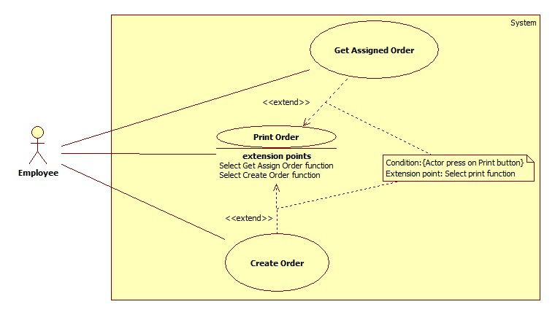**

**Figure 21: <Employee> Overview Use Case Diagram**

##### <Employee> Create Order Use Case Diagram

**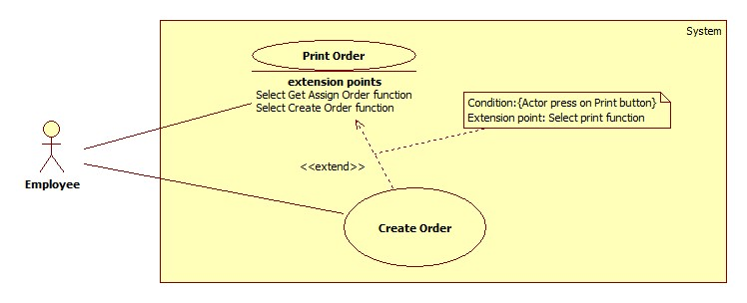**

**Figure 22: <Employee> Create Order Use Case Diagram**

**Use Case Specification**

|  |  |  |  |  |
| --- | --- | --- | --- | --- |
| **USE CASE-18 SPECIFICATION** | | | | |
| **Use-case No.** | EPS018 | **Use-case Version** | | 2.0 |
| **Use-case Name** | Create Order | | | |
| **Author** | Chau Chieu Nguyen | | | |
| **Date** | 14/04/15 | | **Priority** | Medium |
| **Actor:**  Employee  **Summary:**  This use case allow Employee to create an order in Android application.  **Goal:**  Create an order  **Triggers**   * Employee chooses create order function in Android application.   **Preconditions:**   * User must login with role Employee.   **Post Conditions:**   * **On Success**: A new order will be created. * **On Failure**: Show error message.   **Main Success Scenario:**   |  |  |  | | --- | --- | --- | | Step | Actor Action | System Response | | 1 | Employee touches on “Tạo hóa đơn” button on menu screen | System will navigate to choose template screen includes:   * List of templates chosen by storeowner with two cloumns. | | 2 | Employee touches on one template. | System navigate to generate order screen includes:   * “Sản phẩm”: combo box for employee to choose item. Raw sources such as: “máy tính”, “máy in”… * “Số lượng”: textbox for employee to input quantity of item; max length 2. * “Đơn giá”: textbox to show unit price of an item, uneditable * “Thêm sản phẩm”: button. * “Khách hàng”: textbox for employee to input customer’s name, max length 50. * “T.Tính 1”: label. * “T.Tính 2”: label. * “T.Tính 3”: label. * “Tạo hóa đơn”: button.   [Exception 1] | | 3 | Employee chooses an item and input quantity of item. |  | | 4 | Employee touches “Thêm sản phẩm” | System add item to a list an display “Đã thêm” message.  [Alternative 1] | | 5 | Employee touches “Tạo hóa đơn” button. | System will create an order rely on employee choices.  Navigate to preview order screen. |   **Alternative Scenario:**   |  |  |  | | --- | --- | --- | | No | Actor Action | System Response | | 1 | Employee input customer’s name |  | | 2 | Employee touches “T.Tính 1” or “T.Tính 2” or “T.Tính 3” label | System show a dialog includes:   * “ĐVT”: radio button. * “Số lượng”: radio button. * “Đơn giá”: radio button. * “Loại SP”: radio button. * “Thành tiền”: radio button. | | 3 | Employee touches on one radio button | System close dialog and change label. | | 4 | Employee touches “Tạo hóa đơn” button. | System will create an order rely on employee choices.  Navigate to preview order screen. |   **Exceptions:**   |  |  |  | | --- | --- | --- | | No | Actor Action | System Response | | 1 | Employee’s Android phone does not have internet connection | Show message “Vui lòng kết nối mạng và khởi động lại ứng dụng” |   **Relationships:**  Extend for Print Order (Select Print Order function).  **Business Rules:**   * Customer’s name will be “Khách lẻ” if employee does not input in “Khách hàng” textbox. * The maximum number of items to add is 999. * The quantity of items in order will increase if employee adds an item multiple times. * Items of the store will be download every time employee chooses create order function. | | | | |

##### <Employee> Print Order Use Case Diagram

****

**Figure 23: <Employee> Print Order Use Case Diagram**

**Use Case Specification**

|  |  |  |  |
| --- | --- | --- | --- |
| **USE CASE-19 SPECIFICATION** | | | |
| **Use-case No.** | EPS019 | **Use-case Version** | 2.0 |
| **Use-case Name** | Print Order | | |
| **Author** | Dương Le Dinh Khang | | |
| **Date** | 18/01/15 | **Priority** | High |
| **Actor:**  Employee  **Summary:**  This use case allows Employee print an order via Bluetooth printer.  **Goal:**  Print an order and have order’s paper.  **Triggers**   * Employee choose print function button.   **Preconditions:**   * Have a preview report. * User must log in as employee role.   **Post Conditions:**   * **On Success**: Have an order’s paper. * **On Failure**: Show error message.   **Main Success Scenario:**   |  |  |  | | --- | --- | --- | | Step | Actor Action | System Response | | 1 | In main menu, Employee clicks on “In Hoá Đơn” button. | System navigates to “Danh sách hoá đơn” screen.  “Tìm kiếm theo”: combo box with source value is “Tên K.hàng”,”Đ.chỉ K.hàng”.  “Giá trị”: textbox.  “Tìm kiếm”: button.  “Danh sách hoá đơn”: listview.  [Alternative 1] | | 2 | Employee clicks on an order in “Danh sách hoá đơn”. | System navigates to “Chọn mẫu hoá đơn” screen.  [Alternative 2] | | 3 | Employee clicks on a template to select. | System navigates to preview order image.  “Kết nối máy in”: button.  Preview image: imageview. | | 4 | Employee clicks on “Kết nối máy in” button. | System navigates to print settting screen.  “Tìm kiếm máy in”: button.  “Danh sách thiết bị bluetooth”: listview.  [Alternative 3]  [Exception 1] | | 5 | Employee clicks on Bluetooth printer | System navigates to Print screen.  “Số bản in”: textbox.  “In”: button.  [Exception 2] |   **Alternative Scenario:**   |  |  |  | | --- | --- | --- | | No | Actor Action | System Response | | 1 | When Employee do not have any assigned order to print. | Show message “Bạn hiện không có hoá đơn nào để in” | | 2 | Employee input value in “Giá trị” textbox and press “Tìm kiếm” | System updates “Danh sách hoá đơn” with the result matching their search value. |   **Exceptions:**   |  |  |  | | --- | --- | --- | | No | Actor Action | System Response | | 1 | Employees not turn on internet connection on their Android phone. | Show message: “Không thể kết nối đến máy chủ để tạo hoá đơn!” | | 2 | Employee input invalid number of order’s copy | Show error message: “Số bản in từ 1-99 !Xin nhập số hợp lệ” |   **Relationships:**   * Extended by Create Order (Select create order function), Get Assigned Order (Select get assigned order function).   **Business Rules:**   * The phone must have Bluetooth connection to connect to printer. * Input for printer is image file with extension is “.png”. * In main success scenario, Employee will get an order’s paper. * Exception must not violate. | | | |

##### <Employee> Get Assigned Order Use Case Diagram



**Figure 24: <Employee> Get Assigned Order Use Case Diagram**

**Use Case Specification**

**Android**

|  |  |  |  |
| --- | --- | --- | --- |
| **USE CASE-20 SPECIFICATION** | | | |
| **Use-case No.** | EPS020 | **Use-case Version** | 2.0 |
| **Use-case Name** | Get Assign Order | | |
| **Author** | Chau Chieu Nguyen | | |
| **Date** | 15/04/15 | **Priority** | Medium |
| **Actor:**  Employee  **Summary:**  This use case allows Employees to get orders assigned to them.  **Goal:**  Employee will get notify about order which assigned for them.  **Triggers**   * When StoreOwner has assigned orders to employee.   **Preconditions:**   * User must login with role Employee.   **Post Conditions:**   * **On Success**: Employee receive notify about orders and they can accept or decline it. * **On Failure**: Show error message.   **Main Success Scenario:**   |  |  |  | | --- | --- | --- | | Step | Actor Action | System Response | | 1 | Employee scrolls down the notification bar and touch on order notification | Navigate to get assigned order screen and show confirm dialog includes:   * List of order’s information. * “Thôi”: button. * “OK”: button   [Alternative 1] | | 2 | Employee touches “OK” button | Close dialog and download order information to employee’s device.  Send notification back to storeowner.  Show “Tải hóa đơn hoàn tất”. |   **Alternative Scenario:**   |  |  |  | | --- | --- | --- | | No | Actor Action | System Response | | 1 | Employee touches “Thôi” button | Close dialog and send notification back to storeowner. |   **Exceptions:**   * N/A   **Relationships:**   * Extended for Print Order (Select Get Assigned Order function).   **Business Rules:**   * If StoreOwner assigns orders when employee is offline, system will send notification when employee comes online again. * System will send notification back to storeowner after employee accept or decline the assignment. | | | |

#### <Admin> Overview Use Case

**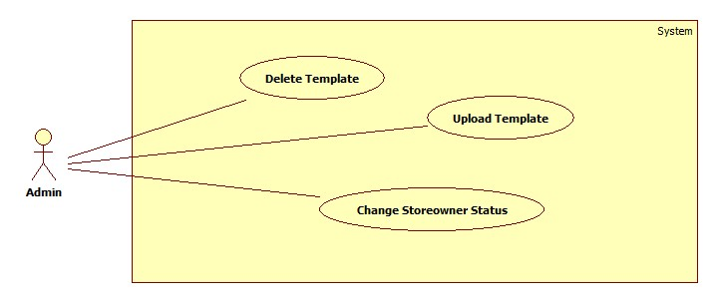**

**Figure 25: <Admin> Overview Use Case Diagram**

##### <Admin> Upload Template Use Case Diagram

**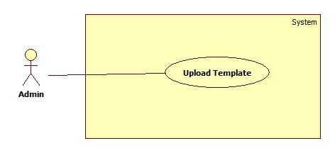**

**Figure 26: <Admin> Upload Template Use Case Diagram**

**Use Case Specification**

|  |  |  |  |
| --- | --- | --- | --- |
| **USE CASE-20 SPECIFICATION** | | | |
| **Use-case No.** | EPS020 | **Use-case Version** | 2.0 |
| **Use-case Name** | Upload Template | | |
| **Author** | Chau Chieu Nguyen | | |
| **Date** | 16/01/15 | **Priority** | Medium |
| **Actor:**  Admin  **Summary:**  This use case allows Admin to upload their template to the system.  **Goal:**  Upload a new template.  **Triggers**   * Admin choose upload template function.   **Preconditions:**   * User must login with role Admin.   **Post Conditions:**   * **On Success**: A new template will be uploaded. * **On Failure**: Show error message.   **Main Success Scenario:**   |  |  |  | | --- | --- | --- | | Step | Actor Action | System Response | | 1 | Admin chooses upload template function. | System will navigate to upload template includes:  -“Tên mẫu hóa đơn”: textbox, min length: 10, max length: 100, required.  - “Mẫu hóa đơn (.xls)”: label  -“Chọn tệp”: button.  - “Hình đại diện (.png)”: label  -“Chọn tệp”: button.  - “Loại hóa đơn”: combobox, raw sources are: Bluetooth, A4.  -“Tải lên”: button. | | 2 | Admin input template’s name. |  | | 2 | Click “Chọn tệp” button. | System will display an open file dialog for user to choose excel file.  -“Open”: button.  - “Close”: button  [Alternative 1] | | 3 | Link to the template and Click “Open” button. | System will display the template file’s name.  [Exception 1] | | 4 | Click “Chọn tệp” button. | System will display an open file dialog for user to choose image file.  -“Open”: button.  - “Close”: button | | 5 | Link to the template and Click “Open” button. | System will display the template image ’s name.  [Exception 1] | | 6 | Admin choose the template’s type |  | | 7 | Click “Tải lên” button | Template’s file and image paths on server will be added to database and a new template will be displayed in list.  [Exception 2, 3, 4] |   **Alternative Scenario:**   |  |  |  | | --- | --- | --- | | No | Actor Action | System Response | | 1 | Admin press “Close” | Close open file dialog |     **Exceptions:**   |  |  |  | | --- | --- | --- | | No | Actor Action | System Response | | 1 | Type of file is not “.xls” | Show error message: “Mẫu hóa đơn phải là file .xls.” | | 2 | Template name with same name already existed. | Show error message: “Mẫu hóa đơn đã có sẵn”. | | 3 | Template’s name is blank | Show error message: “Tên của mẫu hóa đơn không được để trống”. | | 4 | The Excel file is empty | Show error message: “Mẫu hóa đơn không được là file trống” |   **Relationships:**  N/A  **Business Rules:**   * The template’s type must be .xls file with format:   C:\Users\NguyenCCSE60911\Desktop\EPS Template\Template_1.png  Figure 1: Excel format of Bluetooth template.C:\Users\NguyenCCSE60911\Desktop\EPS Template\Template_5.png  Figure 2: Excel format of A4 template.   * Template’s image must be “.png” file. * Template’s name cannot be blank. * When a template is updated, it will be stored at folder Template on server * Length of file path is less or equal to 260 characters. * Template file cannot be empty. * The number of columns is 4 for Template Bluetooth and 6 for Template A4. | | | |

##### <Admin> Delete Template Use Case Diagram

**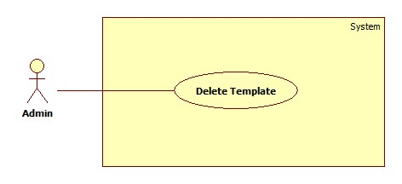**

**Figure 27: <Admin> Delete Template Use Case Diagram**

**Use Case Specification**

|  |  |  |  |
| --- | --- | --- | --- |
| **USE CASE-21 SPECIFICATION** | | | |
| **Use-case No.** | EPS021 | **Use-case Version** | 2.0 |
| **Use-case Name** | Delete Template | | |
| **Author** | Chau Chieu Nguyen | | |
| **Date** | 19/01/15 | **Priority** | Medium |
| **Actor:**  Admin  **Summary:**  This use case allows Admin to delete template.  **Goal:**  Delete an existed template.  **Triggers**   * Admin select delete template function on admin manage template page.   **Preconditions:**   * User must login with role Admin.   **Post Conditions:**   * **On Success**: An existed template will be deleted. * **On Failure**: Show error message.   **Main Success Scenario:**   |  |  |  | | --- | --- | --- | | Step | Actor Action | System Response | | 1 | Admin click “Quản lý mẫu hoá đơn” in navigation bar. | System navigates to “Quản lý mẫu hoá đơn” page. | | 2 | Admin click “Xoá” button | System shows message “Bạn có chắc muốn xoá mẫu hoá đơn này?” | | 3 | Admin click “OK” button | System deletes the selected template.  [Exception 1] |   **Alternative Scenario:**   * N/A   **Exceptions:**   |  |  |  | | --- | --- | --- | | No | Actor Action | System Response | | 1 | Admin click “Cancel” button. | System will cancel delete function. |   **Relationships:**   * N/A   **Business Rules:**  Deleted template will no longer available for use.  StoreOwner already select this template in the past still can use or customize it. | | | |

##### <Admin> Change StoreOwner Status Use Case Diagram

**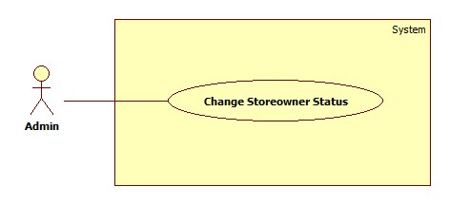**

**Figure 28: <Admin> Change StoreOwner Status Use Case Diagram**

**Use Case Specification**

|  |  |  |  |
| --- | --- | --- | --- |
| **USE CASE-22 SPECIFICATION** | | | |
| **Use-case No.** | EPS022 | **Use-case Version** | 2.0 |
| **Use-case Name** | Change Storeowner Status | | |
| **Author** | Chau Chieu Nguyen | | |
| **Date** | 15/04/15 | **Priority** | Medium |
| **Actor:**  Admin  **Summary:**  This use case allow Admin lock or unlock storeowner.  **Goal:**  Lock/Unlock a Storeowner  **Triggers**   * Admin chooses lock/unlock Storeowner function on manage Storeowner page.   **Preconditions:**   * User must login with role Admin.   **Post Conditions:**   * **On Success**: An existed storeowner and their employees will be lock/unlock. * **On Failure**: Show error message.   **Main Success Scenario:**   |  |  |  | | --- | --- | --- | | Step | Actor Action | System Response | | 1 | Admin chooses lock/unlock storeowner function in manage storeowner page. | System will lock/unlock storeowner and their employees.  Navigate to manage storeowner page. |   **Alternative Scenario:**   * N/A   **Exceptions:**   * N/A   **Relationships:**   * N/A   **Business Rules:**   * Storeowner has two statuses: active and deactivate. * When being locked, storeowner cannot login to the system. * If a storeowner is locked, his/her employee will be locked too. * If locked user not logout yet on Android app, they still can open it but cannot use any function. | | | |

## Software System Attribute

### Usability

#### Graphic User Interface

* + All the texts, labels and should be written in Vietnamese.

#### Usability

* + Admin only need one day of training to use this system.

#### Installation

* + The system must be easy to deploy. Customer can deploy successfully and learn to configure, maintain the system within one day of training.
  + The attached manual guide must be clear. User can read and do themselves without developer’s help.

### Reliability

* + Information about order of StoreOwner can be backup and restore easily using import/export function.

### Availability

* + User need to have an internet connection to use every function of the system in the best way.

### Security

* + Information about employee, item, and order of a StoreOwner only can access by their own. Even Admin cannot do anything.

### Maintainability

* + The system is divided into separated modules.

### Portability

* + The system can be deployed into many type of servers those have Tomcat server.

### Performance

The process of create a printable order only need 10 seconds.

## Conceptual Diagram

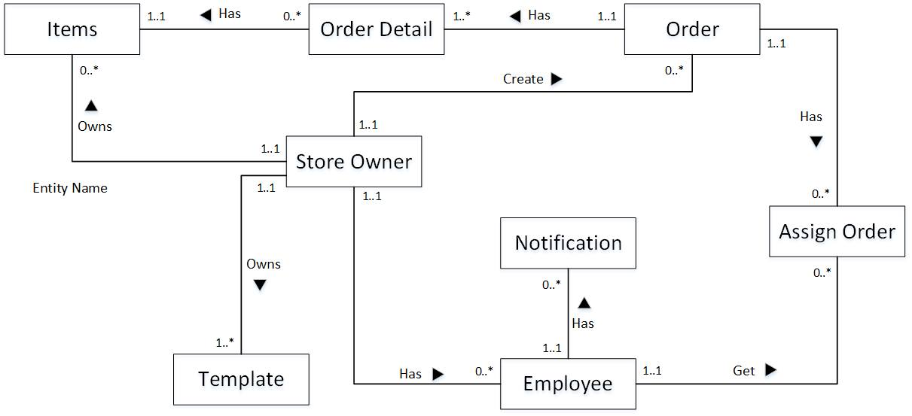

**Data Dictionary**

|  |  |
| --- | --- |
| **Entity Data dictionary: describe content of all entities** | |
| Entity Name | Description |
| Items | Describe all Items in the system. |
| Store Owner | Describe all StoreOwners in the system. |
| Template | Describe all Templates available in the system. |
| Employee | Describe all Employees in the system. |
| Order | Describe all Order in the system. |
| Order Detail | Describe all Order Details in the system. |
| Notification | Describe all Notifications in the system. |
| Assign Order | Describe all templates available in the system. |

# Report No. 4 Software Design Description

## Design Overview

* This document describes the technical and user interface design of EPS System. It includes the architectural design, the detailed design of common functions and business functions and the design of database model.
* The architectural design describes the overall architecture of the system and the architecture of each main component and subsystem.
* The detailed design describes static and dynamic structure for each component and functions. It includes class diagrams, class explanations and sequence diagrams for each use cases.
* The database design describes the relationships between entities and details of each entity.
* Document overview:
* Section 2: gives an overall description of the system architecture design.
* Section 3: gives component diagrams that describe the connection and integration of the system.
* Section 4: gives the detail design description, which includes class diagram, class explanation, and sequence diagram to details the application functions.
* Section 5: describe a fully attributed ERD.

## System Architectural Design

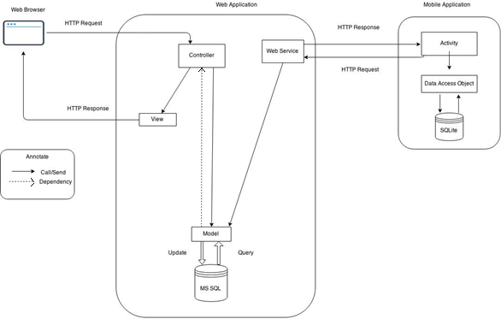

Figure 4: EPS System Architectural



#### Web application architecture description

* The system is developed from MVC architecture style and customized with passive model to adapt to JAVA MVC, RESTful web service technologies.
* **Model** is a part of application which uses to storage and retrieval data.
* **View** is the part of the application that visualizes the data to help user easily to view, update or customize them.
* **Controller** is the parts of the application that acts like event handler to handles user interaction. Typically controller read data from a request and returns respective view for user.
* **Web Service** is the parts of the application which use to provide interface for mobile application to do some background operation such as download template, convert excel file...

#### Mobile application architecture description

* The application is developed as an Android native application. In general, the application architecture conforms to Android architecture.
* **Activity** is the basic core of an android application that handles user input, calls Web Service…
* **Data Transfer Object** is the parts of the application that mapping to SQLite database to storage and retrieval the order and order detail which assigned for employee.

## Component Diagram

**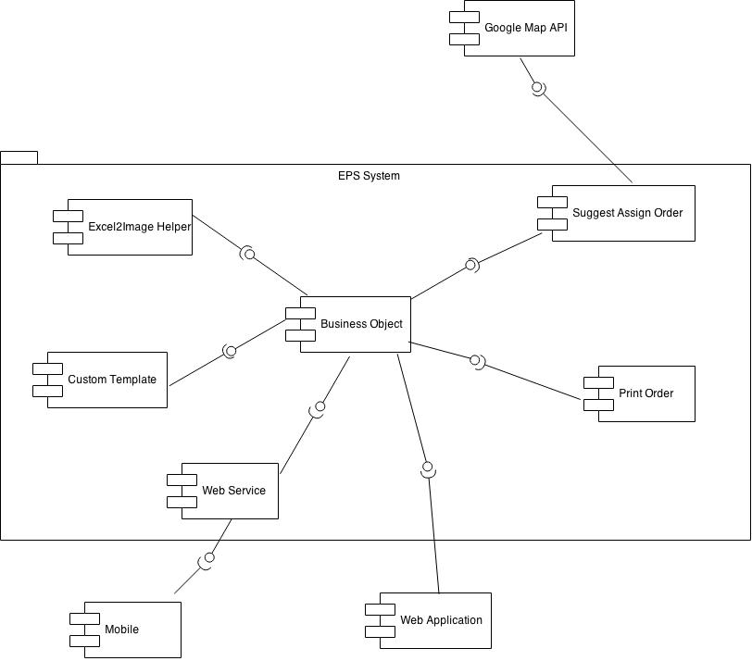**

Figure 4: Conceptual Diagram

|  |  |
| --- | --- |
| **Component dictionary: describe component** | |
| Component Name | Description |
| Business Object | Handle business process. |
| Excel2Html Helper | Handle process of create a printable order, using XSSF Helper library from Apache POI and Html2Image library.  *Html2Image*  *( https://code.google.com/p/java-html2image/ )*  *XSSFHtmlHelper (http://svn.apache.org/repos/asf/poi/trunk/src/examples/*  *src/org/apache/poi/ss/examples/html/)* |
| Web Service | Content all web service of the system. |
| Custom Template | Handle the process of create and customize template. |
| Suggest Assign Order | Use to make suggest for StoreOwner to assign order for their Employee. |
| Print Order | Handle the process of printing order. |
| Google Map API | Use to work with Google Map API to get input data for Suggest Assign Order. |
| Mobile | Android Application. |
| Web Application | Web Application |

## Detailed Description

### Class Diagram

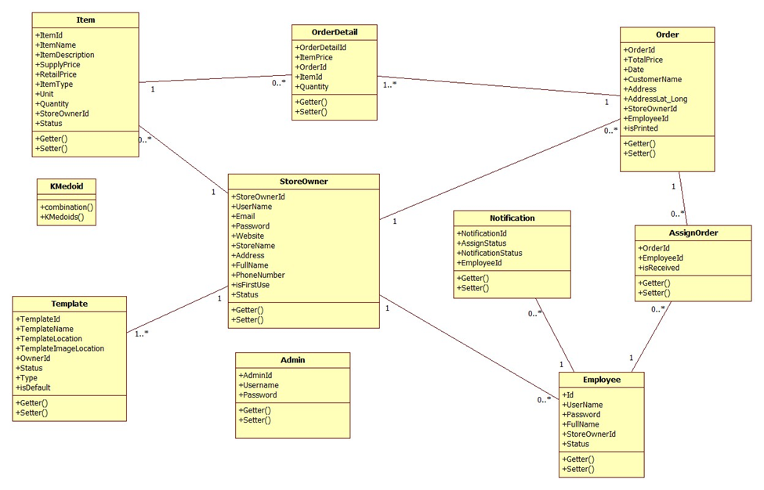

Figure 2: Class Diagram

### Class Diagram Explanation

#### StoreOwner

Attribute

|  |  |  |  |
| --- | --- | --- | --- |
| **Attribute** | **Type** | **Visibility** | **Description** |
| StoreOwnerId | int | Private | Unique identifier of a storeowner |
| UserName | String | Private | Username of storeowner |
| Email | String | Private | Email of storeowner |
| Password | String | Private | Password of storeowner |
| Website | String | Private | Website address of storeowner |
| StoreName | String | Private | Name of the store |
| Address | String | Private | Address of the store |
| FullName | String | Private | Full name of storeowner |
| PhoneNumber | String | Private | Phone number of storeowner |
| isFirstUse | boolean | Private | Value to check whether storeowner log in for the first time or not |
| Status | String | Private | Status of storeowner |

Method

|  |  |  |  |
| --- | --- | --- | --- |
| **Method** | **Return type** | **Visibility** | **Description** |
| Getter | Attribute type | Public | Get attribute value |
| Setter | Void | Public | Set value of attribute |

#### Employee

Attribute

|  |  |  |  |
| --- | --- | --- | --- |
| **Attribute** | **Type** | **Visibility** | **Description** |
| Id | int | Private | Unique identifier of an employee |
| UserName | String | Private | Username of employee |
| Password | String | Private | Password of employee |
| FullName | String | Private | Full name of employee |
| StoreOwnerId | int | Private | Id of storeowner |
| Status | String | Private | Status of an employee |

Method

|  |  |  |  |
| --- | --- | --- | --- |
| **Method** | **Return type** | **Visibility** | **Description** |
| Getter | Attribute type | Public | Get attribute value |
| Setter | Void | Public | Set value of attribute |

#### Item

Attribute

|  |  |  |  |
| --- | --- | --- | --- |
| **Attribute** | **Type** | **Visibility** | **Description** |
| ItemId | int | Private | Unique identifier of an item |
| ItemName | String | Private | Name of an item |
| ItemDescription | String | Private | Description about item |
| SupplyPrice | float | Private | Supply price of item |
| RetailPrice | float | Private | Retail price of item |
| ItemType | String | Private | Type of item |
| Unit | String | Private | Calculating unit of item |
| Quantity | int | Private | Quantity of item in store |
| StoreOwnerId | int | Private | Id of storeowner |
| Status | String | Private | Status of an item |

Method

|  |  |  |  |
| --- | --- | --- | --- |
| **Method** | **Return type** | **Visibility** | **Description** |
| Getter | Attribute type | Public | Get attribute value |
| Setter | Void | Public | Set value of attribute |

#### Template

Attribute

|  |  |  |  |
| --- | --- | --- | --- |
| **Attribute** | **Type** | **Visibility** | **Description** |
| TemplateId | int | Private | Unique identifier of a template |
| TemplateName | String | Private | Name of template |
| TemplateLocation | String | Private | Location of template on server |
| TemplateImageLocation | String | Private | Location of template’s image on server |
| OwnerId | int | Private | Id of template’s owner |
| Status | String | Private | Status of template |
| Type | String | Private | Type of template |
| isDefault | boolean | Private | Value to check whether template is a default template or not |

Method

|  |  |  |  |
| --- | --- | --- | --- |
| **Method** | **Return type** | **Visibility** | **Description** |
| Getter | Attribute type | Public | Get attribute value |
| Setter | Void | Public | Set value of attribute |

#### Order

Attribute

|  |  |  |  |
| --- | --- | --- | --- |
| **Attribute** | **Type** | **Visibility** | **Description** |
| OrderId | int | Private | Unique identifier of an order |
| TotalPrice | float | Private | Total price of order |
| Date | String | Private | Date order was created |
| CustomerName | String | Private | Name of customer |
| Address | String | Private | Address of customer |
| AddressLat\_Long | String | Private | Latitude and longitude of customer’s address |
| StoreOwnerId | int | Private | Id of storeowner |
| isPrinted | boolean | Private | Value to check whether order is a printed or not |

Method

|  |  |  |  |
| --- | --- | --- | --- |
| **Method** | **Return type** | **Visibility** | **Description** |
| Getter | Attribute type | Public | Get attribute value |
| Setter | Void | Public | Set value of attribute |

#### Order Detail

Attribute

|  |  |  |  |
| --- | --- | --- | --- |
| **Attribute** | **Type** | **Visibility** | **Description** |
| OrderDetailId | int | Private | Unique identifier of an order detail |
| ItemPrice | float | Private | Price of an item |
| OrderId | int | Private | Id of order |
| ItemId | int | Private | Id of item |
| Quantity | Int | Private | Number of item |

Method

|  |  |  |  |
| --- | --- | --- | --- |
| **Method** | **Return type** | **Visibility** | **Description** |
| Getter | Attribute type | Public | Get attribute value |
| Setter | Void | Public | Set value of attribute |

#### Notification

Attribute

|  |  |  |  |
| --- | --- | --- | --- |
| **Attribute** | **Type** | **Visibility** | **Description** |
| NotificationId | int | Private | Unique identifier of notification |
| AssignStatus | boolean | Private | Status of order assigned to employee |
| NofiticationStatus | boolean | Private | Status of notification |
| EmployeeId | int | Private | Id of employee |

Method

|  |  |  |  |
| --- | --- | --- | --- |
| **Method** | **Return type** | **Visibility** | **Description** |
| Getter | Attribute type | Public | Get attribute value |
| Setter | Void | Public | Set value of attribute |

#### AssignOrder

Attribute

|  |  |  |  |
| --- | --- | --- | --- |
| **Attribute** | **Type** | **Visibility** | **Description** |
| OrderId | int | Private | Id of order |
| EmployeeId | int | Private | Id of employee |
| isReceived | boolean | Private | Value to check whether order is a received or not |

Method

|  |  |  |  |
| --- | --- | --- | --- |
| **Method** | **Return type** | **Visibility** | **Description** |
| Getter | Attribute type | Public | Get attribute value |
| Setter | Void | Public | Set value of attribute |

#### Admin

Attribute

|  |  |  |  |
| --- | --- | --- | --- |
| **Attribute** | **Type** | **Visibility** | **Description** |
| AdminId | int | Private | Unique identifier of admin |
| UserName | String | Private | Username of admin |
| Password | String | Private | Password of admin |

Method

|  |  |  |  |
| --- | --- | --- | --- |
| **Method** | **Return type** | **Visibility** | **Description** |
| Getter | Attribute type | Public | Get attribute value |
| Setter | Void | Public | Set value of attribute |

#### K – Medoid

Method

|  |  |  |  |
| --- | --- | --- | --- |
| **Method** | **Return type** | **Visibility** | **Description** |
| Combination | String Array | Public | Calculation combination of medoid |
| KMedoids | 2-Dementions String Array | Public | Implement Kmedoid algorithm. |

### Sequence Diagram

##### <Guest> Register

**Summary:** This diagram shows how to guest register as StoreOwner.

**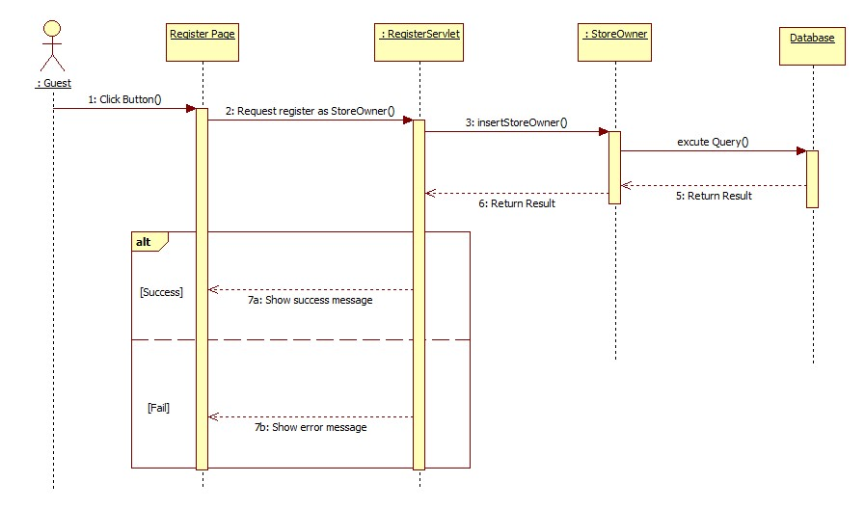**

Figure 29: <Guest> Register

##### <Guest> Login

**Summary:** This diagram shows how to guest login as StoreOwner.

**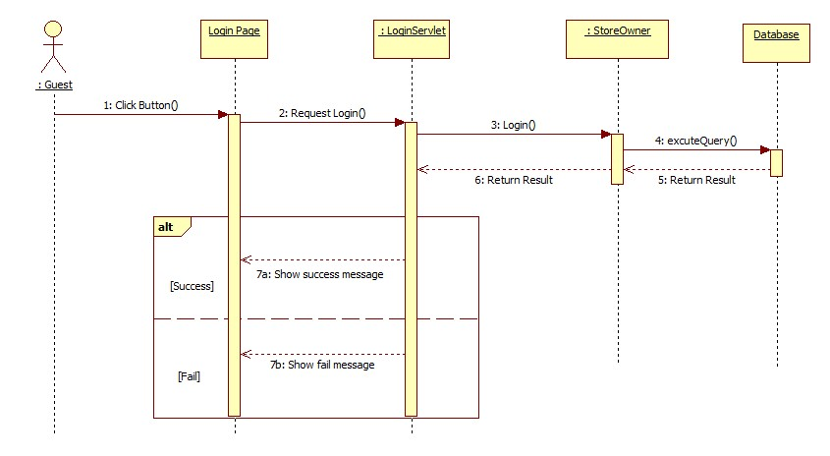**

Figure 30: <Guest> Login

##### <StoreOwner> Insert Item

**Summary:** This diagram shows how a StoreOwner insert new item to system.

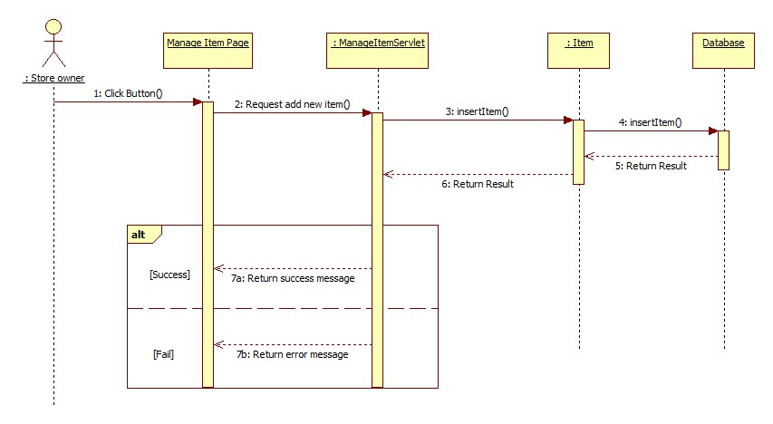

Figure 31: <StoreOwner> Insert Item

##### <StoreOwner> Update Item

**Summary:** This diagram shows how a StoreOwner updates an existed item.

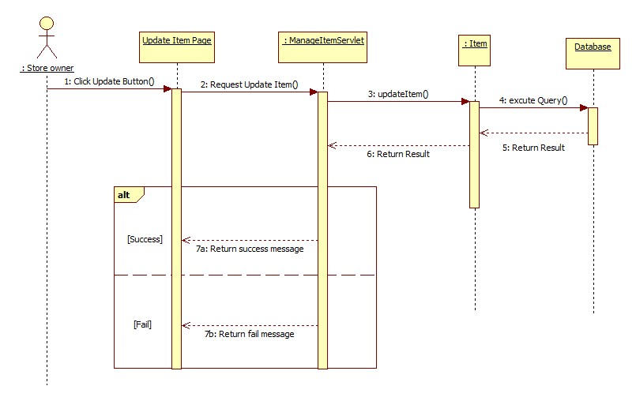

Figure 32: <StoreOwner> Update Item

##### <StoreOwner> Change Item Status

**Summary:** This diagram shows how a StoreOwner locks or unlocks an item in system.

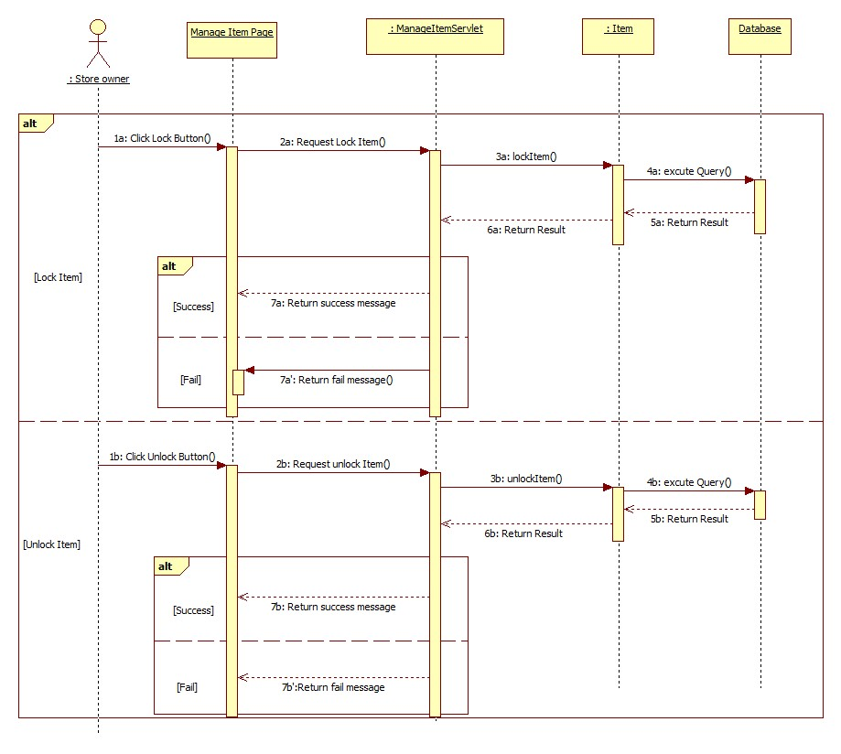

Figure 33: <StoreOwner> Change Item Status

##### <StoreOwner> Import Item

**Summary:** This diagram shows how a StoreOwner import a list of Item into system.

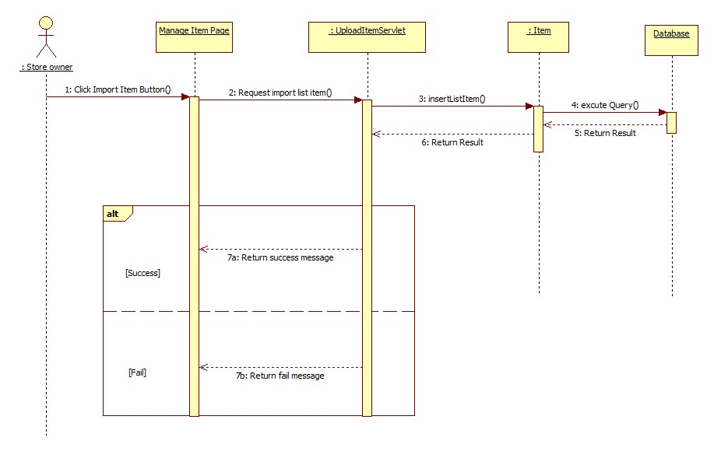

Figure 34: <StoreOwner> Import Item

##### <StoreOwner> Insert Employee

**Summary:** This diagram shows how a StoreOwner a new employee to system.

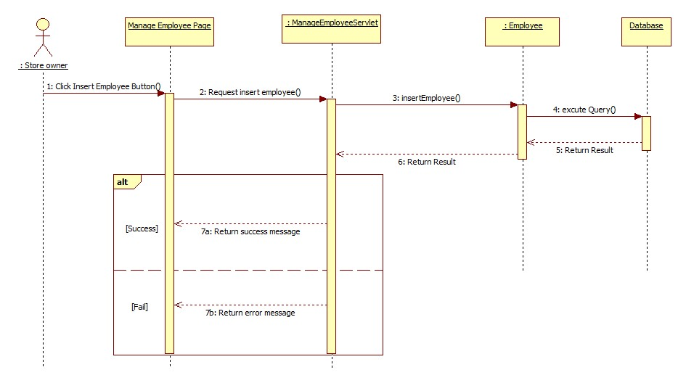

Figure 35: <StoreOwner> Insert Employee

##### <StoreOwner> Update Employee

**Summary:** This diagram shows how a StoreOwner update employee in system.

**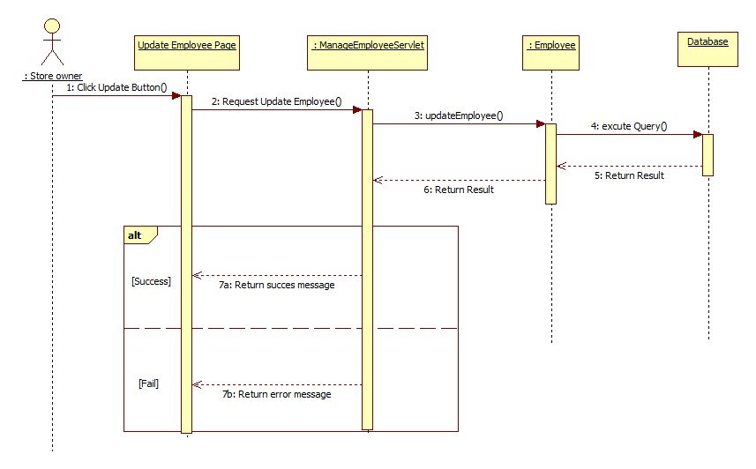**

Figure 36: <StoreOwner> Update Employee

##### <StoreOwner> Change Employee Status

**Summary:** This diagram shows how a StoreOwner changes status of an employee.

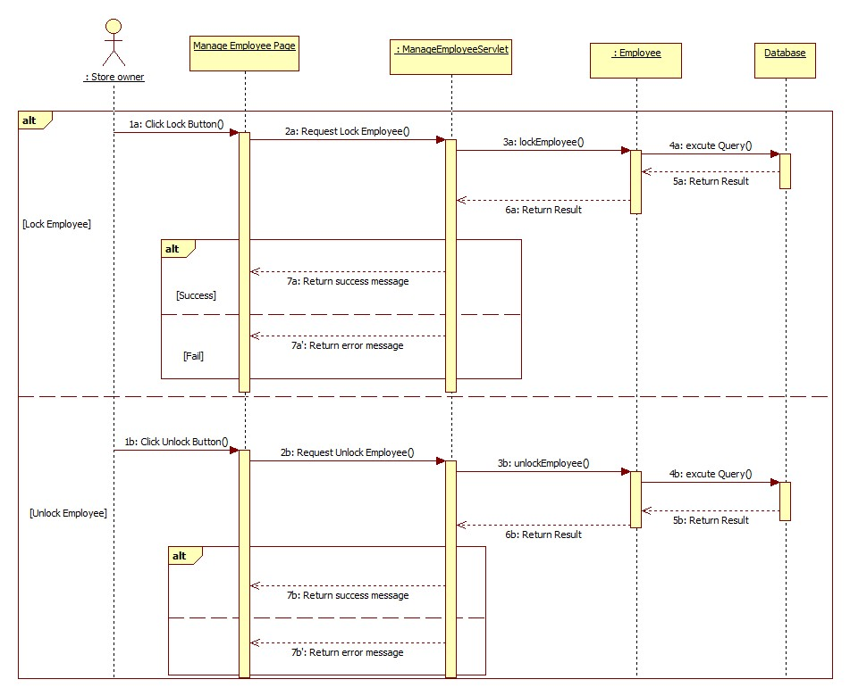

Figure 37: <StoreOwner> Change Employee Status

##### <StoreOwner> Import Employee

**Summary:** This diagram shows how a StoreOwner import a list of Employee into system.

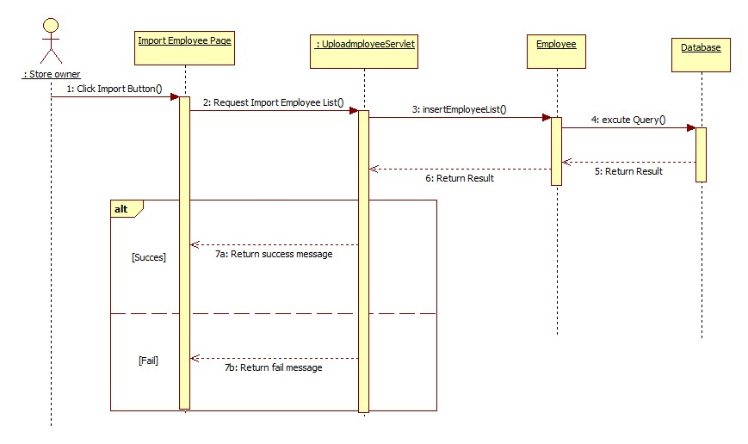

Figure 38: <StoreOwner> Import Employee

##### <StoreOwner> Select Template

**Summary:** This diagram shows how a StoreOwner select template to use when they login for the first time.

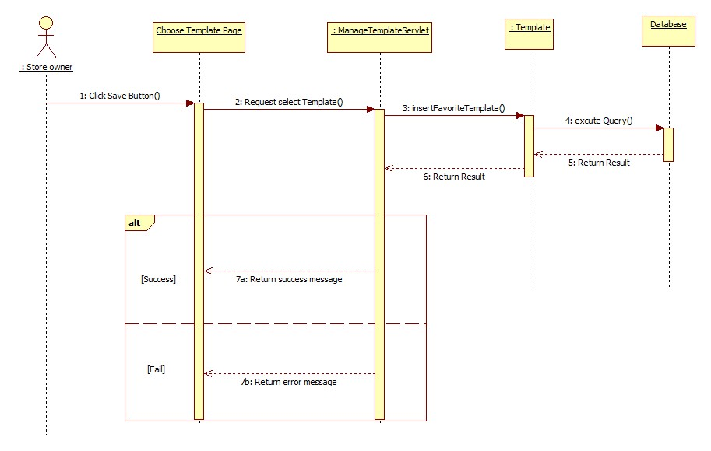

Figure 39: <StoreOwner> Select Template

##### <StoreOwner> Set Template Default

**Summary:** This diagram shows how a StoreOwner set default template to use.

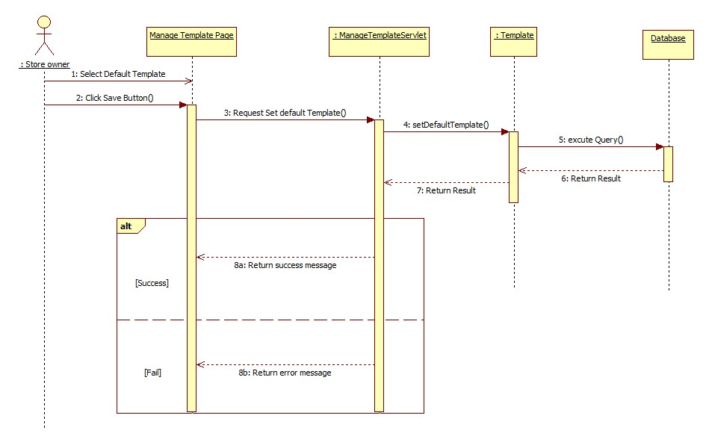

Figure 40: <StoreOwner> Set Template Default

##### <StoreOwner> Custom Template

**Summary:** This diagram shows how a StoreOwner customize template.

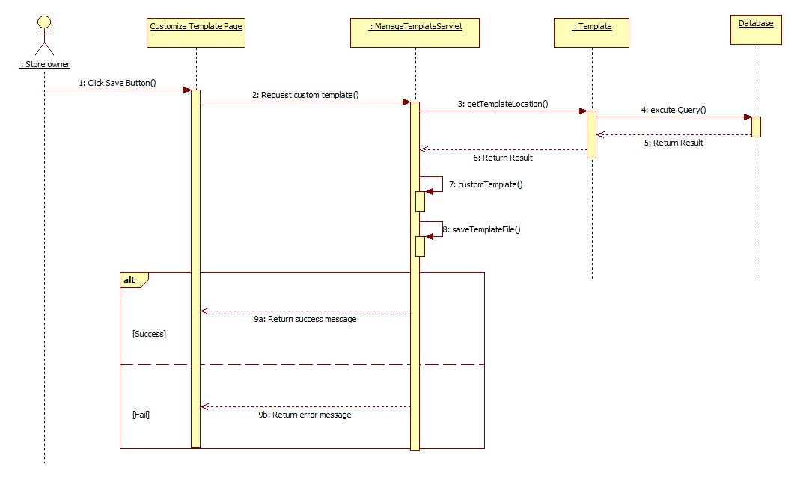

Figure 41: <StoreOwner> Custom Template

##### <StoreOwner> Create Order

**Summary:** This diagram shows how a StoreOwner creates an order.

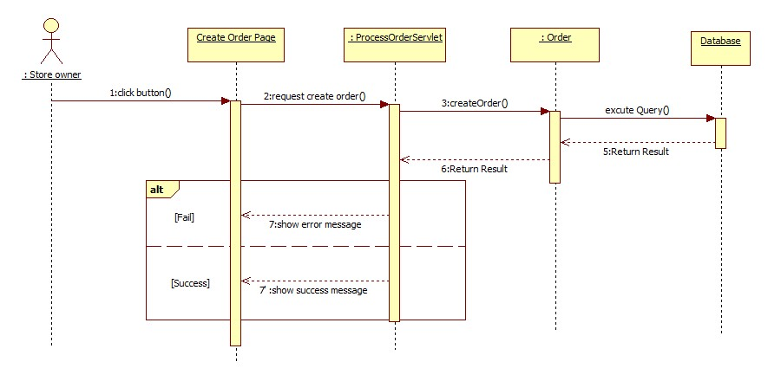

Figure 4: <StoreOwner> Create Order

##### <StoreOwner> Print Order

**Summary:** This diagram shows how a StoreOwner prints an order.

**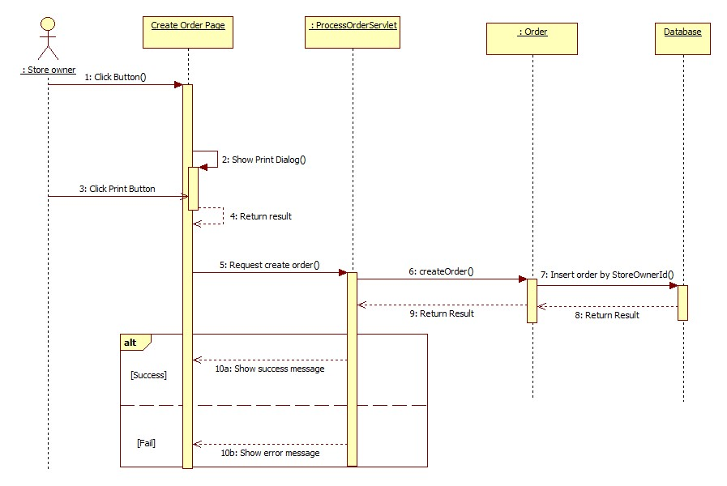**

Figure 42: <StoreOwner> Print Order

##### <StoreOwner> Assign Order

**Summary:** This diagram shows how a StoreOwner assigns orders for their employee to print.

**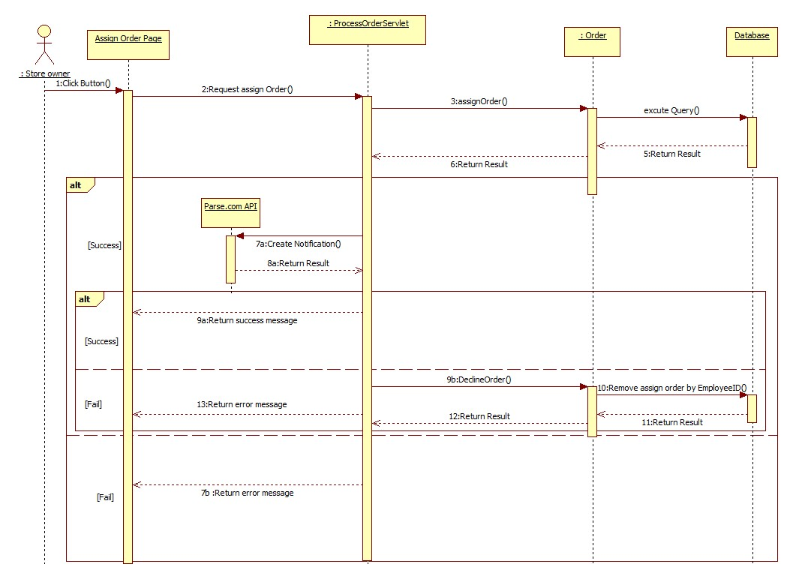**

Figure 43: <StoreOwner> Assign Order

##### <StoreOwner> Suggest Assign Order

**Summary:** This diagram shows how Suggest Assign Order function which help StoreOwner make a suitable assignment.

**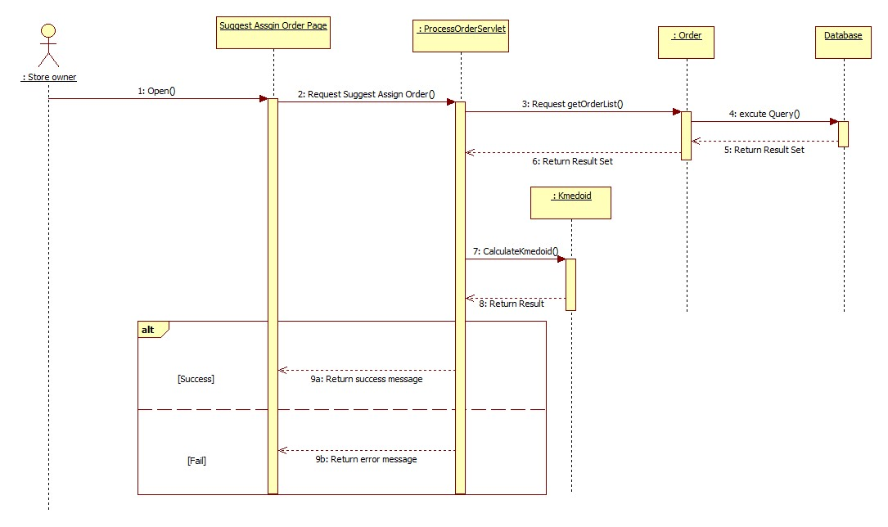**

Figure 44: <StoreOwner> Suggest Assign Order

##### <Admin> Upload Template

**Summary:** This diagram shows how Admin upload new template into system.

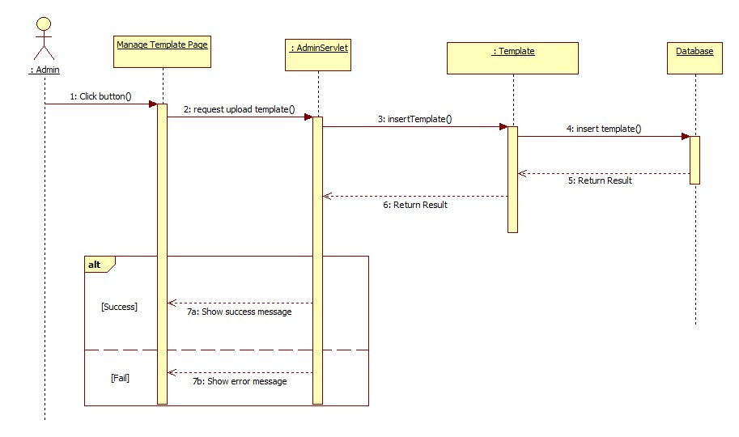

Figure 45: <Admin> Upload Template

##### <Admin> Delete Template

**Summary:** This diagram shows how Admin delete a template from system.

**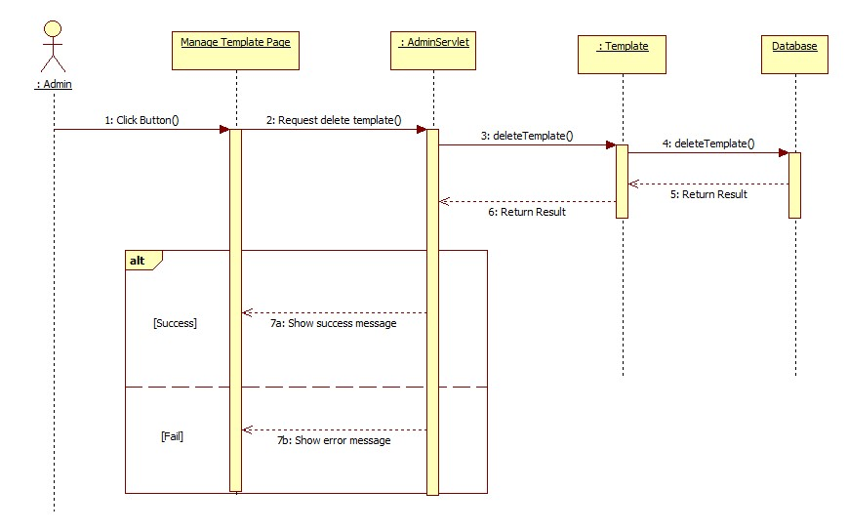**

Figure 46: <Admin> Delete Template

##### <Admin> Change StoreOwner Status

**Summary:** This diagram shows how Admin changes status of StoreOwner.

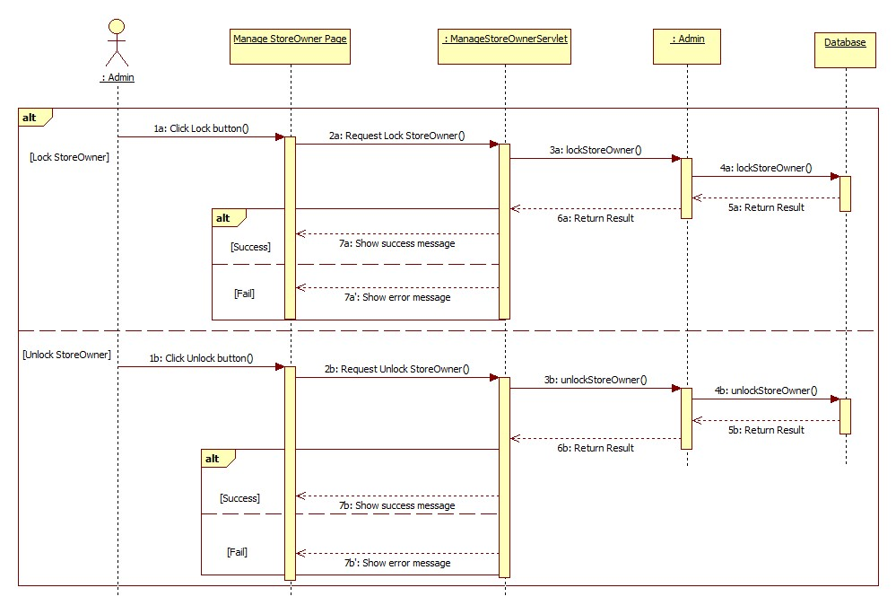

Figure 47: <Admin> Change StoreOwner Status

### Activity Diagram

#### <Employee> Get Assigned Order

**Summary:** This diagram shows how Employee gets orders, which assigned for them.

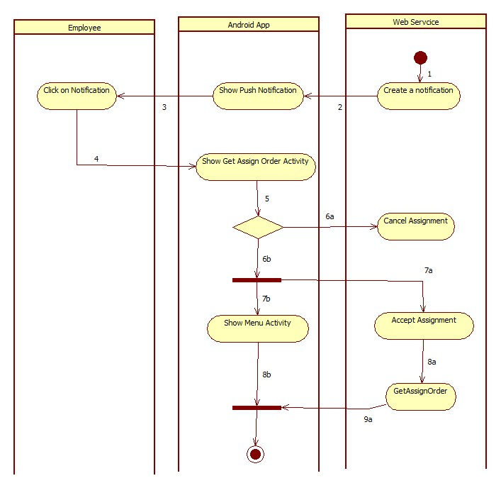

|  |  |  |  |
| --- | --- | --- | --- |
| 1. Start | 2. Call Parse.com API to push the notification to employee’s phone | 3.Show notification | 4. Employee clicks to view notification’s info |
| 5. Employee response to the notification | 6a. Employee cancel assignment | 6b. Employee accept assignment | 7a. Response accept message to server. |
| 7b. Start Activity | 8a. Call GetAssignOrder() | 9a. Response order’s detail |  |

Figure 48: <Employee> Get Assigned Order

#### <Employee> Create Order

**Summary:** This diagram shows how Employee creates a new order on Android phone.

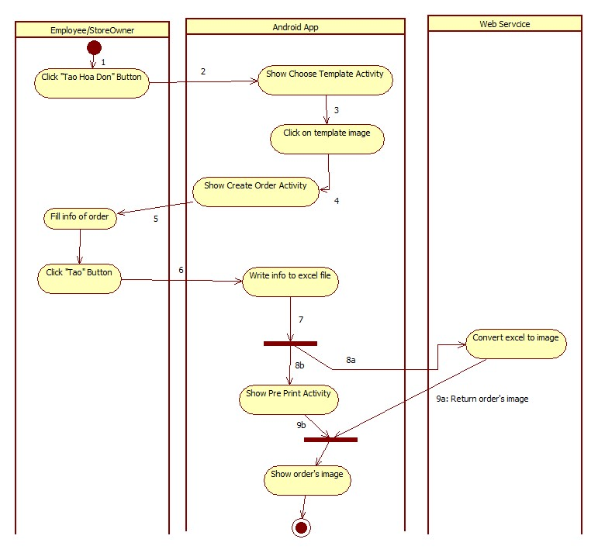

|  |  |  |
| --- | --- | --- |
| 1. Start | 2. Start Activity | 3. Employee select template |
| 4. Start Activity | 5.Employee fill info of order | 6. Click on “Tạo” button to create order. |
| 8a. Call API to convert excel file to image | 8b. Start Activity | 9a. Return Order’s image. |

Figure 49: <Employee> Create Order

#### <Employee> Print Order

**Summary:** This diagram shows how Employee prints a order.

**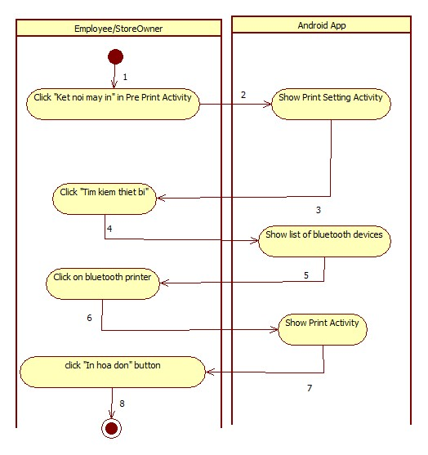**

|  |  |  |
| --- | --- | --- |
| 1. Start | 2. Start Activity | 3. Employee find Bluetooth printer. |
| 4. Get search result | 5. Clicks on suitable device | 6. Start Activity |
| 7. Input Number of copy | 8.Finish |  |

Figure 50: <Employee> Print Order

## User Interface Design

### Admin Interface Design

#### Admin Login

**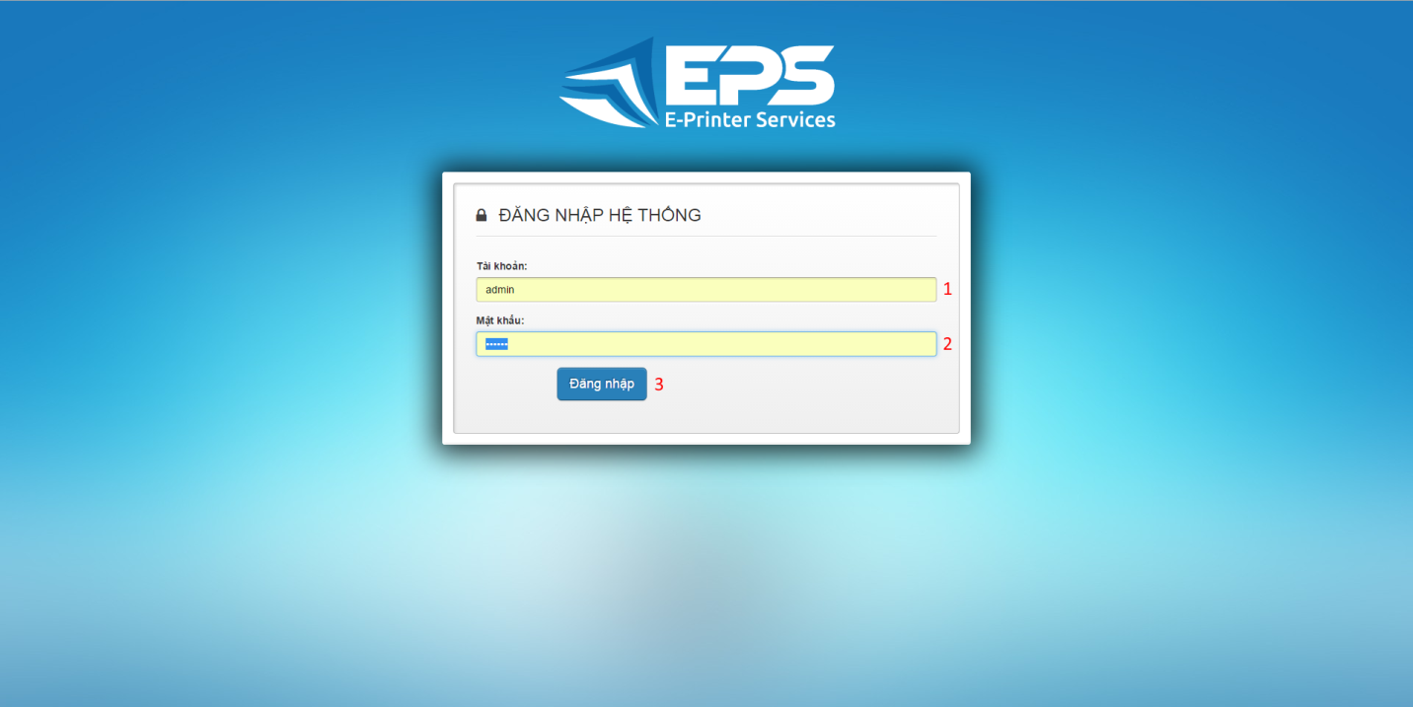**

Figure 1: Admin Login

**Fields**

|  |  |  |  |  |  |  |  |
| --- | --- | --- | --- | --- | --- | --- | --- |
| **No** | **Field Name** | **Description** | **Read only** | **Mandatory** | **Control Type** | **Data Type** | **Length** |
| 1 | Username | Fill user name | No | Yes | Textbox | String | N/A |
| 2 | Password | Fill password | No | Yes | Password | String | N/A |

**Buttons/Hyperlinks**

|  |  |  |  |  |
| --- | --- | --- | --- | --- |
| **No** | **Function** | **Description** | **Validation** | **Outcome** |
| 3 | Sign in | Log-in into the system | N/A | Transfer to admin home page |

#### Admin Manage Templates

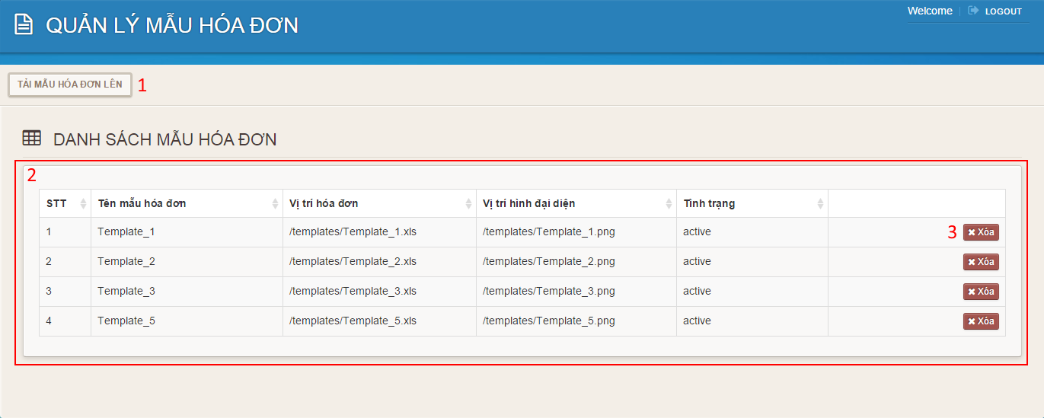

Figure 2: Admin Manage Templates

**Fields**

|  |  |  |  |  |  |  |  |
| --- | --- | --- | --- | --- | --- | --- | --- |
| **No** | **Field Name** | **Description** | **Read only** | **Mandatory** | **Control Type** | **Data Type** | **Length** |
| 2 | Template’s table | Table to show templates | Yes | N/A | Data Table | N/A | N/A |

**Buttons/Hyperlinks**

|  |  |  |  |  |
| --- | --- | --- | --- | --- |
| **No** | **Function** | **Description** | **Validation** | **Outcome** |
| 1 | Upload Template | Click to go to upload template page. | N/A | Transfer to upload template page. |
| 3 | Delete | Delete template | N/A | Delete a template |

#### Admin Upload Template

**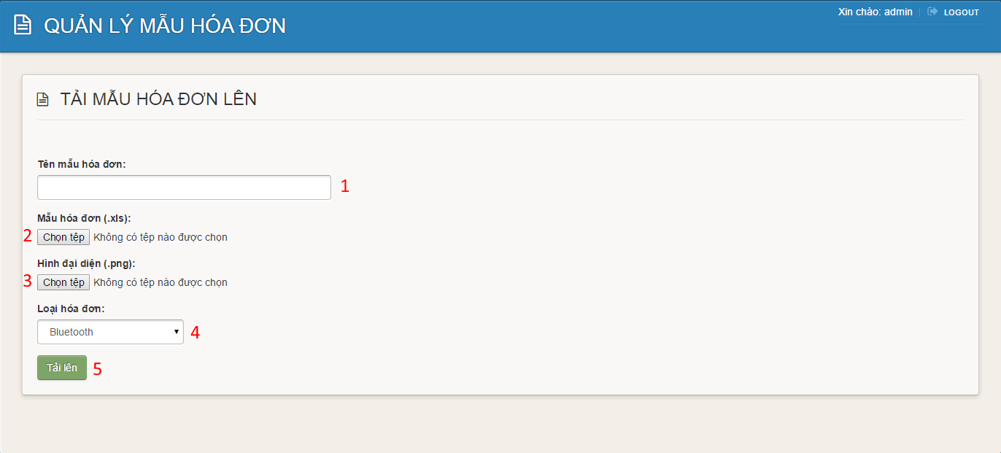Figure 3: Admin Upload Template**

**Fields**

|  |  |  |  |  |  |  |  |
| --- | --- | --- | --- | --- | --- | --- | --- |
| **No** | **Field Name** | **Description** | **Read only** | **Mandatory** | **Control Type** | **Data Type** | **Length** |
| 1 | Template’s name | Fill template’s name | No | Yes | Textbox | String | N/A |
| 4 | Template’s type | Choose template’s type | No | Yes | Comboxbox | String | N/A |

**Buttons/Hyperlinks**

|  |  |  |  |  |
| --- | --- | --- | --- | --- |
| **No** | **Function** | **Description** | **Validation** | **Outcome** |
| 2 | Choose .xls file | Click to go to choose file dialog | N/A | Display choose file dialog |
| 3 | Choose .png file | Click to go to choose file dialog | N/A | Display choose file dialog |
| 5 | Upload template | Click to upload template | N/A | Transfer to manage template page |

#### Admin Manage Storeowners

**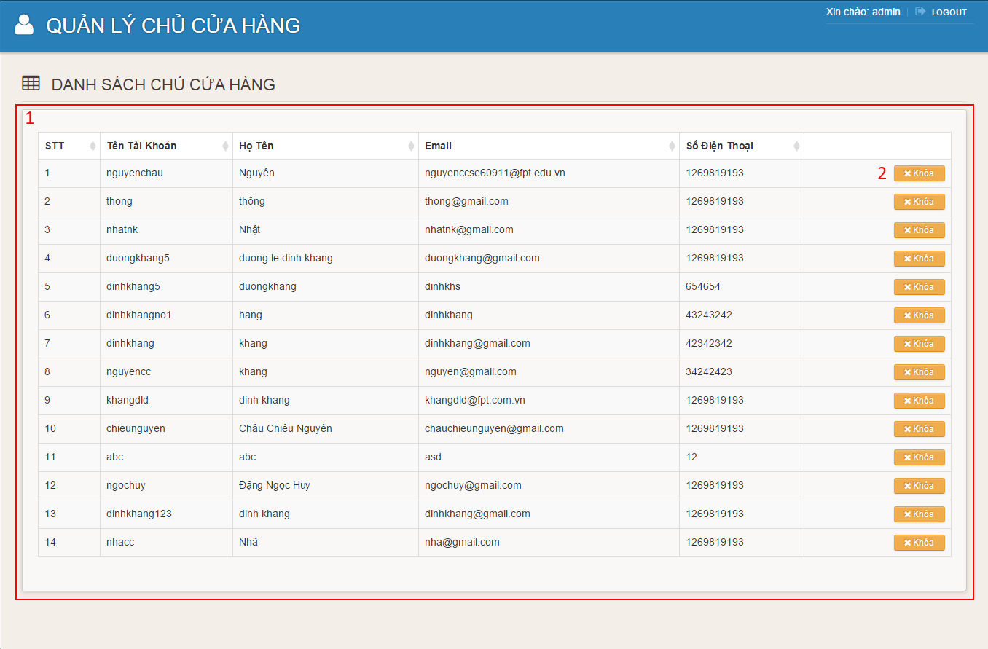Figure 4: Admin Manage Storeowners**

**Fields**

|  |  |  |  |  |  |  |  |
| --- | --- | --- | --- | --- | --- | --- | --- |
| **No** | **Field Name** | **Description** | **Read only** | **Mandatory** | **Control Type** | **Data Type** | **Length** |
| 1 | Storeowner’s table | Table to show storeowners | Yes | No | Data Table | N/A | N/A |

**Buttons/Hyperlinks**

|  |  |  |  |  |
| --- | --- | --- | --- | --- |
| **No** | **Function** | **Description** | **Validation** | **Outcome** |
| 2 | Lock | Click to lock storeowner | N/A | Transfer to manage storeowners page |

### Storeowner Interface Design (Website)

#### Register

**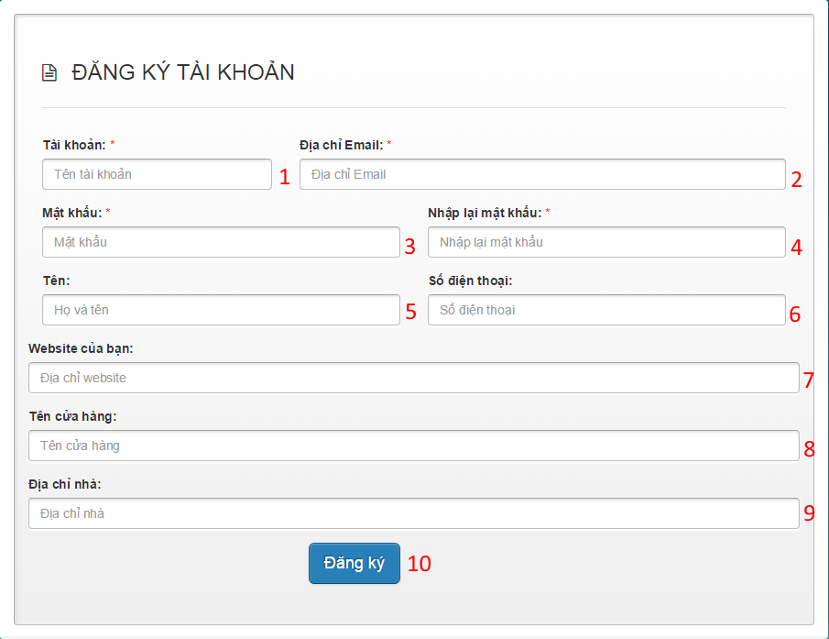Figure 5: Register**

**Fields**

|  |  |  |  |  |  |  |  |
| --- | --- | --- | --- | --- | --- | --- | --- |
| **No** | **Field Name** | **Description** | **Read only** | **Mandatory** | **Control Type** | **Data Type** | **Length** |
| 1 | Username | Fill username | No | Yes | Textbox | String | N/A |
| 2 | Email | Fill email address | No | Yes | Textbox | String | N/A |
| 3 | Password | Fill password | No | Yes | Password | String | N/A |
| 4 | Confirm password | Fill confirm password | No | Yes | Password | String | N/A |
| 5 | Full name | Fill full name | No | No | Textbox | String | N/A |
| 6 | Phone number | Fill phone number | No | No | Textbox | String | N/A |
| 7 | Website | Fill website | No | No | Textbox | String | N/A |
| 8 | Store name | Fill store name | No | No | Textbox | String | N/A |
| 9 | Address | Fill address | No | No | Textbox | String | N/A |

**Buttons/Hyperlinks**

|  |  |  |  |  |
| --- | --- | --- | --- | --- |
| **No** | **Function** | **Description** | **Validation** | **Outcome** |
| 10 | Register | Click to register | N/A | Transfer to welcome page |

#### Storeowner Login

**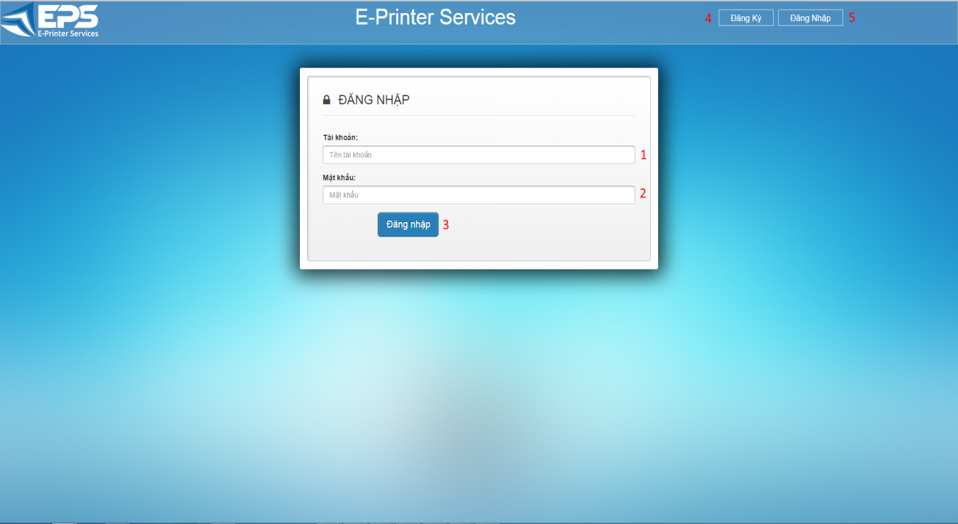**

**Figure 6: Storeowner Login**

**Fields**

|  |  |  |  |  |  |  |  |
| --- | --- | --- | --- | --- | --- | --- | --- |
| **No** | **Field Name** | **Description** | **Read only** | **Mandatory** | **Control Type** | **Data Type** | **Length** |
| 1 | Username | Fill user name | No | Yes | Textbox | String | N/A |
| 2 | Password | Fill password | No | Yes | Password | String | N/A |

**Buttons/Hyperlinks**

|  |  |  |  |  |
| --- | --- | --- | --- | --- |
| **No** | **Function** | **Description** | **Validation** | **Outcome** |
| 3 | Sign in | Log-in into the system | N/A | Transfer to storeowner home page |
| 4 | Register | Click to go to register page | N/A | Transfer to register page |
| 5 | Sign in | Click to go to login page | N/A | Transfer to login page |

#### Storeowner Home Page

**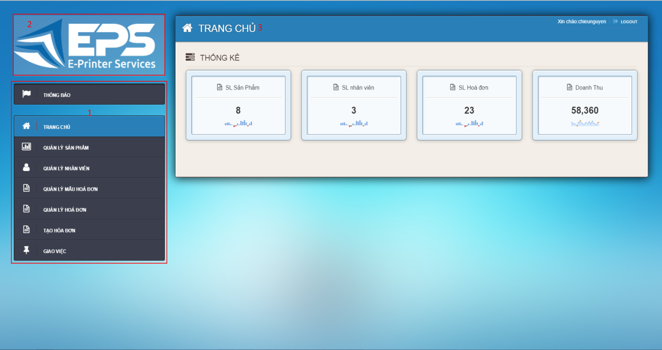**

**Figure 7: Storeowner Home Page**

**Fields**

|  |  |  |  |  |  |  |  |
| --- | --- | --- | --- | --- | --- | --- | --- |
| **No** | **Field Name** | **Description** | **Read only** | **Mandatory** | **Control Type** | **Data Type** | **Length** |
| 1 | Menu | Navigation bar | No | No | Menu bar | N/A | N/A |
| 2 | Logo | Logo of the system | Yes | No | Image | Image | N/A |
| 3 | Title | Title of the page | Yes | Yes | Label | String | N/A |

#### Notification

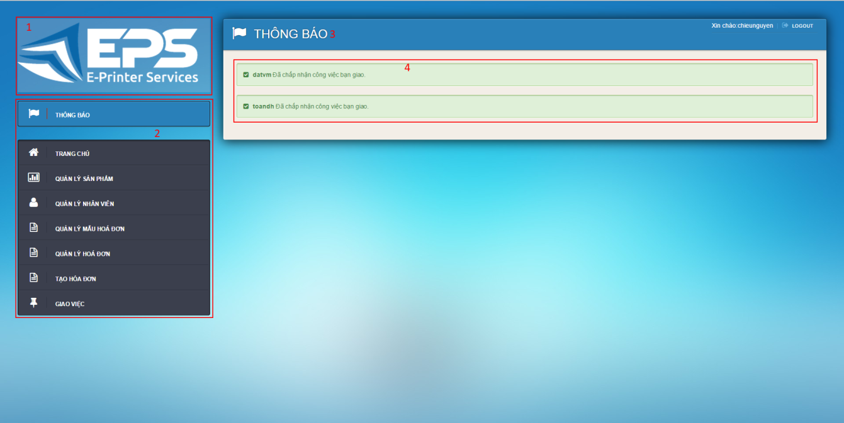

**Figure 8: Notification**

**Fields**

|  |  |  |  |  |  |  |  |
| --- | --- | --- | --- | --- | --- | --- | --- |
| **No** | **Field Name** | **Description** | **Read only** | **Mandatory** | **Control Type** | **Data Type** | **Length** |
| 1 | Menu | Navigation bar | No | No | Menu bar | N/A | N/A |
| 2 | Logo | Logo of the system | Yes | No | Image | Image | N/A |
| 3 | Title | Title of the page | Yes | Yes | Label | String | N/A |
| 4 | Notification | Notification from employee | Yes | Yes | Label | String | N/A |

#### Manage Item

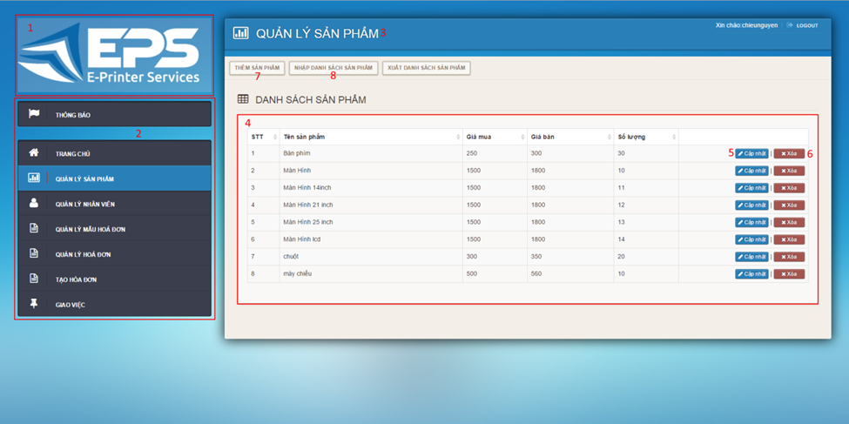

**Figure 9: Mange Items**

**Fields**

|  |  |  |  |  |  |  |  |
| --- | --- | --- | --- | --- | --- | --- | --- |
| **No** | **Field Name** | **Description** | **Read only** | **Mandatory** | **Control Type** | **Data Type** | **Length** |
| 1 | Logo | Logo of the system | Yes | No | Image | Image | N/A |
| 2 | Menu | Navigation bar | No | No | Menu bar | N/A | N/A |
| 3 | Title | Title of the page | Yes | Yes | Label | String | N/A |
| 4 | Item’s Table | Table to show items | Yes | Yes | Data Table | N/A | N/A |

**Buttons/Hyperlinks**

|  |  |  |  |  |
| --- | --- | --- | --- | --- |
| **No** | **Function** | **Description** | **Validation** | **Outcome** |
| 5 | Update | Click to go to update item page | N/A | Transfer to update item page |
| 6 | Delete | Delete an item | N/A | Transfer to manage item page |
| 7 | Add | Click to go to add item page | N/A | Transfer to add item page |
| 8 | Import Item | Click to go to import item page |  | Transfer to import item page |

#### Add Item

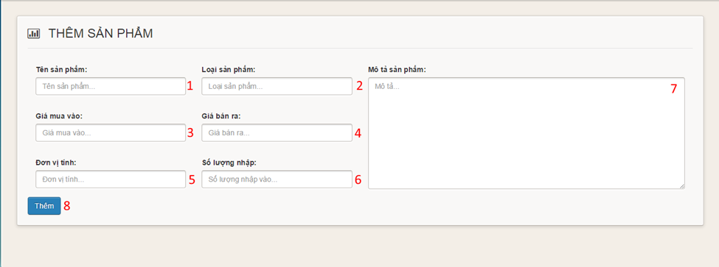

**Figure 10: Add Item**

**Fields**

|  |  |  |  |  |  |  |  |
| --- | --- | --- | --- | --- | --- | --- | --- |
| **No** | **Field Name** | **Description** | **Read only** | **Mandatory** | **Control Type** | **Data Type** | **Length** |
| 1 | Item name | Fill Item name | No | Yes | Textbox | String | N/A |
| 2 | Item type | Fill item type | No | Yes | Textbox | String | N/A |
| 3 | Supply price | Fill supply price | No | Yes | Textbox | String | N/A |
| 4 | Retail price | Fill retail price | No | Yes | Textbox | String | N/A |
| 5 | Item unit | Fill item unit | No | Yes | Textbox | String | N/A |
| 6 | Item quantity | Fill item quantity | No | Yes | Textbox | String | N/A |
| 7 | Description | Fill description | No | Yes | Text area | String | N/A |

**Buttons/Hyperlinks**

|  |  |  |  |  |
| --- | --- | --- | --- | --- |
| **No** | **Function** | **Description** | **Validation** | **Outcome** |
| 8 | Add | Click to add item | N/A | Transfer to manage item page |

#### Import Item

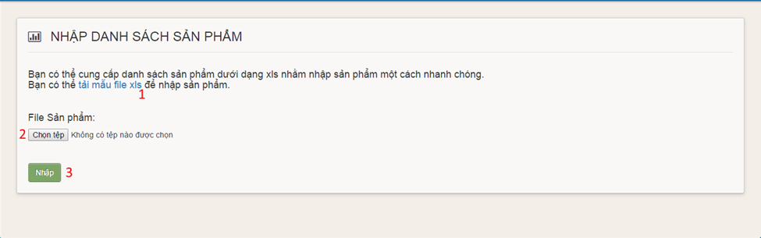

**Figure 11: Import Item**

**Buttons/Hyperlinks**

|  |  |  |  |  |
| --- | --- | --- | --- | --- |
| **No** | **Function** | **Description** | **Validation** | **Outcome** |
| 1 | Item template link | Click to download item template | N/A | Download item template |
| 2 | Choose file | Click to open choose file dialog | N/A | Display choose file dialog |
| 3 | Upload | Click to upload items | N/A | Transfer to manage items page |

#### Update Item

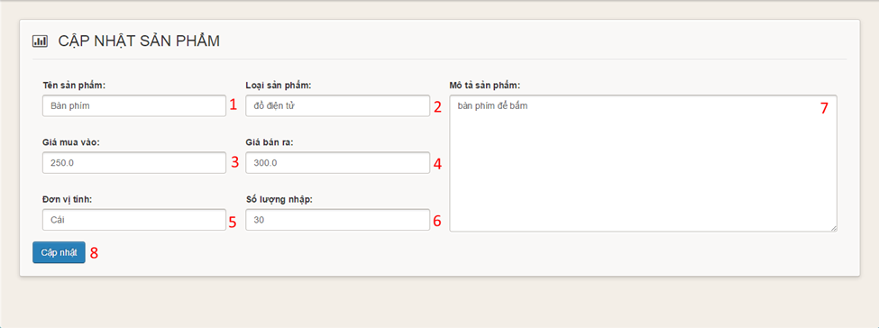

**Figure 12: Update Item**

**Fields**

|  |  |  |  |  |  |  |  |
| --- | --- | --- | --- | --- | --- | --- | --- |
| **No** | **Field Name** | **Description** | **Read only** | **Mandatory** | **Control Type** | **Data Type** | **Length** |
| 1 | Item name | Fill Item name | No | Yes | Textbox | String | N/A |
| 2 | Item type | Fill item type | No | Yes | Textbox | String | N/A |
| 3 | Supply price | Fill supply price | No | Yes | Textbox | String | N/A |
| 4 | Retail price | Fill retail price | No | Yes | Textbox | String | N/A |
| 5 | Item unit | Fill item unit | No | Yes | Textbox | String | N/A |
| 6 | Item quantity | Fill item quantity | No | Yes | Textbox | String | N/A |
| 7 | Description | Fill description | No | Yes | Text area | String | N/A |

**Buttons/Hyperlinks**

|  |  |  |  |  |
| --- | --- | --- | --- | --- |
| **No** | **Function** | **Description** | **Validation** | **Outcome** |
| 8 | Add | Click to update item | N/A | Transfer to manage item page |

#### Manage Employee

**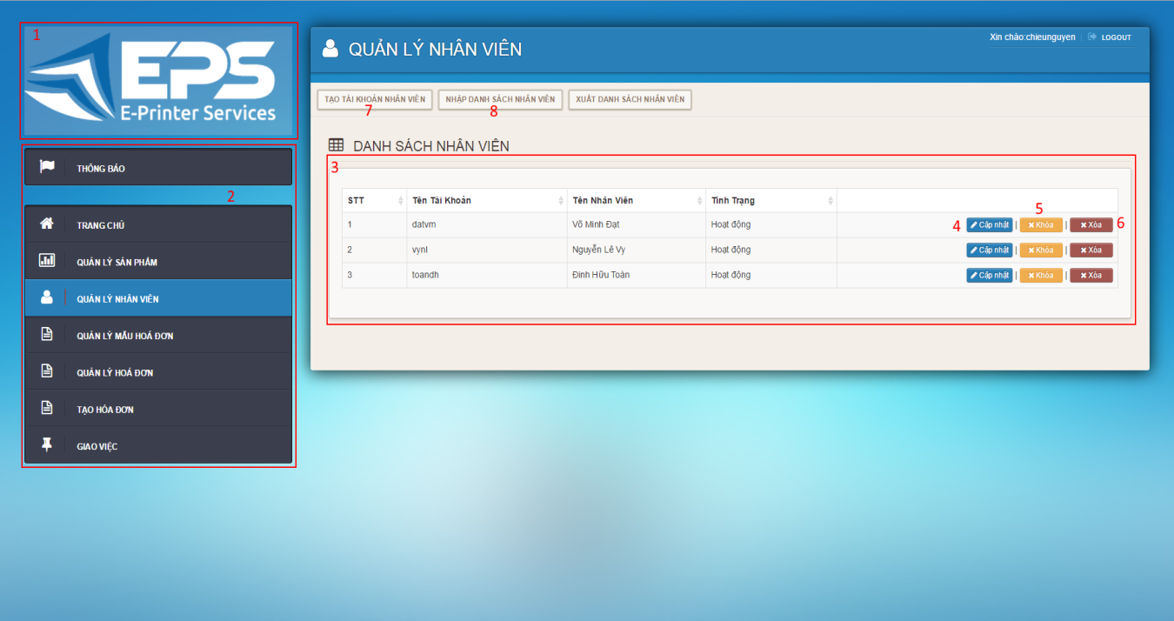Figure 13: Manage Employees**

**Fields**

|  |  |  |  |  |  |  |  |
| --- | --- | --- | --- | --- | --- | --- | --- |
| **No** | **Field Name** | **Description** | **Read only** | **Mandatory** | **Control Type** | **Data Type** | **Length** |
| 1 | Logo | Logo of the system | Yes | No | Image | Image | N/A |
| 2 | Menu | Navigation bar | No | No | Menu bar | N/A | N/A |
| 3 | Employee’s Table | Table to show employees | Yes | Yes | Data Table | N/A | N/A |

**Buttons/Hyperlinks**

|  |  |  |  |  |
| --- | --- | --- | --- | --- |
| **No** | **Function** | **Description** | **Validation** | **Outcome** |
| 4 | Update | Click to go to update employee page | N/A | Transfer to update employees page |
| 5 | Lock | Click to lock employee | N/A | Transfer to manage employees page |
| 6 | Delete | Delete an employee | N/A | Transfer to manage employees page |
| 7 | Add | Click to go to add employee page | N/A | Transfer to add employees page |
| 8 | Import Employees | Click to go to import employee page | N/A | Transfer to import employees page |

#### Add Employee

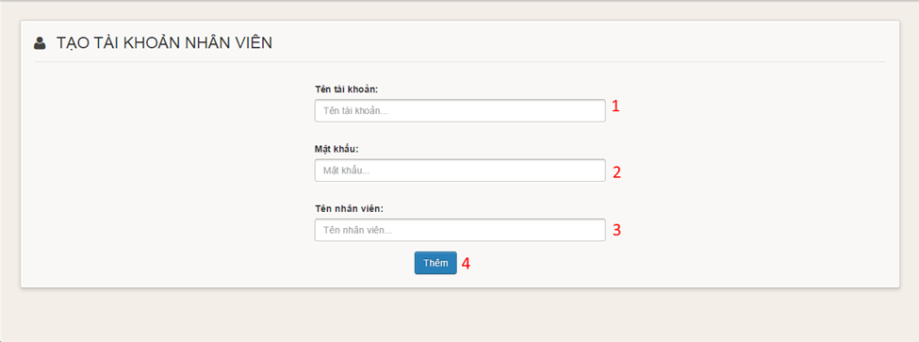

**Figure 14: Add Employee**

**Fields**

|  |  |  |  |  |  |  |  |
| --- | --- | --- | --- | --- | --- | --- | --- |
| **No** | **Field Name** | **Description** | **Read only** | **Mandatory** | **Control Type** | **Data Type** | **Length** |
| 1 | Username | Fill employee username | No | Yes | Textbox | String | N/A |
| 2 | Password | Fill employee password | No | Yes | Password | String | N/A |
| 3 | Full name | Fill employee full name | No | No | Textbox | String | N/A |

**Buttons/Hyperlinks**

|  |  |  |  |  |
| --- | --- | --- | --- | --- |
| **No** | **Function** | **Description** | **Validation** | **Outcome** |
| 4 | Add | Click to add employee | N/A | Transfer to manage employee page |

#### Import Employee

**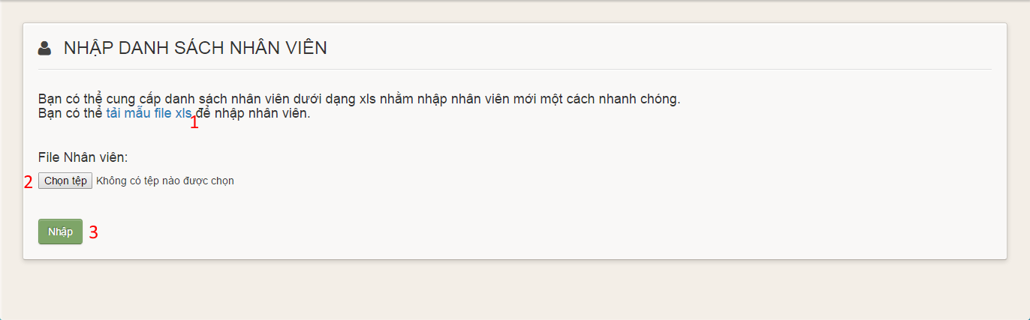Figure 15: Import Employee**

**Buttons/Hyperlinks**

|  |  |  |  |  |
| --- | --- | --- | --- | --- |
| **No** | **Function** | **Description** | **Validation** | **Outcome** |
| 1 | Employee template link | Click to download employee template | N/A | Download employee template |
| 2 | Choose file | Click to open choose file dialog | N/A | Display choose file dialog |
| 3 | Upload | Click to upload employees | N/A | Transfer to manage employees page |

#### Update Employee

**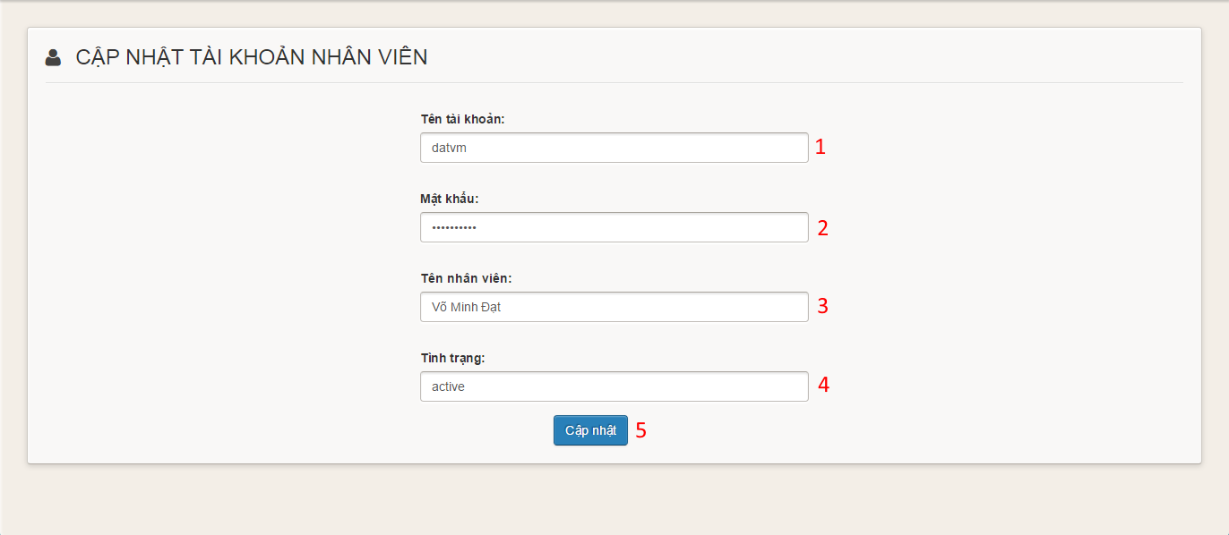**

**Figure 16: Update Employee**

**Fields**

|  |  |  |  |  |  |  |  |
| --- | --- | --- | --- | --- | --- | --- | --- |
| **No** | **Field Name** | **Description** | **Read only** | **Mandatory** | **Control Type** | **Data Type** | **Length** |
| 1 | Username | Fill employee username | No | Yes | Textbox | String | N/A |
| 2 | Password | Fill employee password | No | Yes | Password | String | N/A |
| 3 | Full name | Fill employee full name | No | No | Textbox | String | N/A |
| 4 | Status | Fill employee status | No | Yes | Combobox | String | N/A |

**Buttons/Hyperlinks**

|  |  |  |  |  |
| --- | --- | --- | --- | --- |
| **No** | **Function** | **Description** | **Validation** | **Outcome** |
| 5 | Add | Click to update employee | N/A | Transfer to manage employee page |

#### Storeowner Manage Templates

**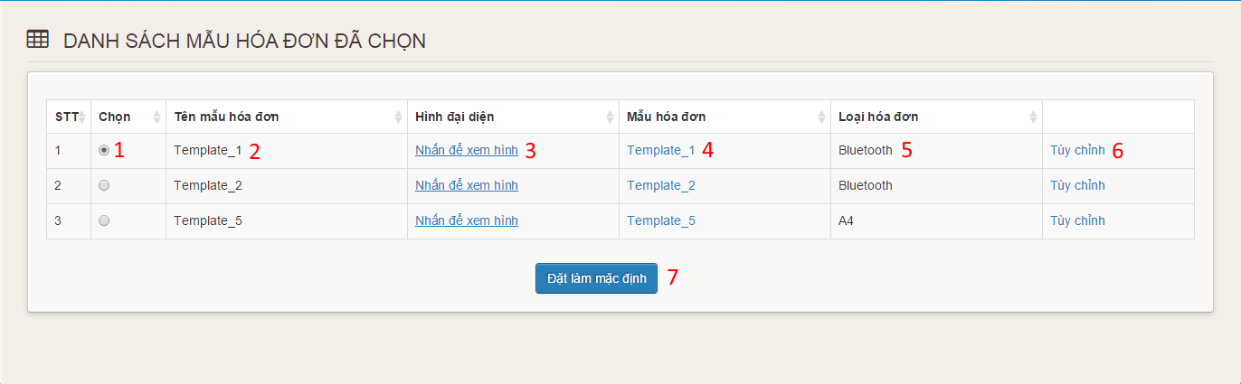**

**Figure 17: Storeowner Manage Templates**

**Fields**

|  |  |  |  |  |  |  |  |
| --- | --- | --- | --- | --- | --- | --- | --- |
| **No** | **Field Name** | **Description** | **Read only** | **Mandatory** | **Control Type** | **Data Type** | **Length** |
| 1 | Choose | Choose default template | No | Yes | Radiobutton | N/A | N/A |
| 2 | Template Name | Display name of template | Yes | Yes | Label | String | N/A |
| 3 | Image link | Click to view image | No | Yes | Link | String | N/A |
| 4 | Template link | Click to download template | No | Yes | Link | String | N/A |
| 5 | Type | Display type of template | Yes | Yes | Label | String | N/A |
| 6 | Customize | Click to go to customize page | No | Yes | Link | String | N/A |

**Buttons/Hyperlinks**

|  |  |  |  |  |
| --- | --- | --- | --- | --- |
| **No** | **Function** | **Description** | **Validation** | **Outcome** |
| 7 | Set Default | Click to set default template | N/A | Transfer to manage template page |

#### Customize Bluetooth Template

**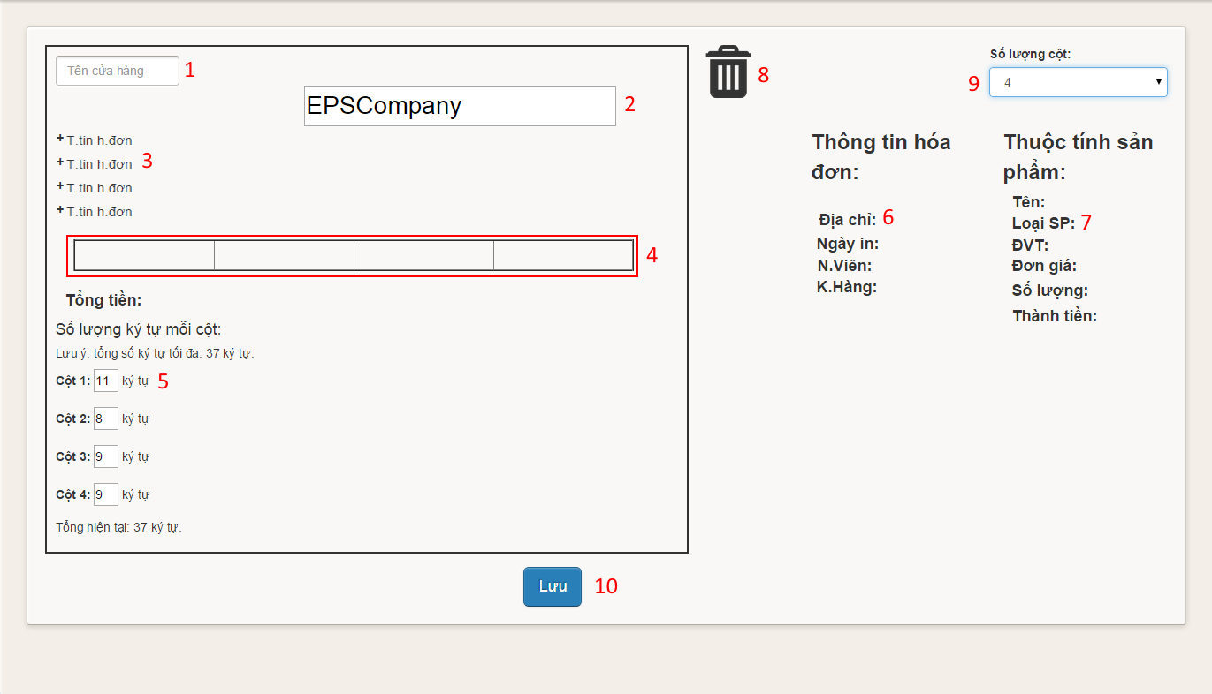**

**Figure 18: Customize Bluetooth Template**

**Fields**

|  |  |  |  |  |  |  |  |
| --- | --- | --- | --- | --- | --- | --- | --- |
| **No** | **Field Name** | **Description** | **Read only** | **Mandatory** | **Control Type** | **Data Type** | **Length** |
| 1 | Store Name | Fill store name | No | Yes | Textbox | String | N/A |
| 2 | Template Title | Fill template title | No | Yes | Textbox | String | N/A |
| 3 | Order Information Position | Fill order information | Yes | Yes | Label | String | N/A |
| 4 | Item Information Position | Fill item information | Yes | Yes | Table | N/A | N/A |
| 5 | Columns limit characters | Fill limit characters | No | Yes | Textbox | String | 2 |
| 6 | Order Information | Order Information | Yes | Yes | Image | Image | N/A |
| 7 | Item Information | Item Information | Yes | Yes | Image | Image | N/A |
| 8 | Trash | To remove information | Yes | Yes | Image | Image | N/A |
| 9 | Number Of Columns | Fill number of columns | No | Yes | Combobox | String | N/A |

**Buttons/Hyperlinks**

|  |  |  |  |  |
| --- | --- | --- | --- | --- |
| **No** | **Function** | **Description** | **Validation** | **Outcome** |
| 10 | Save | Click to customize template | N/A | Transfer to manage template page |

#### Customize A4 Template

**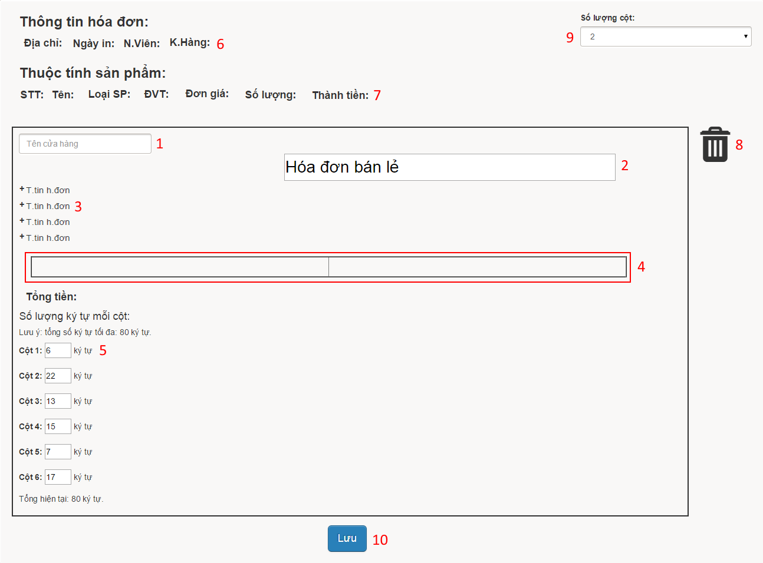**

**Figure 19: Customize A4 Template**

**Fields**

|  |  |  |  |  |  |  |  |
| --- | --- | --- | --- | --- | --- | --- | --- |
| **No** | **Field Name** | **Description** | **Read only** | **Mandatory** | **Control Type** | **Data Type** | **Length** |
| 1 | Store Name | Fill store name | No | Yes | Textbox | String | N/A |
| 2 | Template Title | Fill template title | No | Yes | Textbox | String | N/A |
| 3 | Order Information Position | Fill order information | Yes | Yes | Label | String | N/A |
| 4 | Item Information Position | Fill item information | Yes | Yes | Table | N/A | N/A |
| 5 | Columns limit characters | Fill limit characters | No | Yes | Textbox | String | 2 |
| 6 | Order Information | Order Information | Yes | Yes | Image | Image | N/A |
| 7 | Item Information | Item Information | Yes | Yes | Image | Image | N/A |
| 8 | Trash | To remove information | Yes | Yes | Image | Image | N/A |
| 9 | Number Of Columns | Fill number of columns | No | Yes | Combobox | String | N/A |

**Buttons/Hyperlinks**

|  |  |  |  |  |
| --- | --- | --- | --- | --- |
| **No** | **Function** | **Description** | **Validation** | **Outcome** |
| 10 | Save | Click to customize template | N/A | Transfer to manage template page |

#### Manage Order

**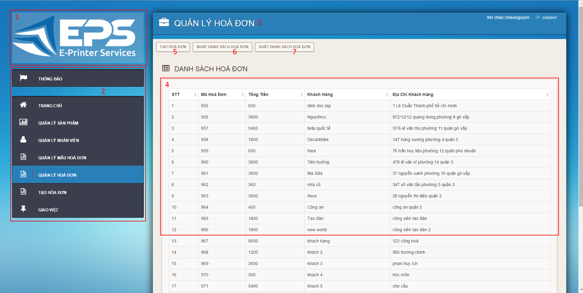**

**Figure 20: Manage Orders**

**Fields**

|  |  |  |  |  |  |  |  |
| --- | --- | --- | --- | --- | --- | --- | --- |
| **No** | **Field Name** | **Description** | **Read only** | **Mandatory** | **Control Type** | **Data Type** | **Length** |
| 1 | Logo | Logo of the system | Yes | No | Image | Image | N/A |
| 2 | Menu | Navigation bar | No | No | Menu bar | N/A | N/A |
| 3 | Title | Title of the page | Yes | Yes | Label | N/A | N/A |
| 4 | Order’s Table | Table to show orders | Yes | Yes | Data Table | N/A | N/A |

**Buttons/Hyperlinks**

|  |  |  |  |  |
| --- | --- | --- | --- | --- |
| **No** | **Function** | **Description** | **Validation** | **Outcome** |
| 5 | Create | Click to go to create order page | N/A | Transfer to create order page |
| 6 | Import | Click to go to import order page | N/A | Transfer to import order page |
| 7 | Export | Click to go to export order page | N/A | Transfer to export order page |

#### Create Order

##### C:\Users\NguyenCCSE60911\Desktop\CP Sreen Shot\CreateOrder1.pngCreate Order step 1

**Figure 21: Create Order step 1**

**Fields**

|  |  |  |  |  |  |  |  |
| --- | --- | --- | --- | --- | --- | --- | --- |
| **No** | **Field Name** | **Description** | **Read only** | **Mandatory** | **Control Type** | **Data Type** | **Length** |
| 1 | Choose Template | Click to choose template | No | Yes | Combobox | String | N/A |

**Buttons/Hyperlinks**

|  |  |  |  |  |
| --- | --- | --- | --- | --- |
| **No** | **Function** | **Description** | **Validation** | **Outcome** |
| 2 | Continue | Click to go to create order step 2 | N/A | Display create order step 2 |

##### Create Order step 2

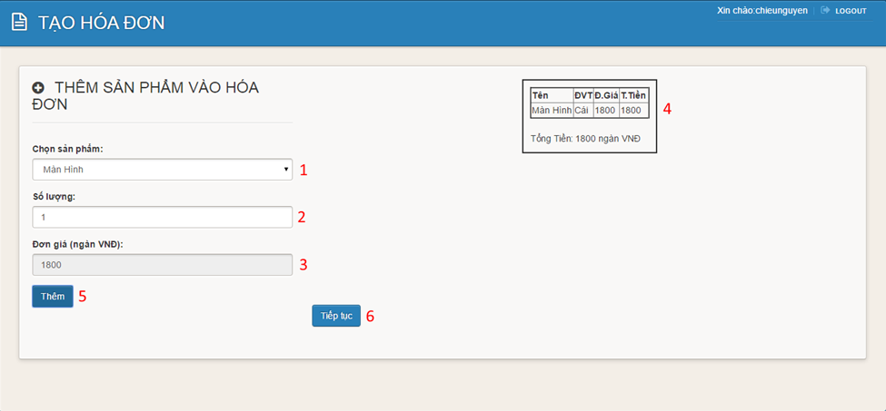

**Figure 22: Create Order step 2**

**Fields**

|  |  |  |  |  |  |  |  |
| --- | --- | --- | --- | --- | --- | --- | --- |
| **No** | **Field Name** | **Description** | **Read only** | **Mandatory** | **Control Type** | **Data Type** | **Length** |
| 1 | Choose Item | Click to item template | No | Yes | Combobox | String | N/A |
| 2 | Quantity | Fill quantity of item | No | Yes | Textbox | String | N/A |
| 3 | Price | Display price of item | Yes | Yes | Textbox | String | N/A |
| 4 | Order | Display order | Yes | Yes | Image | Image | N/A |

**Buttons/Hyperlinks**

|  |  |  |  |  |
| --- | --- | --- | --- | --- |
| **No** | **Function** | **Description** | **Validation** | **Outcome** |
| 5 | Add | Click to add item to order | N/A | Add item to order |
| 6 | Continue | Click to go to create order step 3 | N/A | Display create order step 3 |

##### Create Order step 3

**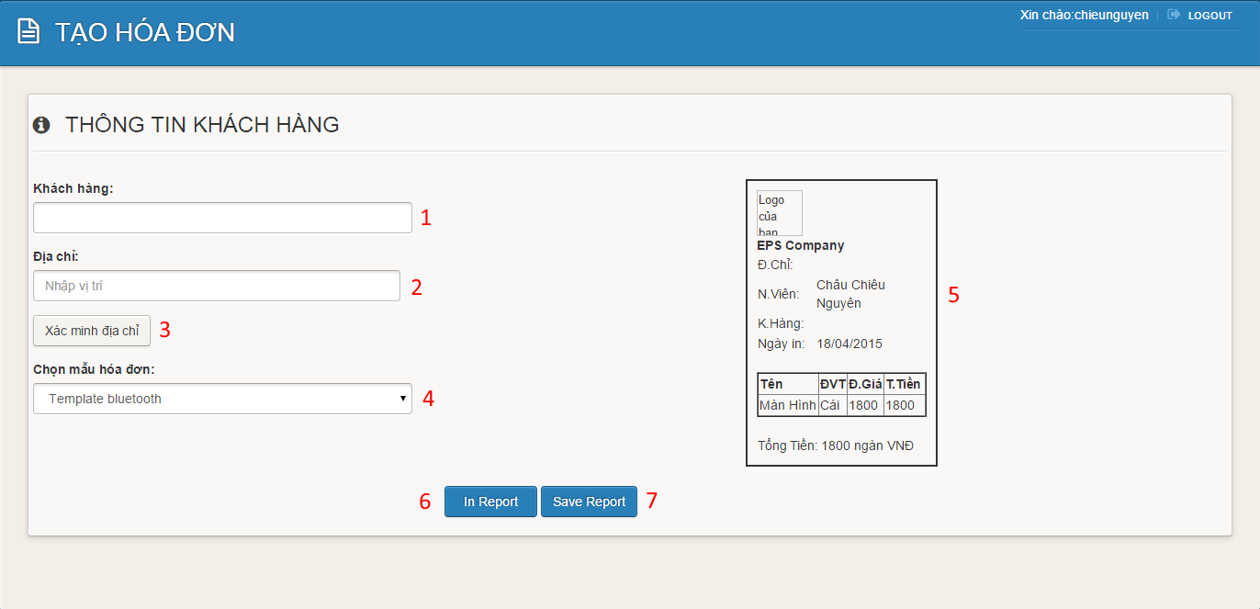Figure 23: Create Order step 3**

**Fields**

|  |  |  |  |  |  |  |  |
| --- | --- | --- | --- | --- | --- | --- | --- |
| **No** | **Field Name** | **Description** | **Read only** | **Mandatory** | **Control Type** | **Data Type** | **Length** |
| 1 | Customer Name | Fill customer name | No | Yes | Textbox | String | N/A |
| 2 | Address | Fill address of customer | No | Yes | Textbox | String | N/A |
| 4 | Choose Template | Click to choose template | No | Yes | Combobox | String | N/A |
| 5 | Order | Display order | Yes | Yes | Image | Image | N/A |

**Buttons/Hyperlinks**

|  |  |  |  |  |
| --- | --- | --- | --- | --- |
| **No** | **Function** | **Description** | **Validation** | **Outcome** |
| 3 | Confirm Address | Click to go to confirm address page | N/A | Transfer to confirm address page |
| 6 | Print | Click to go to print order page | N/A | Display print order page |
| 7 | Save | Click to save order | N/A | Transfer to manage order page |

#### Import Orders

**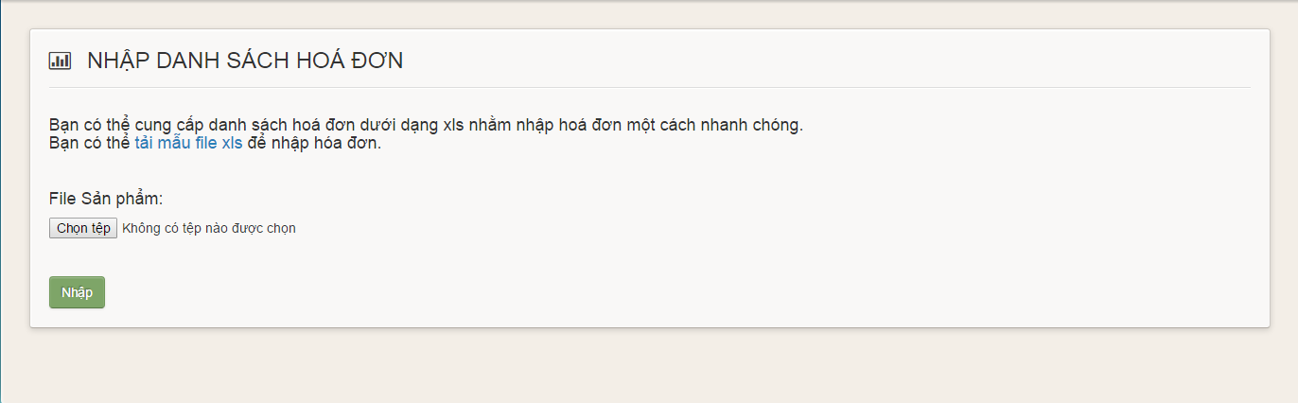Figure 24: Import Orders**

**Buttons/Hyperlinks**

|  |  |  |  |  |
| --- | --- | --- | --- | --- |
| **No** | **Function** | **Description** | **Validation** | **Outcome** |
| 1 | Order template link | Click to download order template | N/A | Download order template |
| 2 | Choose file | Click to open choose file dialog | N/A | Display choose file dialog |
| 3 | Upload | Click to upload orders | N/A | Transfer to manage orders page |

#### Assign Order

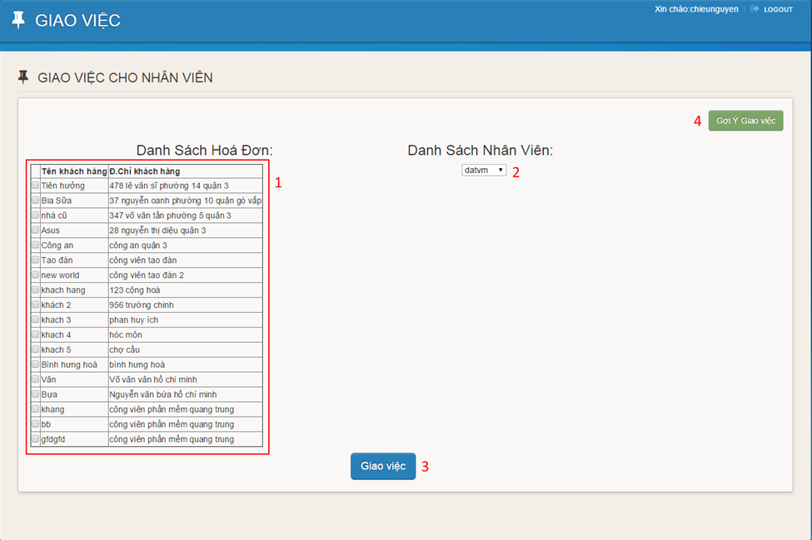

**Figure 25: Assign Order**

**Fields**

|  |  |  |  |  |  |  |  |
| --- | --- | --- | --- | --- | --- | --- | --- |
| **No** | **Field Name** | **Description** | **Read only** | **Mandatory** | **Control Type** | **Data Type** | **Length** |
| 1 | Order Table | Display orders | Yes | Yes | Data Table | N/A | N/A |
| 2 | Choose Employee | Click to choose employee | Yes | Yes | Combobox | String | N/A |

**Buttons/Hyperlinks**

|  |  |  |  |  |
| --- | --- | --- | --- | --- |
| **No** | **Function** | **Description** | **Validation** | **Outcome** |
| 3 | Assign Order | Click to assign order to employee | N/A | Transfer to storeowner home page |
| 4 | Suggest | Click to suggest assigning order | N/A | Transfer to suggesting page. |

#### Choose Template

**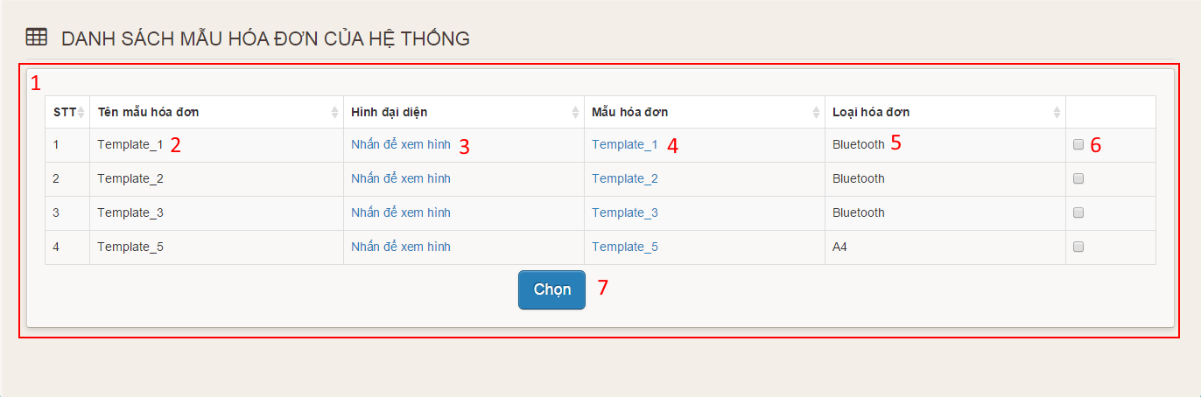**

**Figure 26: Choose Template**

**Fields**

|  |  |  |  |  |  |  |  |
| --- | --- | --- | --- | --- | --- | --- | --- |
| **No** | **Field Name** | **Description** | **Read only** | **Mandatory** | **Control Type** | **Data Type** | **Length** |
| 1 | Template Table | Display templates of the system | Yes | Yes | Data Table | N/A | N/A |
| 2 | Template Name | Display name of template | Yes | Yes | Label | String | N/A |
| 3 | Image link | Click to view image | No | Yes | Link | String | N/A |
| 4 | Template link | Click to download template | No | Yes | Link | String | N/A |
| 5 | Type | Display type of template | Yes | Yes | Label | String | N/A |
| 6 | Choose | Click choose template | No | Yes | Checkbox | N/A | N/A |

**Buttons/Hyperlinks**

|  |  |  |  |  |
| --- | --- | --- | --- | --- |
| **No** | **Function** | **Description** | **Validation** | **Outcome** |
| 7 | Choose | Click to choose template | N/A | Transfer to manage template page |

### Employee Interface Design

#### Login screen

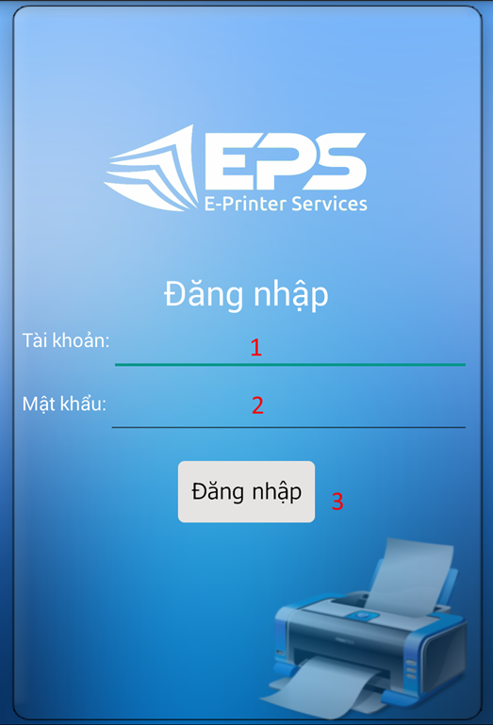

**Figure 27: Mobile Login**

**Fields**

|  |  |  |  |  |  |  |  |
| --- | --- | --- | --- | --- | --- | --- | --- |
| **No** | **Field Name** | **Description** | **Read only** | **Mandatory** | **Control Type** | **Data Type** | **Length** |
| 1 | Username | Fill username | No | Yes | Textbox | String | N/A |
| 2 | Password | Fill password | No | Yes | Password | String | N/A |

**Buttons/Hyperlinks**

|  |  |  |  |  |
| --- | --- | --- | --- | --- |
| **No** | **Function** | **Description** | **Validation** | **Outcome** |
| 3 | Sign in | Log-in into the Android application | N/A | Transfer to menu screen |

#### Menu screen

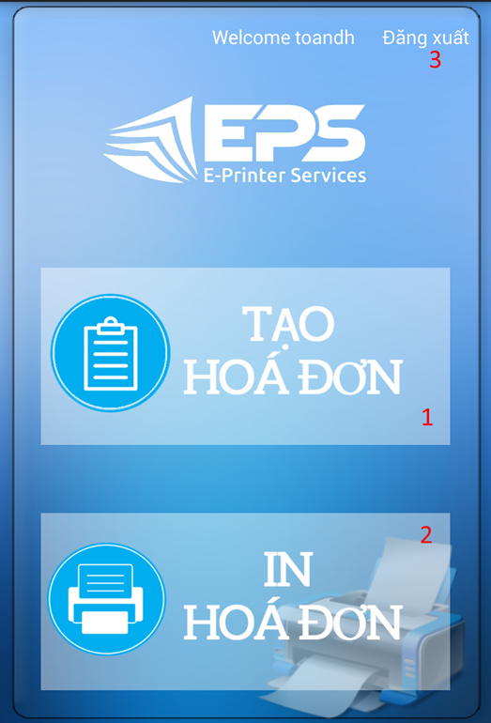

**Figure 28: Mobile Menu**

**Buttons/Hyperlinks**

|  |  |  |  |  |
| --- | --- | --- | --- | --- |
| **No** | **Function** | **Description** | **Validation** | **Outcome** |
| 1 | Create order | Touch to go to create order screen | N/A | Transfer to create order screen |
| 2 | Print order | Touch to go to view order screen | N/A | Transfer to view order screen |
| 3 | Logout link | Touch to logout | N/A | Transfer to login screen |

#### Create Order

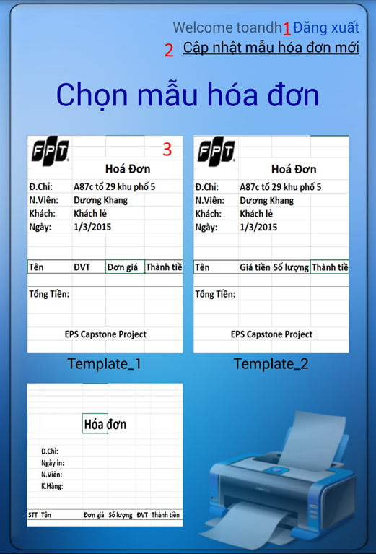

**Figure 29: Create Order**

**Buttons/Hyperlinks**

|  |  |  |  |  |
| --- | --- | --- | --- | --- |
| **No** | **Function** | **Description** | **Validation** | **Outcome** |
| 1 | Logout link | Touch to logout | N/A | Transfer to login screen |
| 2 | Update templates link | Touch to update templates | N/A | Display new templates |
| 3 | Image of template | Touch to choose template | N/A | Transfer to input item screen |

#### Input Item Screen

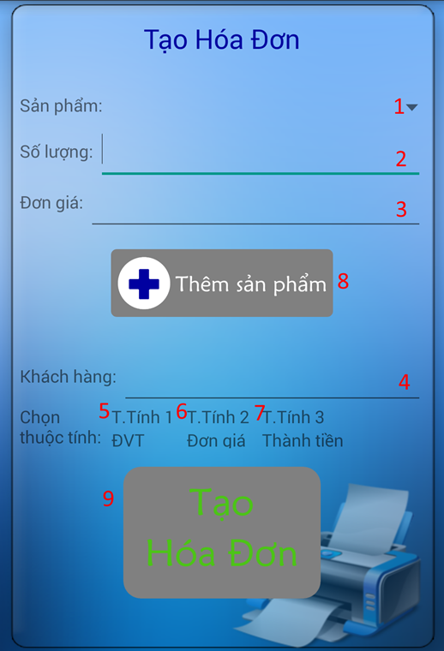

**Figure 30: Input Item**

**Fields**

|  |  |  |  |  |  |  |  |
| --- | --- | --- | --- | --- | --- | --- | --- |
| **No** | **Field Name** | **Description** | **Read only** | **Mandatory** | **Control Type** | **Data Type** | **Length** |
| 1 | Item | Choose item | No | Yes | Combo box | String | N/A |
| 2 | Quantity | Fill quantity | No | Yes | Textbox | String | N/A |
| 3 | Price | Display price | Yes | Yes | Textbox | String | N/A |
| 4 | Customer name | Fill customer name | No | No | Textbox | String | N/A |

**Buttons/Hyperlinks**

|  |  |  |  |  |
| --- | --- | --- | --- | --- |
| **No** | **Function** | **Description** | **Validation** | **Outcome** |
| 5 | Attribute 1 | Touch to choose attribute 1 | N/A | Display attribute 1 |
| 6 | Attribute 2 | Touch to choose attribute 2 | N/A | Display attribute 2 |
| 7 | Attribute 3 | Touch to choose attribute 3 | N/A | Display attribute 3 |
| 8 | Add item | Touch to add item to order | N/A | Display message “Đã thêm”. |
| 9 | Create order | Touch to create order | N/A | Transfer to view order screen |

#### View Order screen

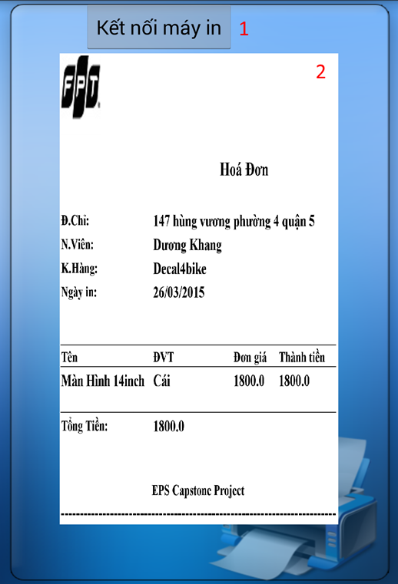

**Figure 31: View Order**

**Fields**

|  |  |  |  |  |  |  |  |
| --- | --- | --- | --- | --- | --- | --- | --- |
| **No** | **Field Name** | **Description** | **Read only** | **Mandatory** | **Control Type** | **Data Type** | **Length** |
| 2 | Order Image | Display order image | Yes | Yes | Image | Image | N/A |

**Buttons/Hyperlinks**

|  |  |  |  |  |
| --- | --- | --- | --- | --- |
| **No** | **Function** | **Description** | **Validation** | **Outcome** |
| 1 | Connect Printer | Touch to connect to printer | N/A | Transfer to search printer screen. |

#### Search Printer

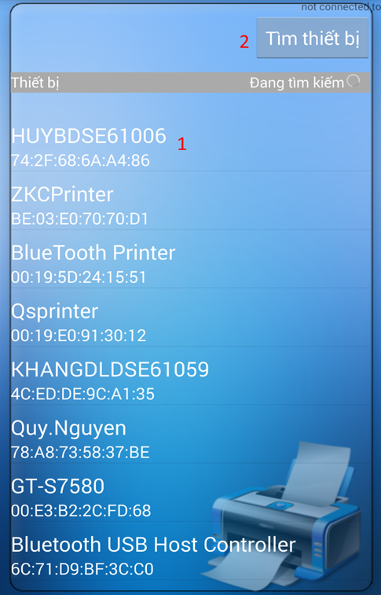

**Figure 32: Search Printer**

**Buttons/Hyperlinks**

|  |  |  |  |  |
| --- | --- | --- | --- | --- |
| **No** | **Function** | **Description** | **Validation** | **Outcome** |
| 1 | Printer | Touch to connect to printer | N/A | Transfer to print screen. |
| 2 | Search | Touch to search printer | N/A | Display list of printer |

#### Print Order

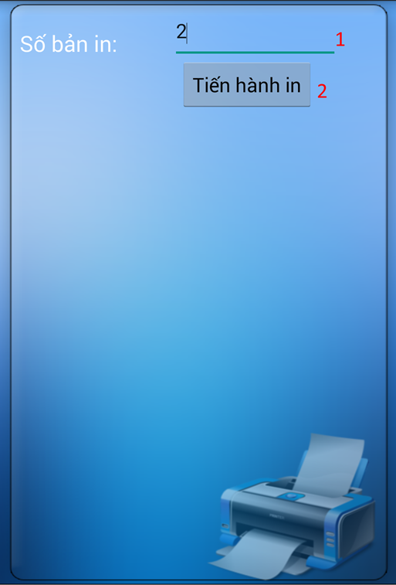

**Figure 33: Print Order**

**Fields**

|  |  |  |  |  |  |  |  |
| --- | --- | --- | --- | --- | --- | --- | --- |
| **No** | **Field Name** | **Description** | **Read only** | **Mandatory** | **Control Type** | **Data Type** | **Length** |
| 1 | Number of copies | Fill number of copies | No | Yes | Textbox | Number | N/A |

**Buttons/Hyperlinks**

|  |  |  |  |  |
| --- | --- | --- | --- | --- |
| **No** | **Function** | **Description** | **Validation** | **Outcome** |
| 2 | Print | Touch to print order | N/A | N/A |

#### View Order Information

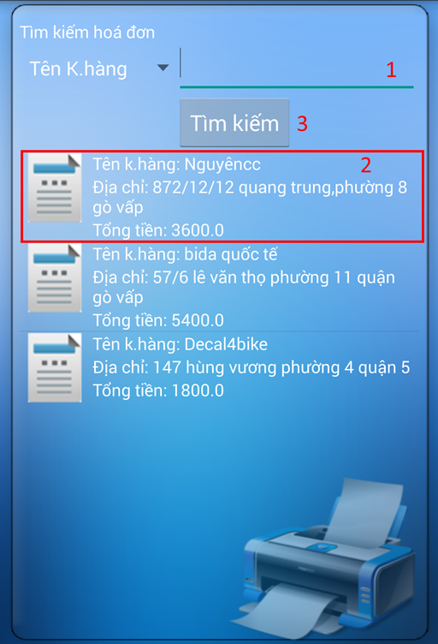

**Figure 34: View Order Information**

**Fields**

|  |  |  |  |  |  |  |  |
| --- | --- | --- | --- | --- | --- | --- | --- |
| **No** | **Field Name** | **Description** | **Read only** | **Mandatory** | **Control Type** | **Data Type** | **Length** |
| 1 | Customer name | Fill keywords to search | No | Yes | Textbox | String | N/A |

**Buttons/Hyperlinks**

|  |  |  |  |  |
| --- | --- | --- | --- | --- |
| **No** | **Function** | **Description** | **Validation** | **Outcome** |
| 2 | Order link | Touch to choose order | N/A | Transfer to choose template screen |
| 3 | Search | Touch to search order based on customer name | N/A | Display order |

#### Choose Template

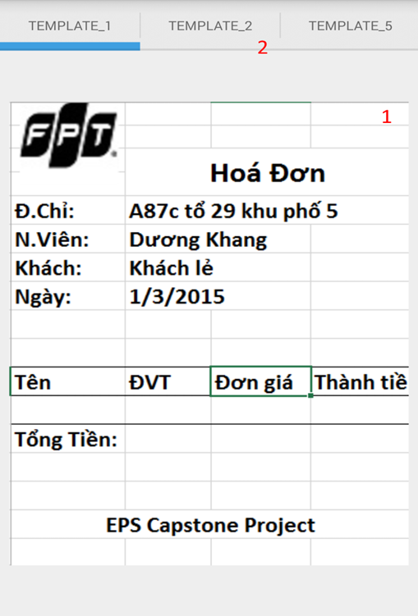

**Figure 35: Choose Template**

**Fields**

|  |  |  |  |  |  |  |  |
| --- | --- | --- | --- | --- | --- | --- | --- |
| **No** | **Field Name** | **Description** | **Read only** | **Mandatory** | **Control Type** | **Data Type** | **Length** |
| 1 | Menu | Display name of template | Yes | Yes | Menu | N/A | N/A |

**Buttons/Hyperlinks**

|  |  |  |  |  |
| --- | --- | --- | --- | --- |
| **No** | **Function** | **Description** | **Validation** | **Outcome** |
| 2 | Template Image | Touch to choose template | N/A | Transfer to view order screen |

## Database Design

### Logical Diagram

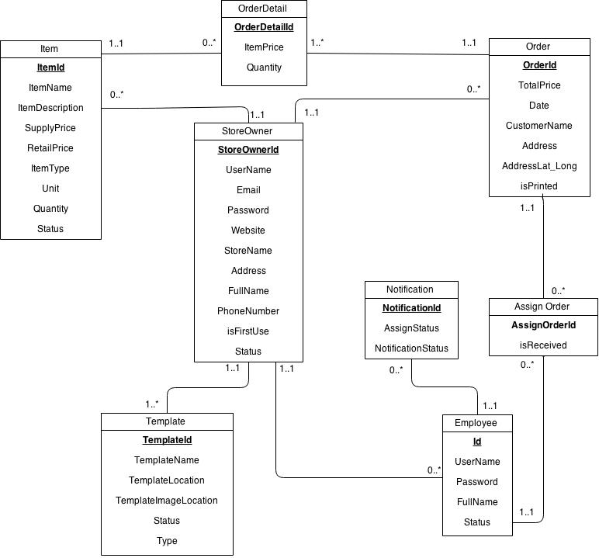

Figure 51: Logical Diagram

### Data Dictionary

|  |  |
| --- | --- |
| **Entity Data dictionary: describe content of all entities** | |
| Entity Name | Description |
| Items | Describe all Items in the system. |
| Store Owner | Describe all StoreOwners in the system. |
| Template | Describe all Templates available in the system. |
| Employee | Describe all Employees in the system. |
| Order | Describe all Order in the system. |
| Order Detail | Describe all Order Details in the system. |
| Notification | Describe all Notifications in the system. |
| Assign Order | Describe all templates available in the system. |

Table 7: Entity Data Dictionary

|  |  |  |  |  |
| --- | --- | --- | --- | --- |
| **Entity name** | **Attributes** | **Description** | **Domain** | **Null** |
| Store Owner | StoreOwnerId | Unique identifier of StoreOwner, auto increment. | int | No |
| UserName | StoreOwner’s username. | nvarchar(50) | No |
| Email | StoreOwner’s email address. | nvarchar(50) | No |
| Password | StoreOwner’s password. | nvarchar(50) | No |
| Website | StoreOwner’s website address. | nvarchar(50) | Yes |
| StoreName | Name of the store. | nvarchar(50) | No |
| Address | The address of StoreOwner. | nvarchar(100) | No |
| FullName | Full name of StoreOwner. | nvarchar(100) | No |
| PhoneNumber | Phone number of StoreOwner. | int | No |
| isFirstUse | Value to check whether StoreOwner log in for the first time or not. | bit | No |
| Status | Status of StoreOwner. | nchar(10) | No |
| Employee | Id | Unique identifier of employee, auto increment. | int | No |
| UserName | Employee’s username. | nchar(20) | No |
| Password | Employee’s password. | nchar(10) | No |
| FullName | Employee’s full name. | nvarchar(50) | Yes |
| Status | Status of employee. | nchar(20) | No |
| Item | ItemId | Unique identifier of item, auto increment. | int | No |
| ItemName | Name of an item. | nvarchar(100) | No |
| ItemDescription | Description about an item. | nvarchar(500) | Yes |
| SupplyPrice | Supply price of item. | float | No |
| RetailPrice | Retail price of item. | float | No |
| ItemType | Type of item. | nvarchar(50) | No |
| Unit | Unit of an item. | nvarchar(50) | No |
| Quantity | Quantity of item in store. | int | No |
| Status | Status of an item. | nchar(10) | No |
| Template | TemplateId | Unique identifier of template, auto increment. | int | No |
| TemplateName | Name of template. | nvarchar(50) | No |
| TemplateLocation | Location of template on server. | nvarchar(260) | No |
| TemplateImageLocation | Location of image template on server. | nvarchar(260) | No |
| Status | Status of template. | nvarchar(20) | No |
| Type | Type of template. | nchar(10) | No |
| Order | OrderId | Unique identifier of order, auto increment. | int | No |
| TotalPrice | Total price of order. | float | No |
| Date | Date order made. | datetime | No |
| CustomerName | Name of the customer. | nvarchar(30) | No |
| Address | Address of customer. | nvarchar(100) | No |
| AddressLat\_Long | Latitude and longitude of address. | varchar(100) | No |
| isPrinted | Value to check whether the order is printed or not. | bit | No |
| OrderDetail | OrderDetailId | Unique identifier of orderdetail, auto increment. | int | No |
| ItemPrice | Price of an item in orderdetail. | float | No |
| Quantity | Quantity of items in order. | int | No |
| Notification | NotificationId | Unique identifier of notification, auto increment. | int | No |
| AssignStatus | Status of job assigned to employee | bit | No |
| NotificationStatus | Status of notification | bit | No |
| AssignOrder | AssignOrderId | Unique identifier of AssignOrder,auto increment | bit | No |
| isReceived | Status of each assign order | bit | No |

Table 8: Detail Data Dictionary

\* Business integrity constraint:

- StoreOwner only can access to their items, employees and orders.

## Algorithms

### K-Medoids Algorithm

#### Definition

K-Medoids algorithm is clustering algorithm, which attempt to partition and minimize the distance between point labeled to be in a cluster and a point designated as the center of that cluster (called medoid).

*K-Medoids (http://en.wikipedia.org/wiki/K-medoids)*

#### Definition Problem

Incase StoreOwner want to assign order for their employees, but they cannot determine the orders located in the map to calculate the distance between each order and make a suitable assignment. Therefore, my Orders Suggest System that has implement K-medoids algorithm can help them do that.

#### Solution

To slove this problem, we can use K-Medoids algorithm to cluster orders. Each order comes with an address which we will convert it to geocoding format (latitude, longitude) using Google Map API.

* First, we need to prepair a list of medoids by select k elements in Order list:

Length of list is: 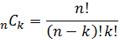 . Where n is the number of Order and k is number of cluster.

* -Second, begin the K-medoids algorithm to cluster order into K group and find best medoids.

#### Complexity

In total, complexity of this algorithm is **O(n^2)**

* n: number of point.

#### Flowchart

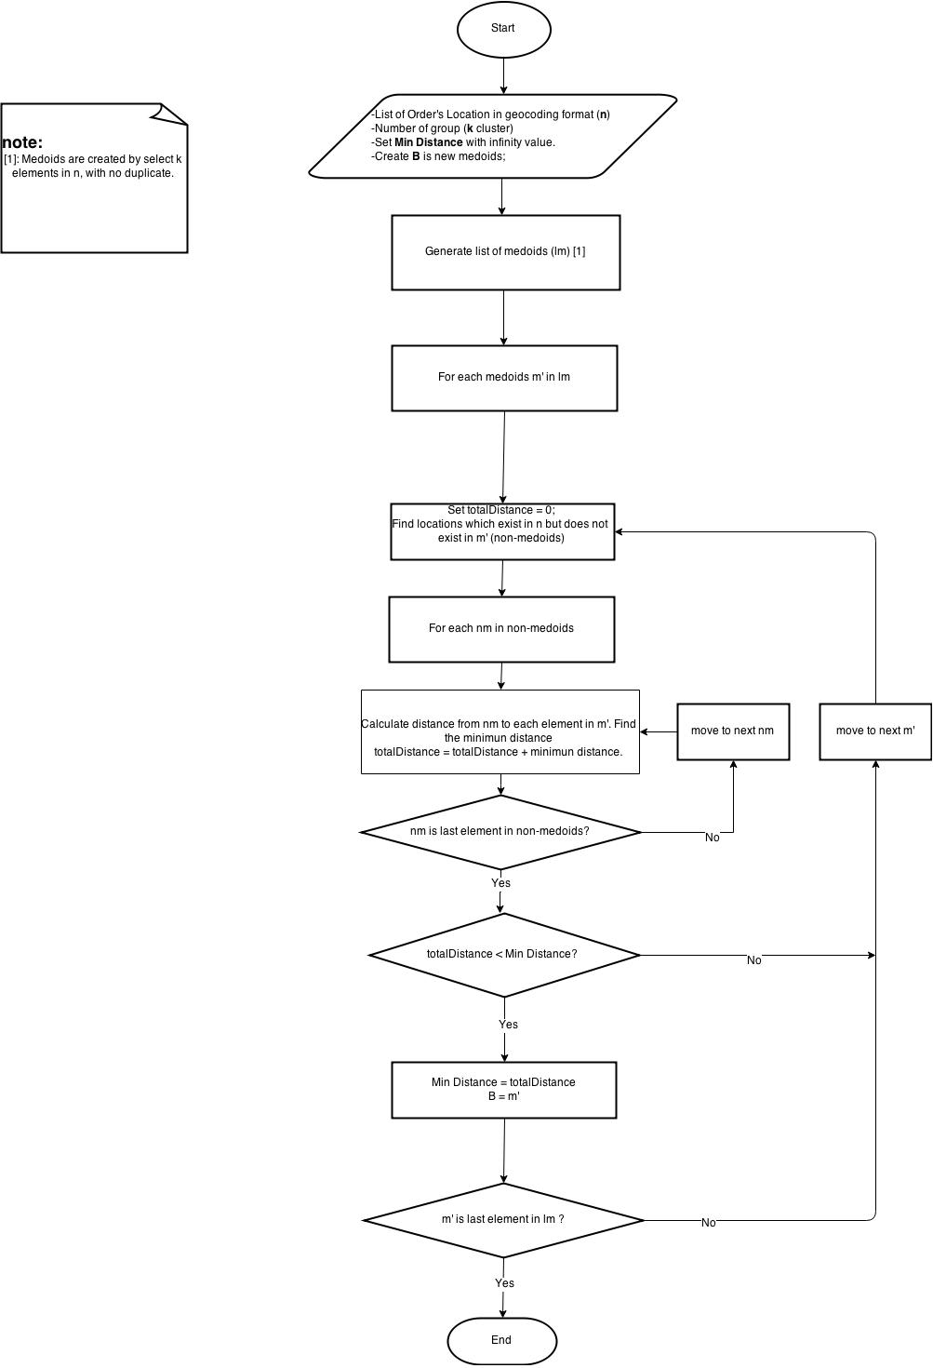

### Create a printable order

#### Definition Problem

Mini Bluetooth printer that we using only support print non-unicode text and image, with image it must be decode using manufacturer library before you want to print it. So if we want to print order in excel format we need to find a way to convert it to a format which printer can understand.

#### Solution

To achieve the goal above, I’m using some helper class from **Apache POI** to convert excel file an html file then use another library called **Html2Image** to convert a Html file to image, and now every become esier than before.

#### Flowchart

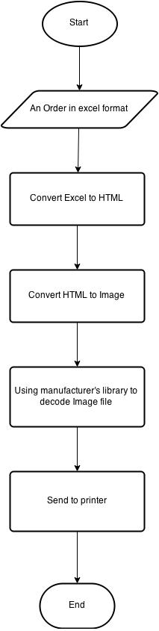

# Report No. 5 System Implementation & Test

## Introduction

### Overview

This section contains in detail of all necessary information about system implementation and testing of EPS System includes all test plans, test cases, test results and test environment.

### Test Approach

- Goal: To test the whole system based on the core flow.

- Method: System testing, Black box testing.

## Database Relationship Diagram

### Physical Diagram

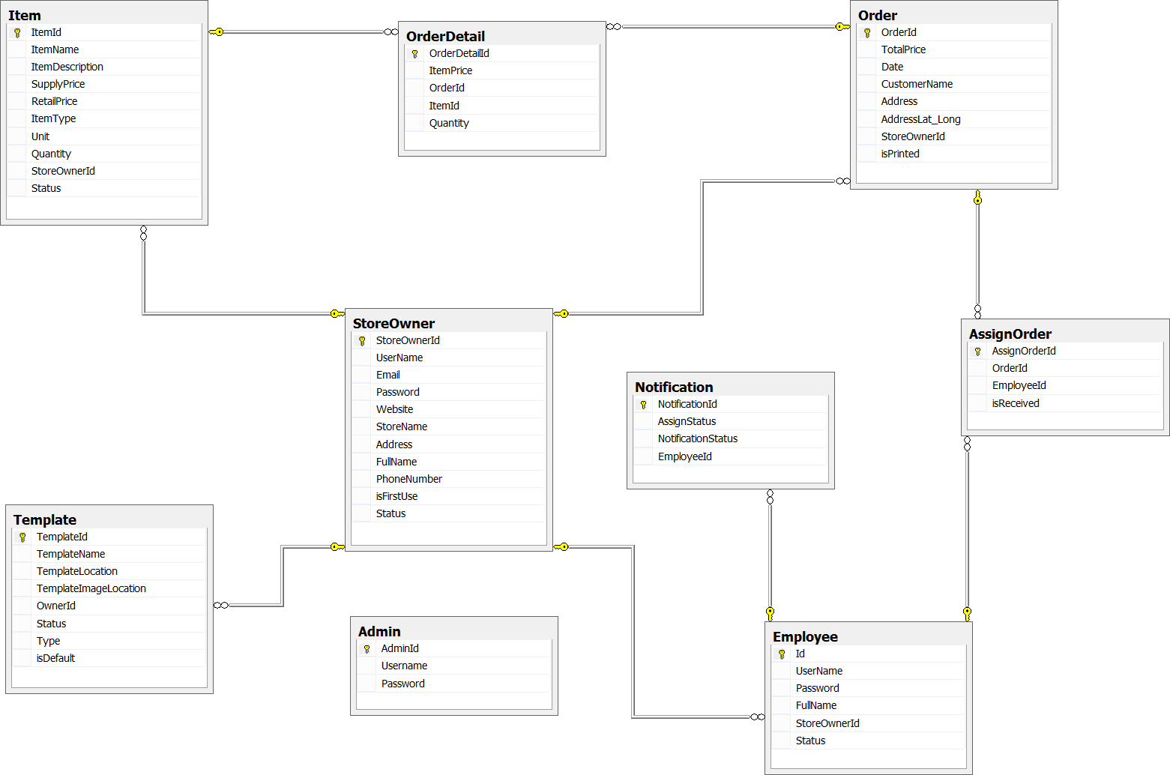Figure 52: Physical Database Diagram

### Data Dictionary

|  |  |
| --- | --- |
| **Entity Data dictionary: describe content of all entities** | |
| Entity Name | Description |
| Store Owner | Describe all storeowner profiles in the system. |
| Employee | Describe all employee profiles in the system. |
| Item | Describe all items stored in the system. |
| Template | Describe all templates available in the system. |
| Order | Describe all order of store in the system. |
| Order Detail | Describe all order detail in the system |
| Notification | Describe all notification of storeowner and employee in the system. |
| AssignOrder | Describe all assignments of orders to employee |

|  |  |  |  |  |
| --- | --- | --- | --- | --- |
| **Entity name** | **Attributes** | **Description** | **Domain** | **Null** |
| Store Owner | StoreOwnerId | Unique identifier of storeowner, auto increment. | int | No |
| UserName | Storeowner’s username. | nvarchar(50) | No |
| Email | Storeowner’s email address. | nvarchar(50) | No |
| Password | Storeowner’s password. | nvarchar(50) | No |
| Website | Storeowner’s website address. | nvarchar(50) | Yes |
| StoreName | Name of the store. | nvarchar(50) | No |
| Address | The address of storeowner. | nvarchar(100) | No |
| FullName | Full name of storeowner. | nvarchar(100) | No |
| PhoneNumber | Phone number of storeowner. | int | No |
| isFirstUse | Value to check whether storeowner log in for the first time or not. | bit | No |
| Status | Status of storeowner. | nchar(10) | No |
| Employee | Id | Unique identifier of employee, auto increment. | int | No |
| UserName | Employee’s username. | nchar(20) | No |
| Password | Employee’s password. | nchar(10) | No |
| FullName | Employee’s full name. | nvarchar(50) | Yes |
| StoreOwnerId | Id of storeowner | int | No |
| Status | Status of employee. | nchar(20) | No |
| Item | ItemId | Unique identifier of item, auto increment. | int | No |
| ItemName | Name of an item. | nvarchar(100) | No |
| ItemDescription | Description about an item. | nvarchar(500) | Yes |
| SupplyPrice | Supply price of item. | float | No |
| RetailPrice | Retail price of item. | float | No |
| ItemType | Type of item. | nvarchar(50) | No |
| Unit | Unit of an item. | nvarchar(50) | No |
| Quantity | Quantity of item in store. | int | No |
| StoreOwnerId | Id of storeowner | int | No |
| Status | Status of an item. | nchar(10) | No |
| Template | TemplateId | Unique identifier of template, auto increment. | int | No |
| TemplateName | Name of template. | nvarchar(50) | No |
| TemplateLocation | Location of template on server. | nvarchar(260) | No |
| TemplateImageLocation | Location of image template on server. | nvarchar(260) | No |
| OwnerId | Id of template’s owner | int | No |
| Status | Status of template. | nvarchar(20) | No |
| Type | Type of template. | nchar(10) | No |
| isDefault | Value to check whether template is a default template | bit | No |
| Order | OrderId | Unique identifier of order, auto increment. | int | No |
| TotalPrice | Total price of order. | float | No |
| Date | Date order made. | datetime | No |
| CustomerName | Name of the customer. | nvarchar(30) | No |
| Address | Address of customer. | nvarchar(100) | No |
| AddressLat\_Long | Latitude and longitude of address. | varchar(100) | No |
| StoreOwnerId | Id of storeowner | int | No |
| isPrinted | Value to check whether the order is printed or not. | bit | No |
| OrderDetail | OrderDetailId | Unique identifier of orderdetail, auto increment. | int | No |
| ItemPrice | Price of an item in orderdetail. | float | No |
| OrderId | Id of order | int | No |
| ItemId | Id of item | int | No |
| Quantity | Quantity of items in order. | int | No |
| Notification | NotificationId | Unique identifier of notification, auto increment. | int | No |
| AssignStatus | Status of job assigned to employee | bit | No |
| NotificationStatus | Status of notification | bit | No |
| EmployeeId | Id of employee | int | No |
| AssignOrder | AssignOrderId | Unique identifier of assign order, auto increment. | int | No |
| OrderId | Id of Order | int | No |
| EmployeeId | Id of Employee | int | No |
| isReceived | Value to check whether the order is received or not. | bit | No |
| Admin | AdminId | Unique identifier of admin, auto increment. | int | No |
| Username | Username of admin | nvarchar(20) | No |
| Password | Password of admin | nvarchar(10) | No |

## Performance Measurement

**3.1 Suggest Assigned Order**

The complexity of K-medoid is **O (n^2),** therefore the performance of this system will depend on the number of n, in this case it is an Order. The system will return result really fast with small number of Order (less than 20 orders).

## Test Plan

### Features to be tested:

We will test the entire system based on the following core workflow (Reference: Figure: Core Flow).

Based on the workflow, all following features will be tested, which can include one or more functions. These features will be focused and tested thoroughly during the test phase.

* Storeowner: Choose template, import items, import employee, import existed orders, assign orders to employee, set default template, customize template, and create order.
* Employee: Download template, confirm order, decline order, print order, and create order.

### Features not to be tested:

* Register, login, logout.
* Manage templates, manage items, manage employees, and manage storeowners.
* Suggest assigning orders.

## System Testing Test Case

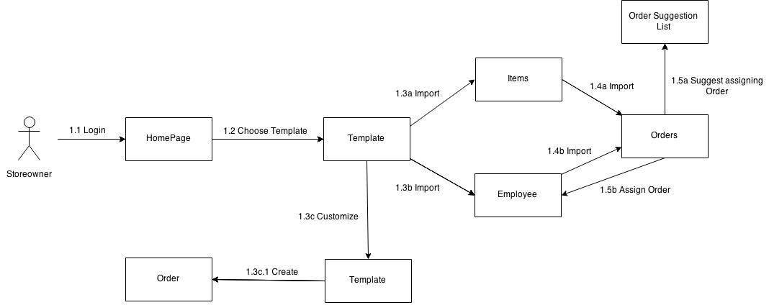

Figure 1: Storeowner Core Flow

**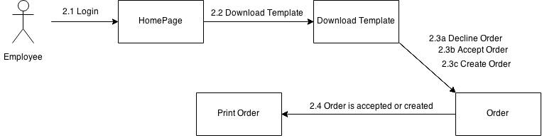**

Figure 2: Employee Core Flow

### Storeowner Core Flow

#### Choose Template

|  |  |  |  |  |  |  |  |
| --- | --- | --- | --- | --- | --- | --- | --- |
| **ID** | **Test Case Description** | **Test Case Procedure** | **Expected output** | **Inter-test Case Dependence** | **Result** | **Test Date** | **Note** |
| CT01 | Storeowner choose one template. | 1. After login for the first time, storeowner choose “Template\_1”.  2. Storeowner clicks “Chọn” button. | * After step 2, navigate to manage template page and display templates table with “Template\_1” in it. | N/A | Passed | 17/04/2015 |  |
| CT02 | Storeowner choose three templates. | 1. After login for the first time, storeowner choose “Template\_1”, “Template\_2” and “Template\_5”  2. Storeowner clicks “Chọn” button. | * After step 2, navigate to manage template page and display templates table with “Template\_1”, “Template\_2” and “Template\_5” in it. | N/A | Passed | 17/04/2015 |  |

#### Import Items

|  |  |  |  |  |  |  |  |
| --- | --- | --- | --- | --- | --- | --- | --- |
| **ID** | **Test Case Description** | **Test Case Procedure** | **Expected output** | **Inter-test Case Dependence** | **Result** | **Test Date** | **Note** |
| II01 | Storeowner upload Excel file with correct form. | 1. Storeowner opens import items page and choose excel file with correct form.  2. Storeowner clicks “Tải lên” button. | * After step 2, navigate to manage items page and display table with items in it | N/A | Passed | 17/04/2015 |  |
| II02 | Storeowner upload blank Excel file. | 1. Storeowner opens import items page and choose excel file which contains nothing.  2. Storeowner clicks “Tải lên” button. | * After step 2, show alert dialog with message: “Vui lòng chọn file có dữ liệu”. | N/A | Passed | 17/04/2015 |  |
| II03 | Storeowner upload image file. | 1. Storeowner opens import items page and choose an image file  2. Storeowner clicks “Tải lên” button. | * After step 2, show alert dialog with message: “Vui lòng chọn file Excel”. | N/A | Passed | 17/04/2015 |  |

#### Import Employees

|  |  |  |  |  |  |  |  |
| --- | --- | --- | --- | --- | --- | --- | --- |
| **ID** | **Test Case Description** | **Test Case Procedure** | **Expected output** | **Inter-test Case Dependence** | **Result** | **Test Date** | **Note** |
| IE01 | Storeowner upload Excel file with correct form. | 1. Storeowner opens import employees page and choose excel file with correct form.  2. Storeowner clicks “Tải lên” button. | * After step 2, navigate to manage employees page and display table with employees in it | N/A | Passed | 17/04/2015 |  |
| IE02 | Storeowner upload blank Excel file. | 1. Storeowner opens import employees page and choose excel file which contains nothing.  2. Storeowner clicks “Tải lên” button. | * After step 2, show alert dialog with message: “Vui lòng chọn file có dữ liệu”. | N/A | Passed | 17/04/2015 |  |
| IE03 | Storeowner upload image file. | 1. Storeowner opens import employees page and choose an image file  2. Storeowner clicks “Tải lên” button. | * After step 2, show alert dialog with message: “Vui lòng chọn file Excel”. | N/A | Passed | 17/04/2015 |  |

#### Import Orders

|  |  |  |  |  |  |  |  |
| --- | --- | --- | --- | --- | --- | --- | --- |
| **ID** | **Test Case Description** | **Test Case Procedure** | **Expected output** | **Inter-test Case Dependence** | **Result** | **Test Date** | **Note** |
| IO01 | Storeowner upload Excel file with correct form. | 1. Storeowner opens import orders page and choose excel file with correct form.  2. Storeowner clicks “Tải lên” button. | * After step 2, navigate to manage orders page and display table with orders in it | II01 | Passed | 17/04/2015 |  |
| IO02 | Storeowner upload blank Excel file. | 1. Storeowner opens import orders page and choose excel file which contains nothing.  2. Storeowner clicks “Tải lên” button. | * After step 2, show alert dialog with message: “Vui lòng chọn file có dữ liệu”. | II01 | Passed | 17/04/2015 |  |
| IO03 | Storeowner upload image file. | 1. Storeowner opens import orders page and choose an image file  2. Storeowner clicks “Tải lên” button. | * After step 2, show alert dialog with message: “Vui lòng chọn file Excel”. | II01 | Passed | 17/04/2015 |  |

#### Assign Order

|  |  |  |  |  |  |  |  |
| --- | --- | --- | --- | --- | --- | --- | --- |
| **ID** | **Test Case Description** | **Test Case Procedure** | **Expected output** | **Inter-test Case Dependence** | **Result** | **Test Date** | **Note** |
| AO01 | Storeowner assign two orders to employee “datvm”. | 1. Storeowner opens assign order page, click two orders and choose employee “datvm”.  2. Storeowner clicks “Giao việc” button. | * After step 2, navigate to dashboard page. And in employee’s device display a notification which shows information about two orders | IO01 | Passed | 17/04/2015 |  |
| AO02 | Storeowner does not choose any order. | 1. Storeowner opens assign order page and choose employee “datvm”.  2. Storeowner clicks “Giao việc” button. | * After step 2, show alert dialog with message: “Vui lòng chọn hóa đơn”. | IO01 | Passed | 17/04/2015 |  |

#### Customize Template

|  |  |  |  |  |  |  |  |
| --- | --- | --- | --- | --- | --- | --- | --- |
| **ID** | **Test Case Description** | **Test Case Procedure** | **Expected output** | **Inter-test Case Dependence** | **Result** | **Test Date** | **Note** |
| CuT01 | Storeowner customize template Bluetooth with 4 item’s attribute. | 1. Storeowner opens manage templates page and clicks “Tùy chỉnh” link of “Template\_1”.  2. Storeowner chooses “4” in “Số lượng cột” combobox.  3. Storeowner design template with 4 columns as following:   * “Tên” * “Đơn giá” * “Số lượng” * “Thành tiền”   4. Storeowner clicks “Lưu” button. | * After step 1, navigate to customize template Bluetooth page. * After step 4, navigate to manage template page. Template was redesign with 4 columns. | CT01 | Passed | 17/04/2015 |  |
| CuT02 | Storeowner customize template Bluetooth with 2 item’s attribute. | 1. Storeowner opens manage templates page and clicks “Tùy chỉnh” link of “Template\_1”.  2. Storeowner chooses “2” in “Số lượng cột” combobox.  3. Storeowner design template with 2 columns as following:   * “Tên” * “Đơn giá”   4. Storeowner clicks “Lưu” button. | * After step 1, navigate to customize template Bluetooth page. * After step 4, navigate to manage template page. “Template\_1” was redesign with 2 columns. | CT01 | Passed | 17/04/2015 |  |
| CuT03 | Storeowner customize template A4 with 6 item’s attribute. | 1. Storeowner opens manage templates page and clicks “Tùy chỉnh” link of “Template\_5”.  2. Storeowner chooses “6” in “Số lượng cột” combobox.  3. Storeowner design template with 6 columns as following:   * “Tên” * “Đơn giá” * “Loại SP” * “ĐVT” * “Số lượng” * “Thành tiền”   4. Storeowner clicks “Lưu” button. | * After step 1, navigate to customize template A4 page. * After step 4, navigate to manage template page. Template was redesign with 6 columns. | CT01 | Passed | 17/04/2015 |  |
| CuT03 | Storeowner customize template A4 with 4 item’s attribute. | 1. Storeowner opens manage templates page and clicks “Tùy chỉnh” link of “Template\_5”.  2. Storeowner chooses “4” in “Số lượng cột” combobox.  3. Storeowner design template with 4 columns as following:   * “Tên” * “Đơn giá” * “Loại SP” * “Số lượng”   4. Storeowner clicks “Lưu” button. | * After step 1, navigate to customize template A4 page. * After step 4, navigate to manage template page. Template was redesign with 4 columns. | CT01 | Passed | 17/04/2015 |  |

#### Create Order

|  |  |  |  |  |  |  |  |
| --- | --- | --- | --- | --- | --- | --- | --- |
| **ID** | **Test Case Description** | **Test Case Procedure** | **Expected output** | **Inter-test Case Dependence** | **Result** | **Test Date** | **Note** |
| CO01 | Storeowner create order with one item and customer name. | 1. Storeowner opens create order page and create an order with “Template\_1” includes:   * Item: “Màn hình”, quantity is one. * Customer name: “Khang”. * Address: “Phú nhuận”.   2. Storeowner clicks “Lưu” button. | * After step 2, navigate to manage order page and display created order in table. | CT01 | Passed | 17/04/2015 |  |
| CO02 | Storeowner create order with one item and customer name is blank. | 1. Storeowner opens create order page and create an order with:   * Item: “Màn hình”, quantity is one. * Customer name: “”. * Address: “Phú nhxuận”.   2. Storeowner clicks “Lưu” button. | * After step 2, navigate to manage order page and customer name will be “Khách lẻ”. | CT01 | Passed | 17/04/2015 |  |

### Employee Core Flow

#### Download Template

|  |  |  |  |  |  |  |  |
| --- | --- | --- | --- | --- | --- | --- | --- |
| **ID** | **Test Case Description** | **Test Case Procedure** | **Expected output** | **Inter-test Case Dependence** | **Result** | **Test Date** | **Note** |
| DT01 | Employee download template by signing in the Android application. | 1. Employee log into the Android application. | * After step 1, Android application downloads templates and show message “Tải mẫu hóa đơn hoàn tất”. | N/A | Passed | 17/04/2015 |  |
| DT01 | Employee download template touches the link (with Internet connection). | 1. Employee touches the “Cập nhật mẫu hó đơn” link on menu screen. | * After step 1, Android application downloads templates and show message “Tải mẫu hóa đơn hoàn tất”. | N/A | Passed | 17/04/2015 |  |
| DT01 | Employee download template touches the link (with no Internet connection). | 1. Employee touches the “Cập nhật mẫu hó đơn” link on menu screen. | * After step 1, show message “Vui lòng kết nối mạng” | N/A | Passed | 17/04/2015 |  |

#### Decline Order

|  |  |  |  |  |  |  |  |
| --- | --- | --- | --- | --- | --- | --- | --- |
| **ID** | **Test Case Description** | **Test Case Procedure** | **Expected output** | **Inter-test Case Dependence** | **Result** | **Test Date** | **Note** |
| RO01 | Employee refuses orders which assigned by storeowner. | 1. Employee touches “Thôi” button on notification dialog. | * After step 1, notification dialog is closed and storeowner gets refused notification on website. | N/A | Passed | 17/04/2015 |  |

#### Accept Order

|  |  |  |  |  |  |  |  |
| --- | --- | --- | --- | --- | --- | --- | --- |
| **ID** | **Test Case Description** | **Test Case Procedure** | **Expected output** | **Inter-test Case Dependence** | **Result** | **Test Date** | **Note** |
| CO01 | Employee confirms orders which assigned by storeowner. | 1. Employee touches “Nhận” button on notification dialog. | * After step 1, notification dialog is closed and show “Tải hóa đơn hoàn tất”. * Storeowner gets confirmed notification on website. | N/A | Passed | 17/04/2015 |  |

#### Print Order

|  |  |  |  |  |  |  |  |
| --- | --- | --- | --- | --- | --- | --- | --- |
| **ID** | **Test Case Description** | **Test Case Procedure** | **Expected output** | **Inter-test Case Dependence** | **Result** | **Test Date** | **Note** |
| PO01 | Employee prints order with default template | 1. Employee touches “In hóa đơn” button on menu screen.  2. Employee touches on the first template.  3. Employee touches “Tìm kiếm thiết bị” and connect to a printer.  4. Employee turn on Bluetooth connection, input “Số bản in” as “2” and touches “Tiến hành in” button | * After step 3, Android application show dialog require employee to turn on Bluetooth connection. * After step 4, the Bluetooth printer will print two orders. | N/A | Passed | 17/04/2015 |  |
| PO02 | Employee prints order without Bluetooth connection | 1. Employee touches “In hóa đơn” button on menu screen.  2. Employee touches on the first template.  3. Employee touches “Tìm kiếm thiết bị” and connect to a printer.  4. Employee turn on Bluetooth connection.  5. After connected to printer, employee turn off Bluetooth connection, input “Số bản in” as “2” and touches “Tiến hành in” button | * After step 3, Android application show dialog require employee to turn on Bluetooth connection. * After step 5, the application will require employee to turn on Bluetooth connection. | N/A | Passed | 17/04/2015 |  |
| PO03 | Employee prints order with A4 template. | 1. Employee touches “In hóa đơn” button on menu screen.  2. Employee touches on the A4 template.  3. Employee touches “Tìm kiếm thiết bị” and connect to a printer. | * After step 3, Android application show message “Mẫu hóa đơn không phù hợp. Vui lòng chọn mẫu hóa đơn Bluetooth” | N/A | Passed | 17/04/2015 |  |

#### Create Order

|  |  |  |  |  |  |  |  |
| --- | --- | --- | --- | --- | --- | --- | --- |
| **ID** | **Test Case Description** | **Test Case Procedure** | **Expected output** | **Inter-test Case Dependence** | **Result** | **Test Date** | **Note** |
| CO01 | Employee create order with template Bluetooth | 1. Employee touches “Tạo hóa đơn” button.  2. Employee touches on a Bluetooth template.  3. Employee choose an item, input quantity and touches “Thêm sản phẩm” button.  4. Employee input customer name and touches “Tạo hóa đơn” button. | * After step 1, go to create order screen. * After step 3, show message ‘Đã thêm”. * After step 4, go to preview screen and display image of order. | N/A | Passed | 17/04/2015 |  |
| CO01 | Employee create order with template A4 | 1. Employee touches “Tạo hóa đơn” button.  2. Employee touches on a A4 template.  3. Employee choose an item, input quantity and touches “Thêm sản phẩm” button.  4. Employee input customer name and touches “Tạo hóa đơn” button. | * After step 1, go to create order screen. * After step 3, show message ‘Đã thêm”. * After step 4, go to preview screen and display image of order. | N/A | Passed | 17/04/2015 |  |

# Report No. 6 Software User’s Manual

## Installation Guide

### Setting up environment at server side

The web application must be installed into the server side:

#### Hardware requirements

Personal computers for developing with the minimum configuration:

* CPU Intel Xeon E3 2.0GHz.
* 2GB of RAM.
* 10GB of hard disk.
* Wi-Fi Internet (> 2Mbps).

#### Software requirements

* Web Server: Apache Tomcat 7.0.34 with JRE 7.
* Microsoft Windows Server 2008 R2 Enterprise (Service Pack 1 64 bit): operating system.
* SQL Server 2008 R2: used to create and manage the database for web application.

### Deployment at server side

#### Set up system variable.

* Set up JRE\_HOME: **Control Panel\All Control Panel Items\System\Advanced system settings**, in “**Advanced”** tab select **Environment variables…** button.

**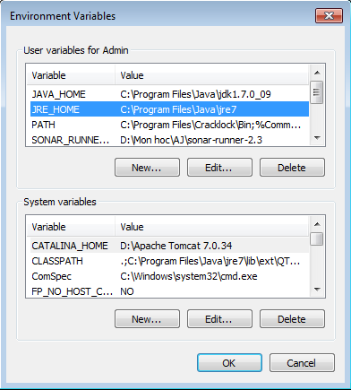**

Figure 56: Environment variable

Click “New…” button in User variables for Admin and fill variable name with JRE\_HOME and variable value with your JRE path installed on your computer.

* Setup CATALINA\_HOME:

Click “New…” button in System variables and fill variable name with CATALINA\_HOME and variable value with your Tomcat server path on your computer.

#### Prepare deployment package

* Copy the deployment package (12.3MB) to a folder on the Tomcat server.
* Ex: D:\Apache Tomcat 7.0.34\webapps

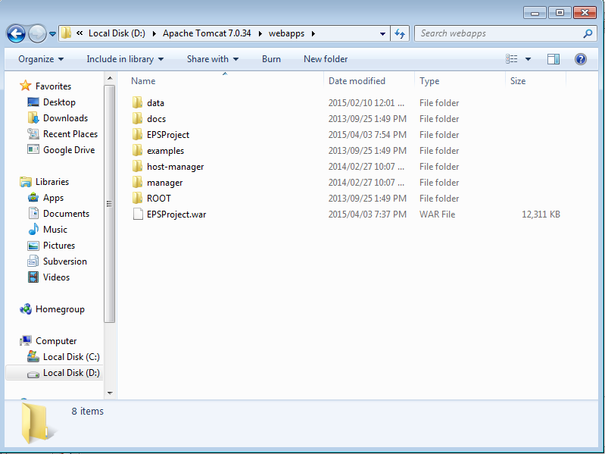

Figure 57: Server location

#### Deploy database

* Open Microsoft SQL Server Management Studio, connect database.
* Server name: the host server IPv4 address or SQL instance name of the machine.
* Login: username of the account.
* Password: password of the account.

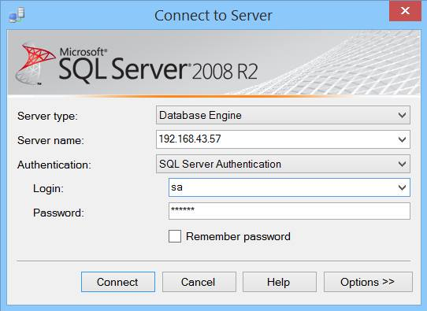

Figure 58: Database server login

* Open capstonePJ.sql file.
* Execute script file.

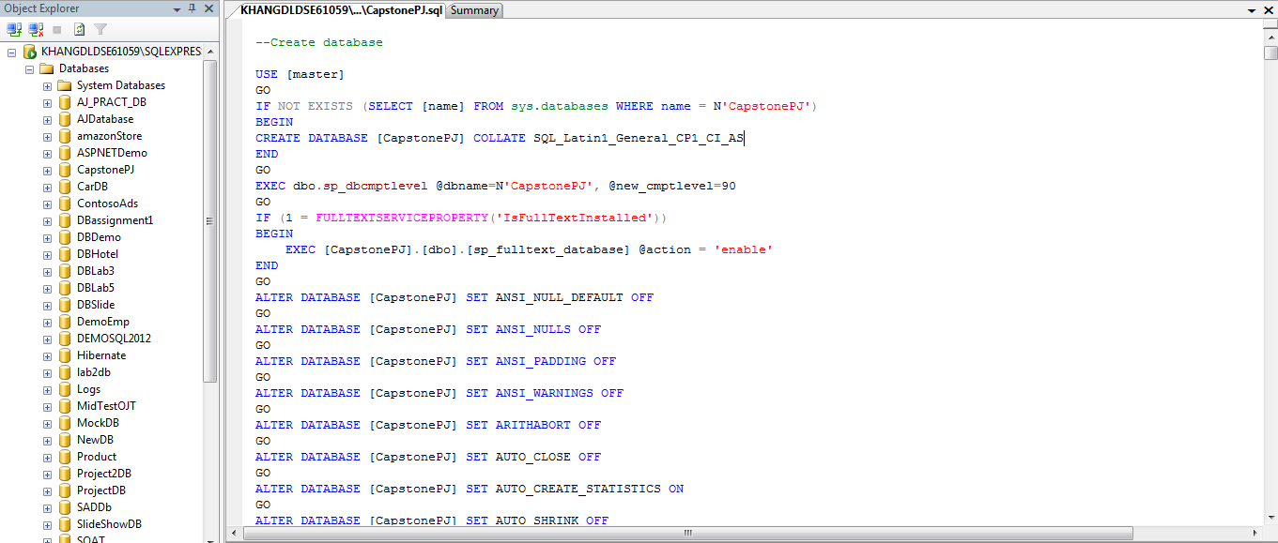

Figure 59: Database script

#### Deploy web application on server

* Start server to unpacked EPSProject.war.
* Change the connection string in **D:\Apache Tomcat 7.0.34\webapps\EPSProject\WEB-INF\classes\** dbconfig.properties.

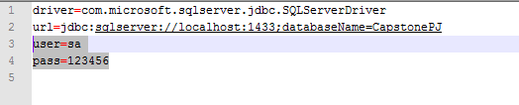

Figure 60: Connection String

* Restart server for the changes to take effect.
* Open localhost on server to see if deployment successful or not.
* Ex: http://localhost:8080/EPSProject.

### Setting up the environment at client side

#### Setting up for computer

##### Hardware requirements

Mini Bluetooth printer (for printing purpose):

* Manufacturer: TAWA (Taiwan Technology).
* Model Number: PRP 085 - BT.
* Paper roll: 58mm.
* Communication method: Bluetooth.

##### Software requirements

Installed at least one web browser:

* Google Chrome.
* Firefox.

##### Mobile Requirement

* Android 4.4.2.

#### Setting up for Android device

* Change setting to install unknown source “.apk”.
* Connect to the same network as the server.
* Download “.apk” at this link:
* Install

## User Guide

### Computer Guide

#### StoreOwner Guide

##### Register

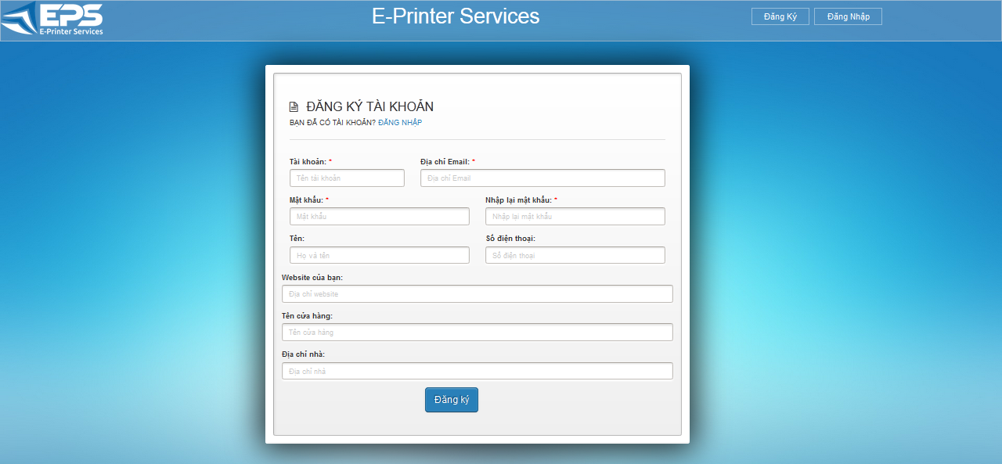

Figure 61: Register screen

|  |  |
| --- | --- |
| **Step** | **Description** |
| 1 | User fills out all of textbox with personal information. |
| 2 | User clicks button “Đăng ký” to register into system as storeowner. |

##### Select Template on first use

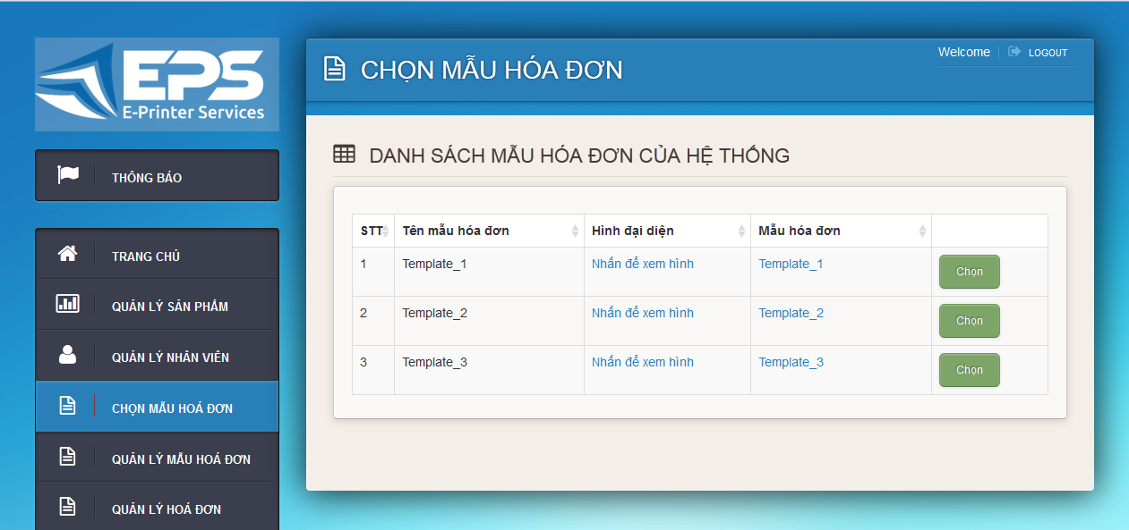

Figure 62: Select Template screen

|  |  |
| --- | --- |
| **Step** | **Description** |
| 1 | StoreOwner clicks on “Chọn” to select template. |

##### Set default template

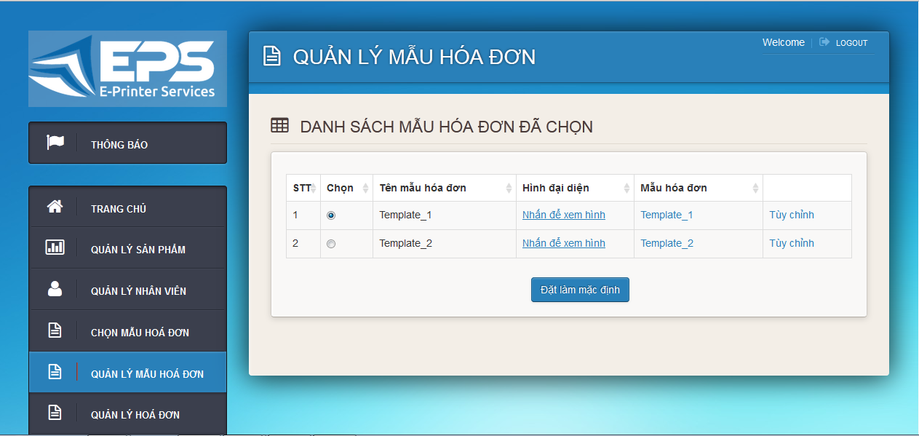

Figure 63: Manage Template screen

|  |  |
| --- | --- |
| **Step** | **Description** |
| 1 | Navigate to Manage Template screen by click on “Quản Lý Mẫu Hoá Đơn”. |
| 2 | Select a template by click ratio button “Chọn” |
| 3 | Set default template by click on “Đặt làm mặc định” button. |

##### Import list of item

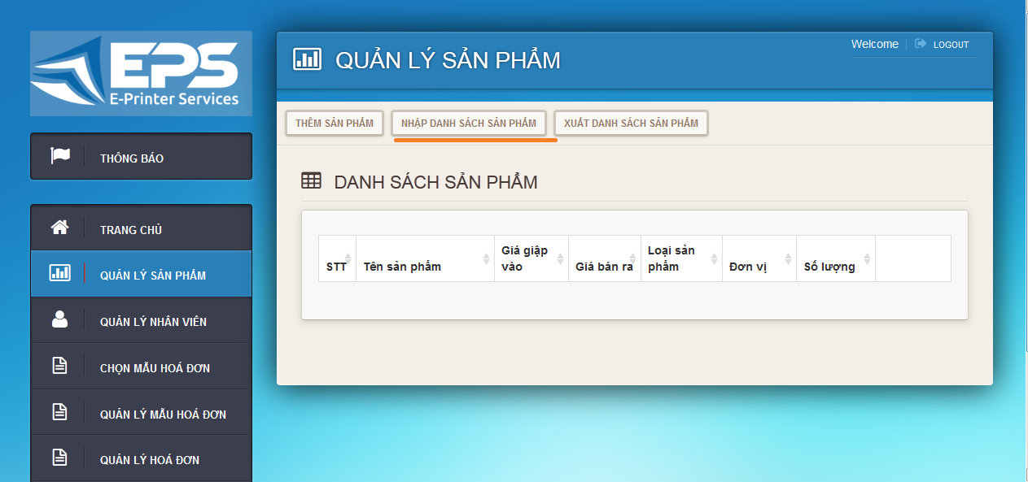

Figure 64: Manage Item

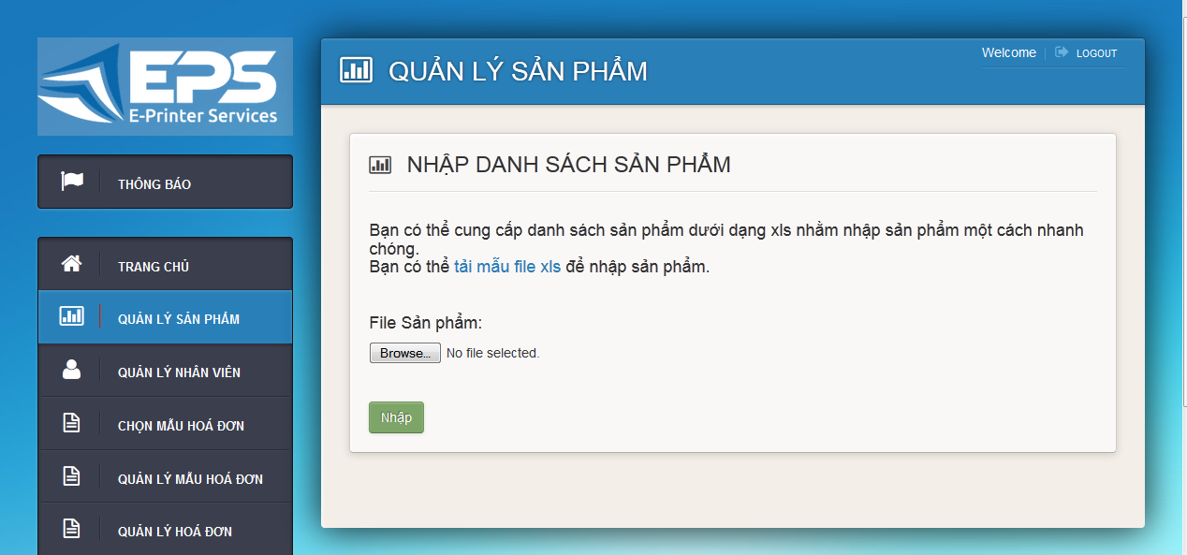

Figure 65: Import item

|  |  |
| --- | --- |
| **Step** | **Description** |
| 1 | Navigate to Manage Item screen by click on “Quản Lý Sản Phẩm”. |
| 2 | Navigate to Import Item screen by click on “Nhập Danh Sách Sản Phẩm”. |
| 3 | Download import item template by click on “tải mẫu file xls”. |
| 4 | Fills out your item info and save it. |
| 5 | Click on “browse” button and select which file you want to import. |
| 6 | Click on “Nhập” to finish import list item process. |

##### Import list of employee

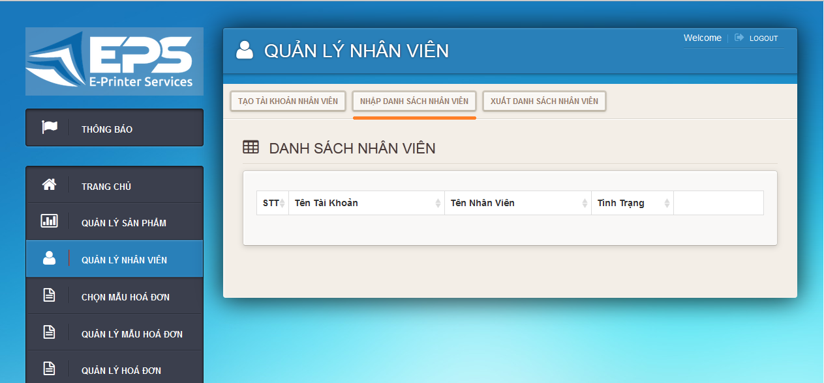

Figure 66: Manage employee

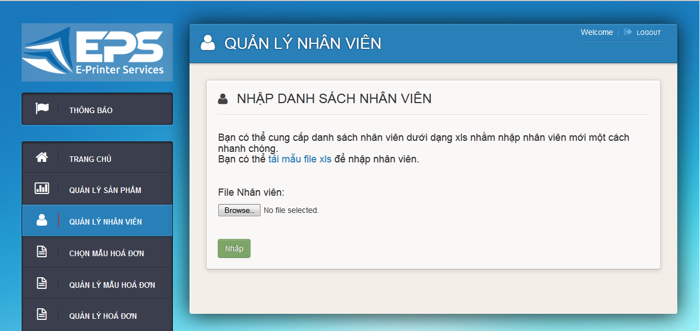

Figure 67: Import employee

|  |  |
| --- | --- |
| **Step** | **Description** |
| 1 | Navigate to Manage Employee screen by click on “Quản Lý Nhân Viên”. |
| 2 | Navigate to Import Employee screen by click on “Nhập Danh Sách Nhân Viên”. |
| 3 | Download import employee template by click on “tải mẫu file xls”. |
| 4 | Fills out your item info and save it. |
| 5 | Click on “browse” button and select which file you want to import. |
| 6 | Click on “Nhập” to finish import list employee process. |

##### Import list of report

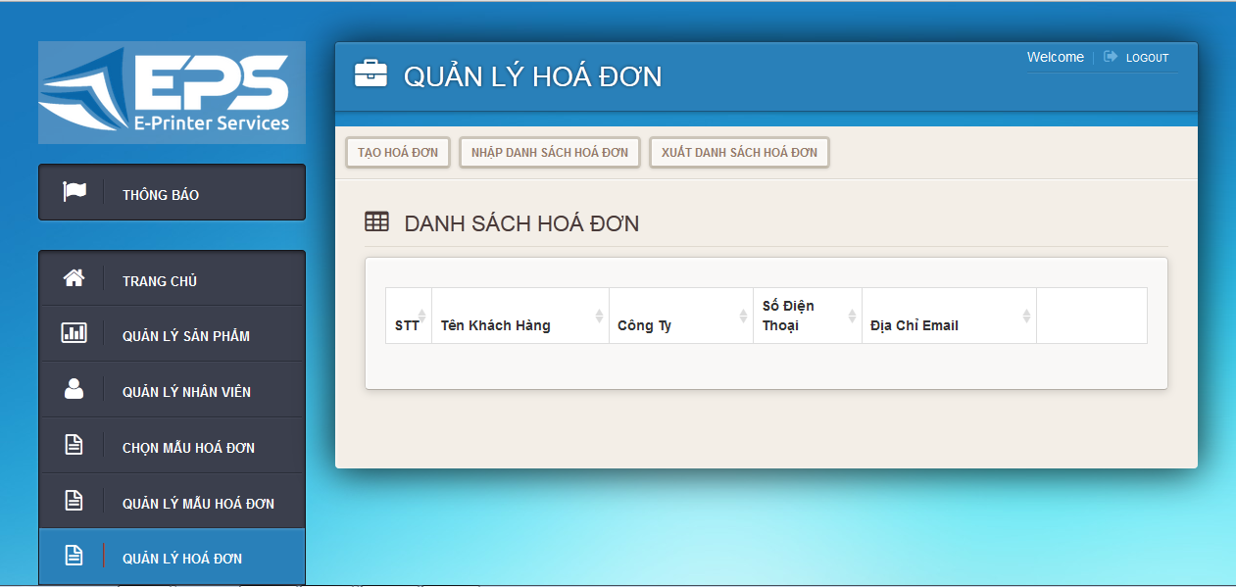

Figure 68: Manage Order

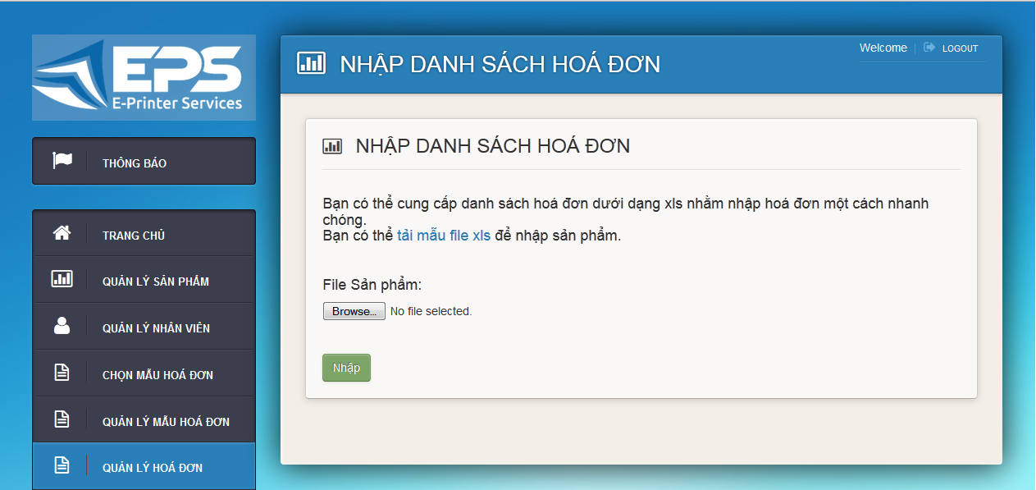

Figure 69: Import order

|  |  |
| --- | --- |
| **Step** | **Description** |
| 1 | Navigate to Manage Report screen by click on “Quản Lý Hoá Đơn”. |
| 2 | Navigate to Import Report screen by click on “Nhập Danh Sách Hoá Đơn”. |
| 3 | Download import report template by click on “tải mẫu file xls”. |
| 4 | Fills out your item info and save it. |
| 5 | Click on “browse” button and select which file you want to import. |
| 6 | Click on “Nhập” to finish import list report process. |

##### Assign Job for Employee

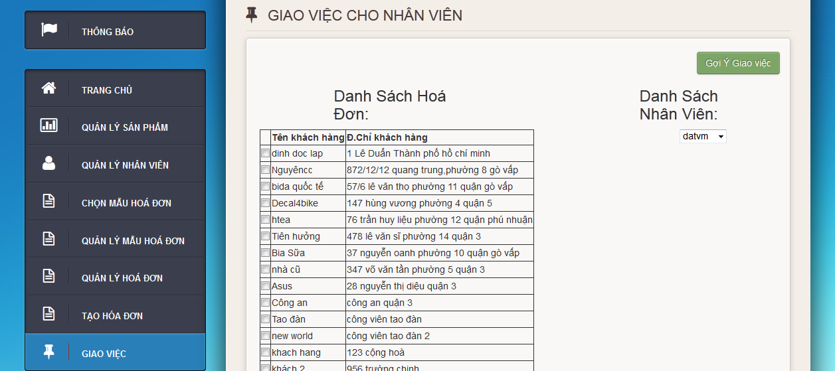

Figure 70: Assign order

|  |  |
| --- | --- |
| **Step** | **Description** |
| 1 | Navigate to Assign Job screen by click on “Giao Việc”. |
| 2 | Select report to assign by click on check box. |
| 3 | Select employee for this job list by select from combo box. |
| 4 | Click on “Giao việc” to finsh Assgin Job process. |

#### Admin Guide

##### Change StoreOwner Status

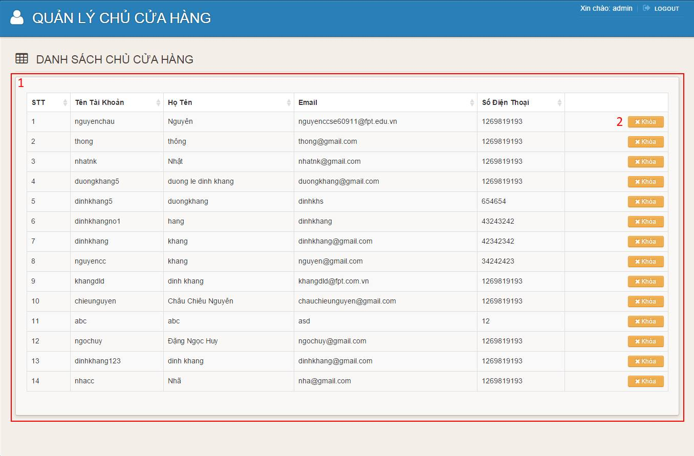

Figure 71: Manage StoreOwner

|  |  |
| --- | --- |
| **Step** | **Description** |
| 1 | Navigate to Manage StoreOwner screen by click on “Quản lý chủ cửa hảng” in navigation bar. |
| 2 | Lock a StoreOwner by click on “Khoá” button. |
| 3 | Unlock a StoreOwner by click on “Mở Khoá” button. |

##### Upload Template

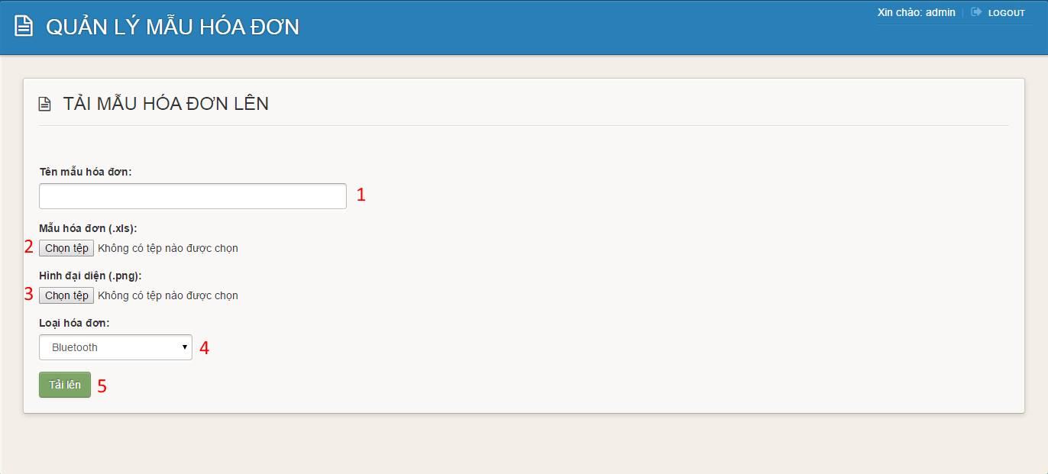

Figure 72: Upload Template

|  |  |
| --- | --- |
| **Step** | **Description** |
| 1 | Navigate to Upload Template screen by click on “Tải mẫu hoá đơn lên” in Manage Template screen. |
| 2 | Fill out the name of template in “Tên mẫu hoá đơn” |
| 3 | Click on (2) and select template in excel format. |
| 4 | Click on (3) and select template image preview. |
| 5 | Choose the type of template in (4), Bluetooth template or an A4 template. |
| 6 | Click on (5) to upload new template to system. |

##### Delete Template

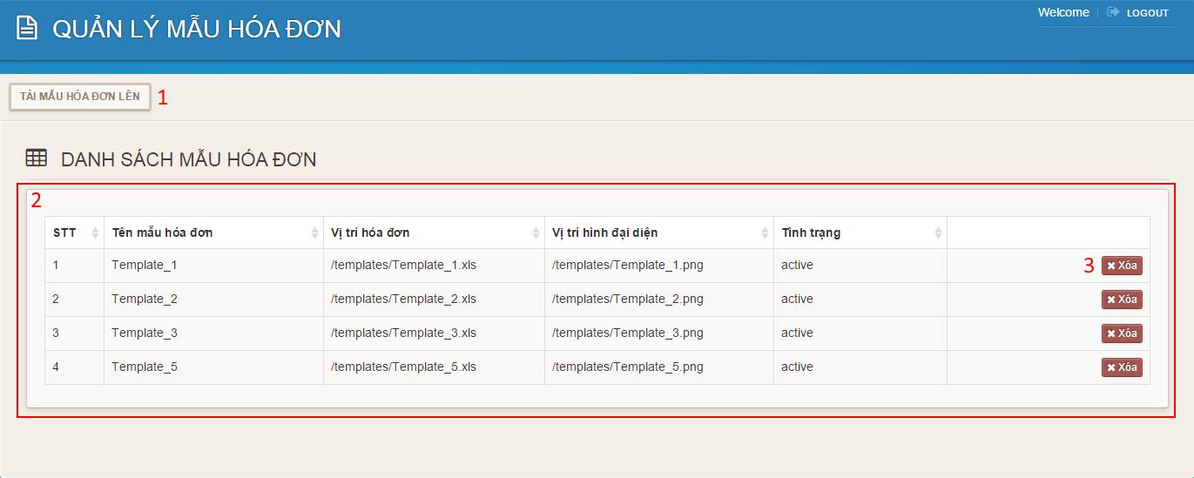

Figure 73: Delete Template

|  |  |
| --- | --- |
| **Step** | **Description** |
| 1 | Navigate to Manage Template screen by click on “Quản lý mẫu hoá đơn” in navigation bar. |
| 2 | Delete a template by click on “Xoá” button. |

### Mobile Guide

#### Employee Guide

##### Login

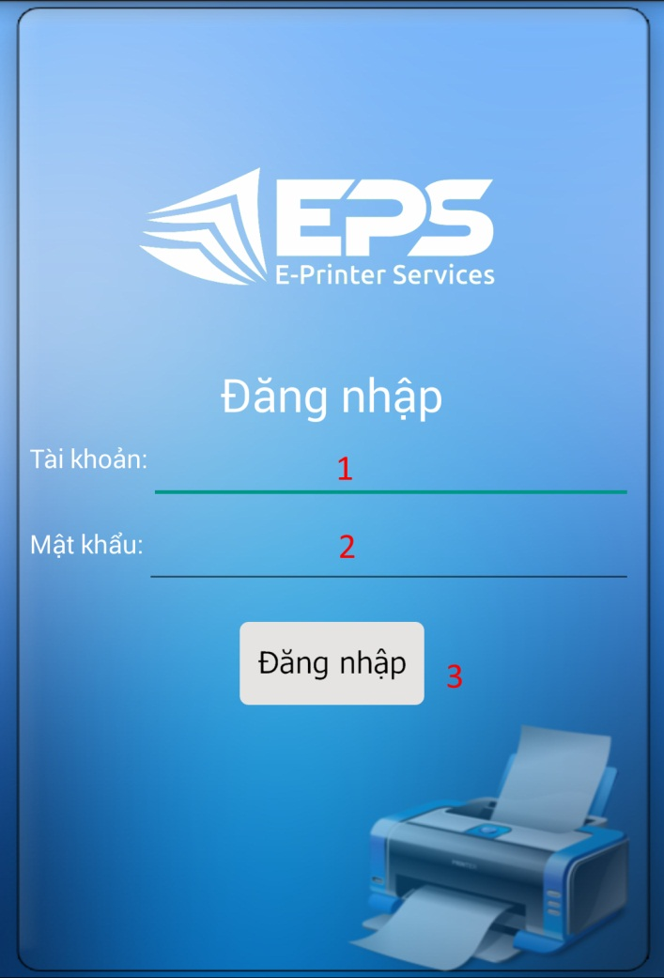

Figure 74: Login

|  |  |
| --- | --- |
| **Step** | **Description** |
| 1 | Employee fill their username in (1). |
| 2 | Employee fill their password in (2). |
| 3 | Click on (3) to login. |

##### Create Order

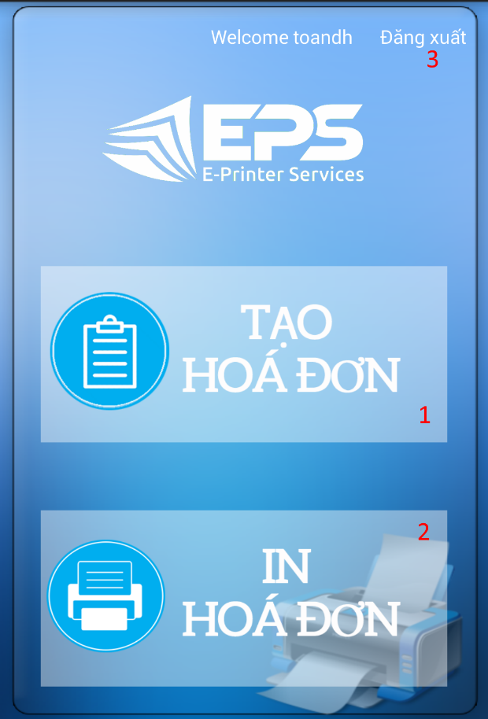

Figure 75: Menu Screen

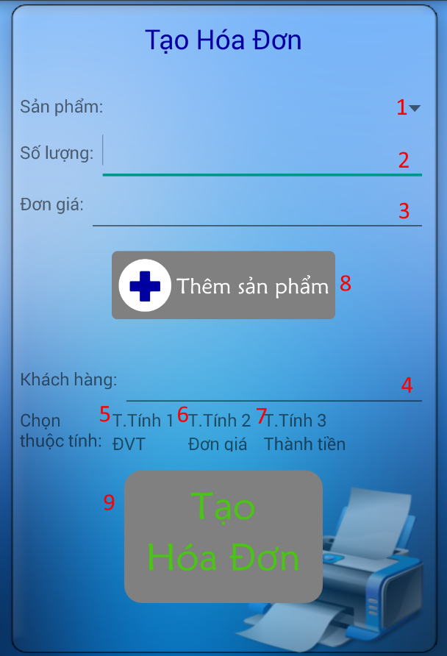

Figure 76: Create Order Screen

|  |  |
| --- | --- |
| **Step** | **Description** |
| 1 | Employee press on (1) in Menu Screen to start Create Order Activity. |
| 2 | In Create Order Screen, select item from (1), set quantity to add in (2) then click on (8) to add it to the order. |
| 3 | Input customer’s name in (4). |
| 4 | Set the attribute of item you want to see in order’s paper in (5),(6) and (7). |
| 5 | Click on (9) to create order. |